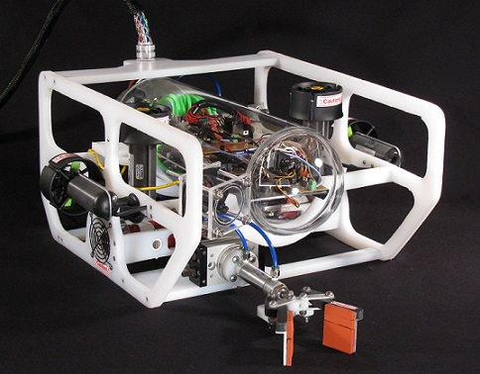
Cornerstone Academy, Gainesville, Florida
Technical Report

DeepView Technologies

Ghost Crab

Mentors
Jeffrey Knack, Alex Angerhofer, Connie Davis, Greg Spencer, Darell Taylor
Company Directory

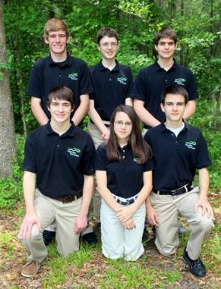
Timon Angerhofer: Chief Software Engineer, Computer Science, Class of 2015.
Tirza Angerhofer: Media Specialist,
Computer Science, Class of 2017.
Timothy Davis: Video Specialist,
Marine Biology, Class of 2014.
Noah Goodall: CFO and Design Engineer, Mechanical Engineering, Class of 2015.
Richard Hurlston: CEO,
Mechanical Science, Class of 2013.
Andrew Maule: Chief Design Engineer,
Biomedical Engineering, Class of 2014.

Top row: Richard, Timothy, Noah
Bottom row: Andrew, Tirza, Timon

Abstract

DeepView Technologies is located in Gainesville, Florida and specializes in underwater robotics, primarily in the field of submersibles operating in severe environments. The company has developed a Remotely Operated Underwater Vehicle (ROV), named the Ghost Crab, specifically designed for repair and upkeep of Regional Scale Nodes (RSN). This system provides a wide array of real-time information including chemical, geological, and biological data that can be accessed around the world. The mission can be accomplished due to the exceptional subsystems contained on the ROV such as custom-made payload tools that can be positioned precisely by the pilot operating the submersible. All system control signals on the Ghost Crab are transmitted from the control console to the ROV via fiber-optic and digital data cables. This allows the transmission of complex signals through a thin cable without interference. Camera systems are a critical part of the ROV operation, and provide a close-up view of tools the pilot needs to operate during the mission. All subsystems are mounted on a custom-made UHMW (Ultra High Molecular Weight poly-ethylene) frame designed by the company.
Table of Contents

Company Mission 3
Design Process 3
Design Rationale:
Research and Development 4
Propulsion 5
Cameras 5
Electronics 6
Pneumatics 7
Waterproof Canisters 8
Frame 10
Buoyancy 10
Tether 11
Sensors 11
Control System 12

Payload Systems and Tasks 12
Safety 13
Future Improvements 14
Reflections 14
Software Flowchart 15
Troubleshooting Process 15
Description of Challenges 16
Lessons Learned 16
Financial Report 17
Electrical Schematics 18
References 20
Acknowledgements 20
Appendices 21
Pneumatic Schematic 21
Fiber-optics Software 22

Company Mission
At DeepView Technologies, we strive to provide the finest, most cost-efficient products in the marine ROV industry. This year's ROV model, the Ghost Crab, was manufactured with extreme care and precision, in accordance with MATE standards, to complete the assigned mission. The Ghost Crab has been engineered specifically for marine equipment deployment and maintenance in a sensitive ocean environment. Recognizing the fragility of underwater environments, DeepView has taken great care to develop a ROV with precise movements to ensure mission success. As one of the top contenders in the market, DeepView Technologies aims to offer the best systems for any deep water data collection challenges.

Design Process
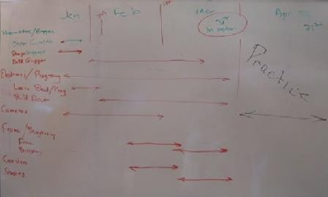
The creative process at DeepView Technologies began with a week-long brainstorming session. Out of that session came several overall ROV designs. The team agreed upon a design that emphasized effective camera positioning, maneuverability, and a streamlined frame shape. The team then assigned specific tasks to team members and drew up a timeline. After evaluating existing knowledge and capabilities, the team determined that further research was needed on payload tool and pneumatic systems.
Figure 1-1: The proposed schedule for completion of important tasks devised at the beginning of production.

After researching payload tool concepts, the team developed three gripper designs that operate in a similar fashion but are different in detail. The first design utilizes pads to secure a firm grip on payloads. In addition, this gripper is capable of 90 degree rotation that allows it to realign dropped payloads. This gripper was conceived to be useful for a diverse set of tasks, and is used in task one for removing pins and manipulating cable connectors. In task two it is used for placing the temperature sensor, and in task three it is used for operating doors and connecting cables. The second gripper features a claw-like design made for grasping handles. This gripper is capable of 180 degree rotation, and is useful for locking doors. It serves in task one for opening doors, in task three for locking doors, and in task four for removing biofouling. The third design is a finger gripper much like the second design, except it is oriented vertically, pointing downward for moving large objects. Unlike the other two grippers, it does not rotate, but can instead extend below the ROV for grasping vertically mounted U-bolts, which is its primary function throughout the whole mission. Each of the grippers were specifically designed for specialized tasks. Combined together, they make the Ghost Crab highly versatile.

Working from previous experience, the development team designed placements for vertical, horizontal, and lateral thrusters. The Ghost Crab’s vertical and horizontal thruster placements were chosen for controllable velocity and high speed. The vertical and horizontal thrusters were selected specifically with high power in mind. Both lateral thrusters were placed inside the frame for effective lateral movement that does not interfere with the vertical and horizontal thrusters. The lateral thrusters were chosen with cost effectiveness in mind. The thrusters are used in every task for a variety of actions.

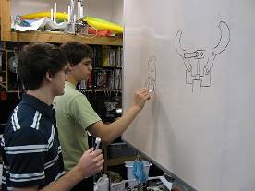
The design team then devised a plan for positioning the cameras, and selecting the type of cameras to use. The team decided on three types of cameras to provide an effective view of each payload tool and give pilots a good sense of direction. The first type of camera is a forward perspective camera that provides both a view of a payload tool and of the space in front of it. The team decided to put two of these cameras on the ROV, one on the front and one on the back. The second type of camera provides a bottom view of the ROV for viewing the extending gripper and various payloads. The team chose to place three of these cameras on the ROV, two for viewing the gripper and one for positioning. The third type is a pan-and-tilt camera that provides a broad view of the area in front of the ROV. The team decided to position this camera in a protected dome on the top of the ROV. Except for the pan-and-tilt camera which is used for navigation, each camera is tied to a specific action and is used in conjunction with its respective gripper.
Figure 1-2: The design team at work on gripper design.

After planning the components, the development team focused on designing compact printed circuit boards (PCB), and effective integration of the pneumatic components. The team developed three PCB’s; one for pneumatics, one for the cameras, and one for the thrusters. These boards were designed in a way that minimizes space utilization while retaining functionality. The team then designed the pneumatic layout and decided on a location for the manifold. The layout was designed to be compact and organized without restricting air flow.

With the PCB, pneumatic, and camera layout in mind, the development team designed three clear canisters for housing the Ghost Crab’s water sensitive components. The first canister houses the PCB’s, pneumatic manifold, three bottom facing cameras, and the pan-and-tilt-camera. The canister was fitted with a dome on its front end, so that the pan-and-tilt camera’s view would be undistorted no matter how the camera is positioned. The canister received a waterproof cap on the other end, and glands to allow cords to exit while maintaining a perfect seal.

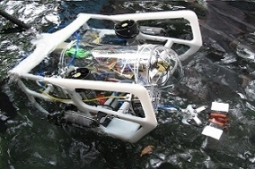
The next step was to design the frame and tether. The development team came up with several concepts and chose one that made room for all of the components while still being streamlined. The main canister is secured in the center of the ROV, the payload tools in the front, rear, and center, and the thrusters in positions that allow water to flow freely through them. The tether exits at the top of the frame. The team designed the tether to contain all of the ROV’s wires and remain neutrally buoyant. This allows the Ghost Crab to move freely with very little drag from the tether.
Figure 1-3: The finished product undergoing a mission.

The last step in the design process was to design the control station that consists of a control box, monitor, and two joysticks. The control box was equipped with easily accessible switches and intuitive controls, allowing the co-pilot to control the payload tools with ease. The monitor and joysticks are positioned to give the pilot a full range of motion and a complete view of the cameras. These designs allow the pilots to operate every aspect of the Ghost Crab with ease.

Design Rationale: Research and Development
Propulsion
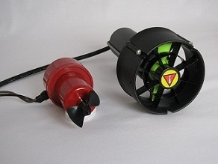
The Ghost Crab uses two Seabotix BTD-150 thrusters for forward and reverse motion. These thrusters provide approximately 9.6 Newtons of thrust at 12 Volts and are equipped with Kort nozzles around the propellers to increase thrust. For vertical thrust, the Ghost Crab is equipped with two additional Seabotix BTD-150 thrusters for quick ascending and descending motion. Lateral movement is facilitated by two modified Rule
100 gph bilge pumps. This array of thrusters provides adequate maneuverability for the pilot to effectively control the ROV during particular mission tasks.
Figure 1-4: Thrusters used for navigation: modified bilge pump on the left, Seabotix thruster on the right.

The forward/backward thrusters are controlled by a differential drive propulsion system. This system relies on two independently controlled thrusters positioned on the starboard and port sides of the ROV. Each thruster can run at varied speeds and directions to maneuver the ROV along the desired path. The path is determined by the difference in the thrust of the two independent thrusters. This positioning gives the ROV a small turning radius and allows it to make a turn without any forward motion.

Some payload tools are positioned on the stern of the ROV, requiring the pilot to adjust the position of the ROV. To address this problem, the Ghost Crab has the ability to invert the thruster signals, allowing for a seamless reversal of forward and reverse controls. This eliminates much of the operator’s difficulty in utilizing payload tools on the stern of the ROV.
To promote a safe working environment around the Ghost Crab, the thrusters are placed in protected positions, and both lateral thrusters are furnished with custom enclosures. This allows unobstructed water flow, yet prevents any unwanted objects from striking the propellers.

Cameras
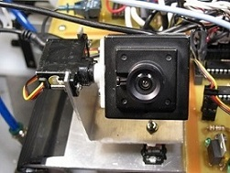
DeepView Technologies equipped the Ghost Crab with six newly acquired cameras: three CM320 micro video color cameras and three 208C Mini-wired NTSC security color video LED cameras. Two of the CM320 cameras are mounted in new custom-designed waterproof canisters (see Canister section below for further discussion). One of the CM320 cameras is mounted on a custom built manifold containing two variable control servos for pan and tilt functionality (Figure 1-5). The angle of view for the pan and tilt camera has a 180 degree tuning range both horizontally and vertically. The pan and tilt camera allows the pilot to easily switch between a view of the onboard tools and a forward facing view. The three 208C cameras are mounted on the inside of the main canister, underneath the electronics mounting bracket. These three cameras give the pilot an excellent view of the padded and extending grippers. Because the Ghost Crab’s tools are mounted on the bow and stern of the vehicle, DeepView Technologies’ engineers placed one of the two independently waterproofed cameras in the bow, and the other in the stern. These two cameras allow the pilot to view both the bow and stern, while still yielding a broad perspective of the general surroundings for navigation. All camera signals are sent through a pair of Cat 5e cables to minimize distortion and interference. In order to increase signal reliability, camera wires are connected to printed circuit boards that were custom-designed and built by DeepView Technologies. At the control center, the video signals are fed into an 8-channel video multiplexer, followed by a BNC to VGA converter, which then connects to an LCD monitor. The 8-channel video multiplexer allows the pilot to switch from viewing all camera signals simultaneously, to viewing a single camera on a large LCD screen. The camera displays are logically positioned in sequence, so an object passing through the views of all the cameras will move across the monitor. This allows the pilot to immediately locate an object, based on the field of view of the specific camera. Since images from the onboard video cameras are critical to completing mission tasks, DeepView Technologies invested great care in the design, construction, and installation of the Ghost Crab’s camera system in order to make operation of the ROV as precise and convenient as possible.
Figure 1-5: The pan and tilt camera.

Electronics
The focus at DeepView Technologies is to create well-designed ROVs with efficient systems. To maintain this goal, fiber-optic communication is used to transmit complex data streams, greatly increasing signal strength compared with a traditional #16 AWG stranded copper wire. The fiber-optic cables transmit a variety of control values generated from switches and potentiometers. To send this data, the PIC16F88 microcontroller acts as a multiplexer with several sensor inputs. The microcontroller sends out a string of bits into a fiber-optic transmitter. The transmitter then converts the electrical signal into pulses of light which are sent along the cable instantaneously until they are detected by a fiber-optic receiver. The receiver then transforms them back into electrical signals which are sent to multiple PIC16F88 microcontrollers. Each separate PIC16F88 acts as a demultiplexer, retrieving only the control data for the system it directs.

To maximize control of the Ghost Crab, the hardware and software allow for stepped variable speed of the ROV. Variable speed functionality allows the pilot to control the ROV more naturally through the water and aids in navigating through hazardous surroundings. To provide this advantage, the Ghost Crab is furnished with four BTD150 thrusters controlled by Pololu 18v15 High-Power motor-drivers. These motor-drivers respond to Hardware Pulse Width Modulation (HPWM) signals received from one of the ROV microcontrollers. This signal has an average input voltage ranging from 0 to 5 Volts, which is created by varying the duration of the 5 Volt pulse within the repetition cycle. The motor-driver uses this value to create a proportional stream of pulses between 0 and 12 Volts directed towards the thruster motors. The polarity of the thruster is determined by a direction pin on the motor-driver. When the pin changes its state, the polarity of the corresponding thruster reverses. These motor-driver inputs are determined by two potentiometers that are embedded inside two ergonomic joysticks. Each joystick controls one thruster, forward and reverse. The two forward/reverse thrusters form a differential drive arrangement where the turning motion of the ROV is determined by the difference in the thrust between the two sides. By alternating these joystick positions, the ROV will turn, move forward, etc. The Ghost Crab offers three different speed settings for the side thrusters, fast, slow, and neutral. Fast speeds are used when the pilot is positioning the ROV or moving to a desired location, and slow speeds are used to complete delicate tasks. Included on the left joystick is a switch which powers the vertical thrusters in a similar fashion, with the exception that there is no variable speed because it is not needed. Another useful function recently added to improve the capabilities of the Ghost Crab is the ability to reverse the polarity of the motors. The software controlling the forward/reverse thrusters contains two matching subroutines which are selected based on the state of a switch. When the ROV needs to be steered backward, the switch is thrown and the state of the direction pins are changed so that the pilot may look at the rear-facing camera and operate the ROV as if it were driving forward. This addition allows the pilot to navigate backward as well as forward with ease, while avoiding the frustration of having to mentally switch directions when steering in reverse.

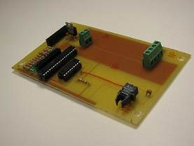
All payload systems on the Ghost Crab are pneumatically powered, but require electronics to control them. Solenoids are used to open and close valves that move each of the pneumatic cylinders. There are two solenoids per payload tool, allowing for each tool to have two positions, which includes open or closed for the gripper, or extended and withdrawn for the extending gripper. A new function of this year’s ROV is the addition of rotary actuators which can turn the grippers 90 or 180 degrees. Having the ability to turn the grippers allows more functionality from fewer grippers, and increases mission performance. The 16F88 transmits inputs from several switches to the ROV to control each tool. Each switch has exactly two positions to represent the position of the tool. No intermediate positions can be realized at this time because the payload tools can only be all the way open or all the way closed.
Figure 1-6: The pneumatics printed circuit board.

An additional aspect of the Ghost Crab’s electronics is the pan and tilt function on the front camera through two servos. Using potentiometers, the microcontroller transmits the input values through the fiber-optic cable to the ROV and directly to the servo motors. This creates variable control over the camera positioning, optimizing the use of the camera, and allowing for precise positioning.

Pneumatics
To complete the mission tasks, DeepView’s Ghost Crab must have the capability to generate swift, powerful motion. With this in mind, DeepView engineers settled on pneumatics as the power source of choice. It features better underwater functionality compared with electric components, and eliminates the potential of hazardous fluids leaking as in the case of a hydraulics system. The Ghost Crab uses pneumatic pistons provided by Fabco-Air, Inc. located in Gainesville, Florida. They are compact, powerful, yet simple, and mount easily to the UHMW frame. Along with the lateral pistons, engineers used two of Fabco's rotary pneumatic actuators (Figure 1-7). These can be adjusted to rotate up to 190 degrees. The grippers are mounted to the rotating head, and the rotary actuator is mounted to the frame.

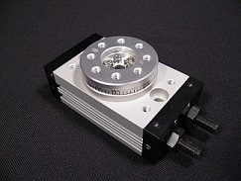
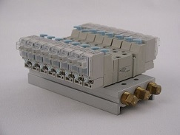
All six pneumatic tools are supplied with air by six double-action valves, which are mounted within the waterproof cylinder (Figure 1-8). These valves receive signals via a fiber optic cable from the control box at the surface. Double-action valves are more reliable than single-action valves, a feature which is helpful during critical operations in unstable environments. DeepView engineers used miniature valves and fittings, saving room inside the canister. These valves are connected to a six port manifold which splits air received from the surface to each of the valves. Two ¼ inch nylon tubes supply air to the manifold, exhaust excess pressure to the surface, and power tools throughout the ROV. These tubes are flexible, add very little diameter to the tether, and can bend around tight spaces with ease. All valves use push-to-connect fittings which quickly secure pneumatic lines firmly in place, and are completely waterproof.
Figure 1-7: A rotary pneumatic actuator.

One of DeepView Technologies’ highest priorities is customer safety. Due to the potential dangers associated with high pressure pneumatics, an operator safety checklist must be followed before use. The steps are as follows:
Figure 1-8: The valve bank which supplies all the pneumatic tools.
- Always wear safety goggles and ear protection when operating a compressor.
- Before connecting power to the compressor, make sure the release valve is closed and the unit is off.
- Attach power and then turn on the compressor, allowing the air tank to fill.
- Verify the supply air tank is filled to maximum capacity, and then turn the compressor off.
- Check all air lines for leaks and ensure fittings are attached securely.
- Attach the ROV hose line to the tank.
- Slowly release air into the system until the gauge reads a maximum of 276 kPa (40 psi).
- Test all pneumatic tools before embarking on a mission.
- When finished with the compressor, turn off the system, unplug the power cord, and then slowly release excess pressure.

Waterproof Canisters
DeepView Technologies has designed and built onboard waterproof canisters to accommodate two different applications on the ROV. The first canister type serves as an integrated housing for electronics, pneumatics, and video cameras, which simplifies repairs and maintenance of these assemblies (Figure 1-9). The second canister type is dedicated to housing a single camera, and can be easily repositioned on the ROV to compensate for the fixed nature of the cameras in the first canister (Figure 1-10). These two canister designs are a major improvement over earlier designs because they are more practical to use and maintain.

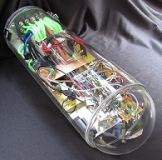
Since the first canister must serve as an integrated housing for electronics, pneumatics, and video cameras, the tube is large in size, measuring 17.8 cm (7 inches) in diameter, 47 cm (18.5 inches) in length, and 0.635 cm (1/4 inch) in wall thickness. The large size of the canister provides most of the buoyancy necessary for the ROV. The canister itself is made from a transparent acrylic tube, which gives the cameras an unobstructed view of the outside. However, cameras inside the canister must be positioned in a way that does not cause optical distortion, due to the cylinder’s shape. The acrylic tube also allows operators to observe the interior circuits and LEDs so they can easily check to see if the ROV’s electronics are functioning properly without opening the canister. The front of the canister has a transparent acrylic dome which is glued to the cylinder with Weld-on #16 Solvent Cement. The dome provides a large 2π solid angle unobstructed viewing range for the pan and tilt camera. The other end of the canister is fitted with a cap made of 2.54 cm (1 inch) PVC sheet. This cap houses a flat aluminum mount that holds the electronics, pneumatics, and cameras inside. Having an exterior PVC cap prevents corrosion and extends the longevity of the canister as a whole. The cap has a groove which holds a rubber O-ring. Three DiveRite quick-connect connectors are mounted on the sides of the cap. The connectors clamp the cap down on the tube, giving the O-ring a watertight seal and preventing water intrusion which could potentially damage the electronics. These DiveRite connectors also provide quick and easy access to the components within the canister when there is a need for maintenance or repair.
Figure 1-9: The main waterproof canister.

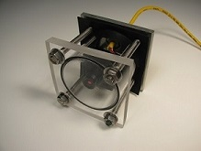
Two smaller canisters of the second type were created to serve as housings for two separate cameras. An operator is not expected to need access to the inside of these canisters because the cameras are maintenance-free, and consequently, they do not need a quick connect design. The canisters for the two cameras are made of a transparent acrylic tube just large enough for the camera to fit comfortably inside. The tube has a diameter of 6.35 cm (2.5 inches), a length of 5.08 cm (2.00 inches), and a wall width of 0.32cm (1/8 inch). One end of the tube has a transparent acrylic plate window attached with Weld-on #16 Solvent Cement. The other end has an aluminum plate that serves as a mount for the camera. A sheet of rubber is placed between the aluminum plate and the acrylic tube to serve as a seal to protect the camera after the tube and plate are bolted together.
Figure 1-10: One of the maintenance-free camera canisters.

Both canister designs utilize DiveRite metal glands that screw into tapped holes on the ROV canister caps. All fiber-optic signal wires, pneumatic tubing, and power cables go through these glands into the canisters. When the glands are screwed down on the rubber inside, a watertight seal is created on the cables.

DeepView Technologies’ canisters are manufactured to withstand extreme pressures, and are designed to house all equipment inside without excess space, thus enabling a smaller, nimbler ROV. As a result of thorough research and deliberate design, these canisters provide reliable housing for essential equipment aboard the ROV.
Frame
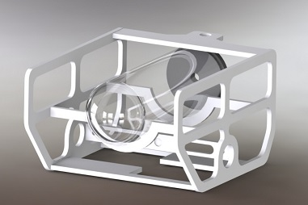
DeepView Technologies’ Ghost Crab features a light and compact frame, allowing for superior maneuverability. The design team chose UHMW as the material of choice for the frame. UHMW has near-neutral buoyancy, and is sturdy, yet simple to machine into any desired shape.

Taking into account the dimensions of the ROV’s waterproof canisters and thrusters, DeepView engineers designed a frame to enclose and protect the crucial system components. The canister rests on cross-members that span the frame. Lateral faces of the frame have large void spaces to reduce weight, while still leaving room to mount thrusters and tools. This design configuration decreases weight and drag, thus increasing the ROV’s hydrodynamic performance. Each tool is mounted to the Ghost Crab’s frame with specially designed brackets. These brackets allow tools to be easily detachable for maintenance purposes. On both rotational grippers, an aluminum bracket is mounted to cross sections beneath the frame, supporting the grippers while in use. The extending gripper is tucked away near the starboard vertical thruster. DeepView engineers created a hook shaped mount made of UHMW to ensure that the extending gripper would not move out of place.
Figure 1-11: CAD drawing of the UHMW frame and main waterproof canister.

The two horizontal thrusters were mounted outside the frame, to increase effectiveness in turning speed. The vertical thrusters are directly adjacent to the horizontal thrusters on the inside of the frame. The two smaller lateral thrusters presented a greater challenge to mount, as they had to fit within the frame, while facing outboard. DeepView Technologies’ talented engineers cut ventilation holes through a 42cm x 5cm x 1.25cm bar of UHMW to improve water flow, then mounted it amidships, in the lower center of the frame. At either end of this bar, two small thrusters were mounted and directed sideways, thrusting water from holes in the frame. Sturdy, maneuverable, and versatile, the frame of the Ghost Crab is perfect for any task.

Buoyancy
DeepView Technologies’ engineers designed the Ghost Crab with buoyancy in mind. With a specific gravity of 0.94, UHMW is slightly buoyant, making it a perfect choice for the Ghost Crab’s frame. With the weight of common ROV payload tools, additional floatation is often necessary. However, due to the amount of buoyancy that the ROV’s large integrated canister creates, DeepView engineers were able to eliminate additional floatation devices. Without the bulky floatation devices that are common to many ROVs, a pilot can maneuver the ROV with less difficulty, because drag is reduced. Although the frame was constructed with UHMW, minor weight adjustments still had to be made to optimize buoyancy. DeepView Technologies’ engineers utilized an adjustable stainless steel washer system. Two bolts run through the front lower sides of the frame, an equal amount of washers are mounted to both sides, and a wing nut holds the washers in place. The number of washers can then be adjusted as necessary. This allows operators to fine-tune the buoyancy of the ROV between slightly negative or positive. The washer system gives the ROV the stability necessary to complete the mission. With optimized buoyancy, the Ghost Crab can effectively maneuver through the water, and complete mission tasks with speed and precision.

Tether
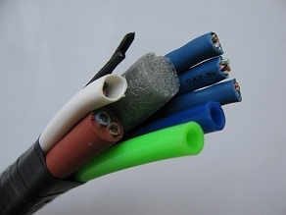
The Ghost Crab’s tether contains two #12 AWG wires, two #16 AWG wires, three Cat 5e cables, two fiber-optic wires, two pneumatic tubes, and a piece of foam for buoyancy. Twelve Volts of power are supplied to the ROV by a single pair of #12 AWG wires which are attached to the battery on the surface, and protected by a 25 A fuse. The #12 AWG wires are beneficial because they have very low resistivity leading to a combined resistance of only 0.19 ohms over 36.5 meters of wire, which results in a much lower voltage drop compared to our previous designs. The two #16 AWG wires are used by the lateral thrusters to produce a strong voltage for only those motors. Three Cat 5e cables are used to carry sensor data, camera pan and tilt commands, and camera images. Two fiber optic cables in the tether are also used for data transmission for the Ghost Crab’s thruster navigation and pneumatic control. The Cat 5e cables are beneficial because the twisted-pair wires inside reduce interference. There are also two pneumatic tubes within the tether. One tube is pressurized, transferring pneumatic power to the ROV's tools. The other tube is for the exhaust that vents air from the valve bank back to the surface. The vent tube prevents dangerous pressure build-up in the canister. The engineers at DeepView Technologies used ¼ inch pneumatic lines which are more flexible, making the tether more manageable and less prone to affecting ROV operation through excessive drag. DeepView Technologies has developed a tether that is thin, flexible, and reliable.
Figure 1-12: A cross section of the complete tether.

Sensors
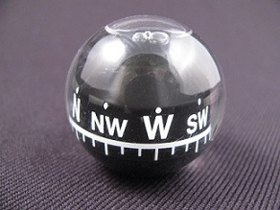
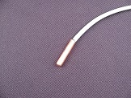
This year’s mission tasks require a temperature reading of a nearby thermal vent. To complete this task, DeepView Technologies designed and constructed a new temperature sensor comprised of three main components, including a housing, sensor, and circuit board. The housing for the sensor is made of an acrylic tube, with a PVC cap placed on one end. A U-bolt is screwed into the end cap, allowing the Ghost Crab’s grippers to grab and hold the sensor. The shape of the housing enables the ROV to easily transport and position the sensor over the thermal vent. The sensor is comprised of a thermistor soldered to a #16 AWG pair of copper wires and covered with epoxy for waterproofing (Figure 1-13). The wires are routed to a circuit board containing a PIC16F88 microchip and an LCD screen. This chip is programmed to read and translate the thermistor voltage drop into an accurate temperature which is then displayed on the screen. Another temperature sensor is included inside the canister of the ROV to check for overheating. Pilots can easily see all thermometer readings from the surface via an LCD screen embedded in the control box. A buzzer circuit inside the box, located near the temperature circuit, beeps every 1.5 minutes to remind the co-pilot to read and record the temperature reading. A second sensor implemented on the Ghost Crab is an analog compass (Figure 1-14). The waterproof compass is positioned in view of one of the cameras, and reports the orientation of the Ghost Crab to the nearest degree. This function is critical during the rare occasion the pilot becomes disoriented. The compass allows the pilot to determine the location of certain objects relative to magnetic north, allowing for a more efficient and speedy mission. Both the temperature sensor and the compass are important tools on the Ghost Crab.
Figure 1-14: The compass sensor.
Figure 1-13: The thermistor.

Control System
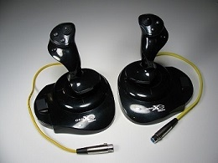
To efficiently control the Ghost Crab, DeepView Technologies has developed a streamlined console which houses electronics to transmit data to the ROV as well as receive sensor and control inputs. In order to provide an aesthetically pleasing and dependable control system, DeepView Technologies consulted the offices of Tel-Test, who generously donated a custom housing for the control box. Although Tel-Test manufactured the housing, all of the designs for the housing were created exclusively by DeepView Technologies. Attached to the console is a pair of joysticks that provide navigation for the ROV (Figure 1-15). The control box includes nine switches and two linear potentiometers for the operation of the tools and functions on the ROV. An LCD screen is central to the control system console for the display of sensor outputs. The pilot operates the ROV with the joysticks, and the co-pilot controls the switches and linear potentiometers, while keeping an eye on the LCD screen.
Figure 1-15: Two joysticks for navigation.

The control electronics inside the console have been realized using printed circuit boards which reduce space requirements and maintenance time. DeepView’s previous design used breadboards which suffered from weak connections and were prone to failure. In case of an emergency or short circuit, a safety switch is located on the back of the command system which controls power to the entire control board as well as the ROV. When the Ghost Crab is on standby or under maintenance, it is powered off with this switch for safety. A bright LED is illuminated whenever the system is on and turns off when a short circuit occurs. This allows users to quickly realize the presence of a short circuit and turn the system off.

For easy setup, the flexible tether splits into its individual lines as it nears the control hub and attaches quickly with dependable connectors. DeepView Technologies places utmost importance on the safety of its products, and the control box is always screwed tightly shut when not under maintenance. However, if the need arises to make adjustments inside the control system, the screws can be easily removed for quick accessibility.

Payload Systems and Tasks
To effectively complete its missions, DeepView Technologies’ Ghost Crab is outfitted with a variety of specialized grippers. Each of the three grippers is actuated by lateral pneumatic pistons powered by compressed air, at a pressure of 276 kPa (40 psi). Each gripper assembly is detachable, and compact enough to fit into the confined space within the frame.
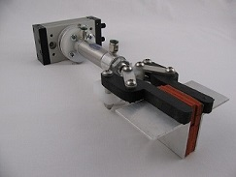
The first piston, mounted at the front of the ROV, has a flat tip machined from UHMW, the same material used for the frame (Figure 2-1). The two sides of the UHMW tip are symmetric, and are hinged together by custom made aluminum bars (gripper arms) connected to a bracket. As the piston extends, the hinges are pushed outward, separating the sides. Rubber pads attached to each arm provide friction as well as protection when holding objects.

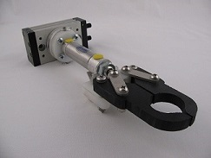
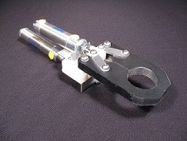
A similar gripper is mounted at the rear of the ROV (Figure 2-2). Instead of a flat UHMW tip, each half of this gripper's head has a finger-like shape. The finger gripper is designed to hold objects such as handles, loops, and hooks. Both the front and rear gripper assemblies are mounted on a pneumatic rotary actuator. Each actuator is set to rotate differently; the finger gripper rotates through 180 degrees, while the padded gripper rotates through only 90 degrees. The padded gripper’s 90 degree arc enables it to pivot and set upright any connectors that have turned over underwater. The finger gripper’s 180 degree arc allows the pilot to unlock the mooring platform’s door.
Figure 2-3: The extending gripper.
Figure 2-1: The padded gripper.

A third gripper is mounted vertically near the center of the ROV’s frame (Figure 2-3). This tool includes a system similar to the finger gripper, but without a rotary actuator. Unlike its rear mounted counterpart, this gripper assembly is attached adjacent to a second piston, which allows it to extend beneath the frame. Using this unique ability, the extending gripper can lift and carry objects underneath the ROV.

In summary, the versatile range of grippers on the Ghost Crab allows DeepView’s pilots to lift, open, move, and manipulate a wide range of objects underwater.
Figure 2-2: The finger gripper.

Safety
DeepView Technologies has always strived to make safety the highest priority in the design, construction, and operation of its vehicles. It is important to DeepView that our products, employees, customers, scientific instruments, and ocean environments remain safe. DeepView engineers have specifically designed the Ghost Crab to prevent injury or damage to the operator and underwater environment. During the design, development, and maintenance of the Ghost Crab, all engineering and manufacturing staff are required to wear personal protective equipment such as ear and eye protection. The workforce has been trained to check for safety violations during manufacturing operations. All employees must be certified in the use of power tools and pneumatic systems.

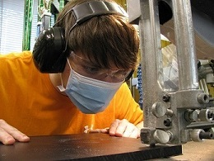
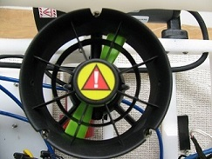
Safety features have also been built into the ROV’s electrical systems. A 25 ampere fuse on the main power supply trips in the event of a short circuit. The main power switch on the control box gives the operator the ability to quickly disconnect all electronics from the power source in case of an emergency. Keeping sturdy covers over thruster propellers ensures operator and environmental safety (Figure 3-2). The use of rounded edges on the frame and tools minimizes damage to underwater scientific instruments and the ocean environment. The pneumatic fittings and tubings are rated to at least 1 MPa (150 psi) which is above the maximum operating pressure of 276 kPa (40 psi). DeepView engineers have developed a water sensor that notifies the pilot to quickly bring the ROV to the surface in the event of water leakage into the canister. A temperature sensor has also been developed for the main canister to inform the pilot if circuits are overheating. As a safety precaution the ROV is never carried by fewer than two people. Before operating the ROV, operators always check to make sure the air compressor is adjusted to discharge air at 276 kPa (40 psi) or less, and ensure that all pneumatic tubing connections are sound before the ROV is placed in the water. Warning stickers placed on the tools and thrusters remind people to keep hands away from potentially dangerous areas. The company has developed a safety checklist that is reviewed before operating the vehicle. DeepView Technologies’ commitment to these safety features makes the Ghost Crab a safe and reliable product to operate.
Figure 3-1: Safety is top priority when working with dangerous tools.
Figure 3-2: Protective thruster shroud.

Future Improvements
Although the Ghost Crab can accomplish all mission tasks successfully, DeepView Technologies’ engineers have highlighted several future improvements that can be incorporated into the next generation ROV. One possible change is to use a handheld game controller, such as an Xbox controller, to control the ROV. This type of controller will allow one person to pilot the ROV and manipulate the grippers simultaneously, consolidating the control mechanisms from two operators to one. Having only one operator eliminates the possibility of miscommunication between the pilot and copilot. Moreover, the pilot’s familiarity with the controller will reduce response time, and allow for quicker eye-hand coordination. Incorporating this hardware into the control system will improve the next generation ROV.

Reflections
This year, engineers at DeepView Technologies learned that they work well together under pressure. Several times before the competition, the development team was asked to work long hours from sunrise to sunset, in order to complete the ROV. Under such strenuous circumstances, the team worked effectively together to complete a given task. Stress was minimized by keeping a positive attitude with situational humor, and having fun while building or piloting the ROV. By maintaining a pleasant workplace, efficiency and productivity increased dramatically. Team members were compatible with each other, and could work together to solve particular problems, while going above and beyond individual job requirements to help other teammates complete their tasks. This team dynamic greatly increased productivity as company members strove to complete the Ghost Crab.

Software Flowchart
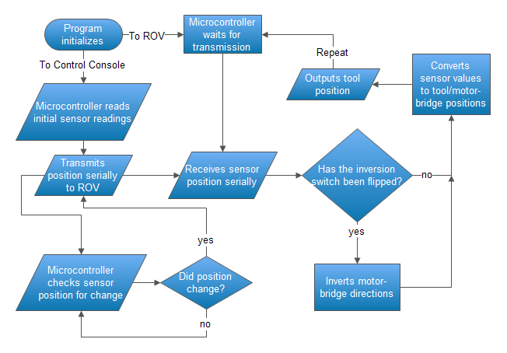
The logical flow of programming has been carefully designed and developed by the experienced programmers at DeepView Technologies. The switches and potentiometers at the surface send data to the microcontrollers, which in turn translate the data into fiber-optic light pulses. The fiber-optic cables descend to the ROV and transmit the information to the onboard microcontrollers. These microcontrollers convert the light pulses to electrical signals controlling tool and motor positions.

Troubleshooting Process

DeepView Technologies’ engineers have created a specific troubleshooting process to quickly identify and fix any problem which may arise with an individual system or the entire ROV. One of the main issues DeepView Technologies experienced while designing the Ghost Crab was optimizing buoyancy. Although having a highly buoyant canister was a helpful feature, equalizing the orientation of the ROV in water was more of a challenge. The center of buoyancy was toward the bow of the ROV while the center of gravity was at the stern of the ROV. In order to resolve this matter DeepView engineers shifted the center of gravity forward by adding stainless steel weights toward the bow of the ROV. The troubleshooting process used was to submerge the ROV into a test pool to see how it would react to the modifications. In order to trim the vehicle, we utilized an adjustable steel washer weight system. This was done by adding or taking away washers from the front of the ROV, further explained in the Buoyancy section. We added only two washers, one on each side of the ROV, each time until the ROV was neutrally buoyant. By perfecting this process, DeepView Technologies has effectively learned how to troubleshoot.
Description of Challenges
Non-Technical Challenge
Of the team challenges this year, scheduling proved to be one of the most difficult. The schedule was planned so that we would have three weeks before regionals to practice with the Ghost Crab. However, due to unforeseen technical problems our practice time was shortened to only two full days. It was hard to effectively prepare and practice for the impending regional competition. However, our pilot and copilot were skilled enough to obtain a reasonably high score, despite their limited practice time. Our team worked hard to complete the tasks, and we were able to overcome this challenge and win the Florida Regional competition.
Technical Challenge
Challenged with the difficult task of creating and using a temperature sensor to monitor a thermal vent in one of this year’s missions, the design team began by developing ideas for an effective sensor. After considering several ideas, the team decided on a sensor that utilized a DS1620 temperature sensor chip. A weighted frame that fit around the vent was created and tested with no complications. A temperature sensor circuit was developed and linked to an LCD with promising results. However, when the sensor was attached to the frame and submerged, the sensor displayed a constant value of 255 degrees Celsius. The design team attempted troubleshooting for several weeks and discovered two problems: the sensor chip worked close-range but could not carry a long-range signal, and the chip was in contact with water. While the latter problem could be fixed by covering the chip and solder joints with epoxy, the team was unable to solve the former problem for some time. Engineers tried replacing the original Cat 5e cable that carried the signal with separate cords, but it gave the same results. An attempt was then made to rework the circuit but to no avail. Although it appeared the team would not be able to fix the sensor, DeepView Technologies solved the problem after researching the issue further. It was realized that replacing the sensor chip with a thermistor would solve the problem. The thermistor was capable of accomplishing everything the chip could do, in addition to functioning over long distances. Implementing this new system has allowed the task to be accomplished flawlessly, and given DeepView Technologies a new method for developing temperature sensors in the future.
Lessons Learned
Non-Technical Lessons Learned
This year, DeepView Technologies’ engineers learned valuable lessons on efficiency and time management. This includes team members actively searching for tasks rather than idly waiting for someone to assign them a job. Another lesson learned was the importance of prioritizing which items to research and build first. Learning these valuable lessons has greatly increased the productivity of the engineers, and ensured the company's success in the future.
Technical Lesson Learned
In DeepView Technologies’ quest to improve the quality and versatility of its ROVs, the company is constantly researching and testing new methods in order to produce cutting edge products. This year, DeepView Technologies’ engineers designed and built a single canister layout, where all main components (save two module cameras) are contained in one large container. By building a single canister, our engineers reduced the complexity of the Ghost Crab and efficiently utilized available canister space. Learning how to design and build a single canister has greatly improved the quality of DeepView Technologies’ ROV.
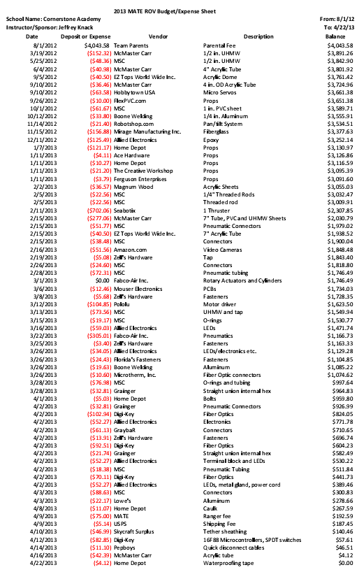
Financial Report
Electrical Schematics
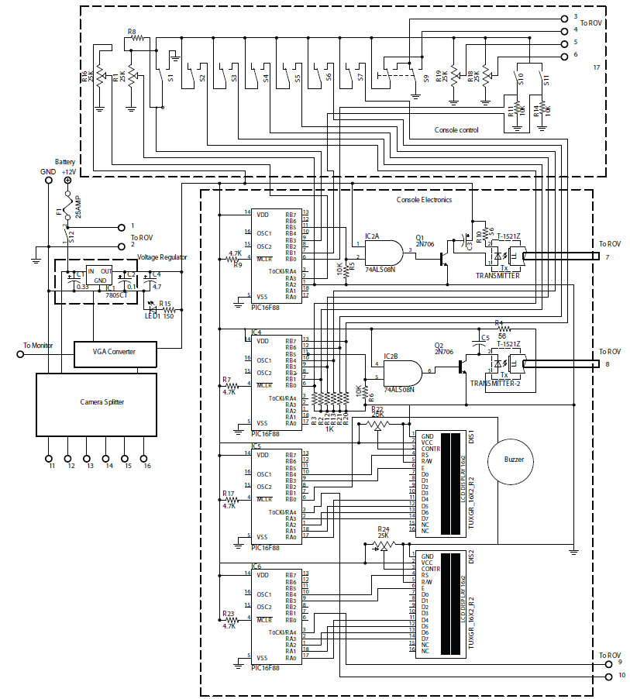
This schematic represents our control system at the surface. Included is every electrical aspect of control console and camera systems. Note the 25A fuse at the top left of the schematic diagram labeled F1.
Legend:
1. +12 Volts
2. GND
3. Lat. Thruster 1
4. Lat. Thruster 2
5. Camera Pot. 1
6. Camera Pot. 2
7. Thruster Fiber-optics
8. Pneumatic Fiber-optics
9. Temp. Sensor 1
10. Temp. Sensor 2
11. Camera 1
12. Camera 2
13. Camera 3
14. Camera 4
15. Camera 5
16. Camera 6

Control Console Schematic

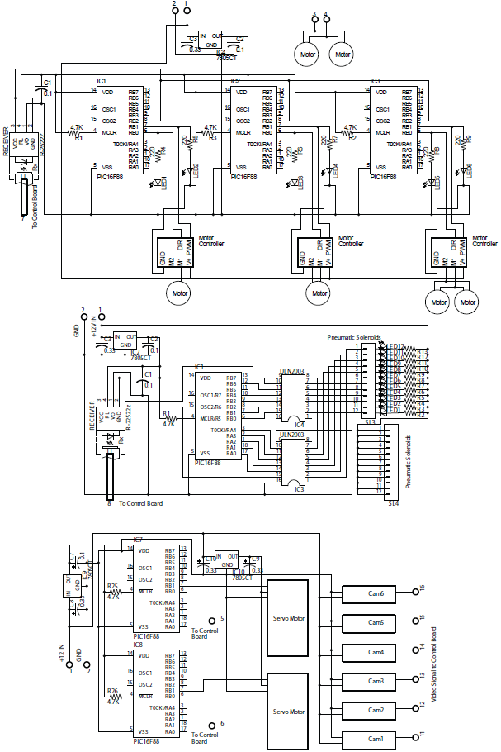
Propulsion Schematic:
Fiber-optic input is received at the far left by the R-2522Z and is transmitted to the microcontrollers, which direct the four thruster motors. The lateral thrusters are on the top right, receiving signals from 3 and 4.

Pneumatics Schematic:
Fiber-optic input is received at the far left by the R-2522Z and is transmitted to the PIC16F88. This microcontroller controls all the pneumatic solenoids.

Camera Schematic:
The two PIC16F88’s receive two potentiometer signals and translate them to servo positions for pan and tilt. The 6 camera signals go directly through the tether to the control board.

References
- MATE Center, Underwater Robotics Science, Design & Fabrication, http://www.materover.org/main/.
- MeLabs Forums, http://www.picbasic.co.uk/forum/forum.php
- MicroEngineering Labs, Inc. Picbasic Pro Compiler, Print
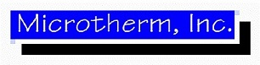
Acknowledgements
Financial Sponsors:
- Seabotix
- Dassault Systèmes Solid Works
- Fabco-Air, Inc.
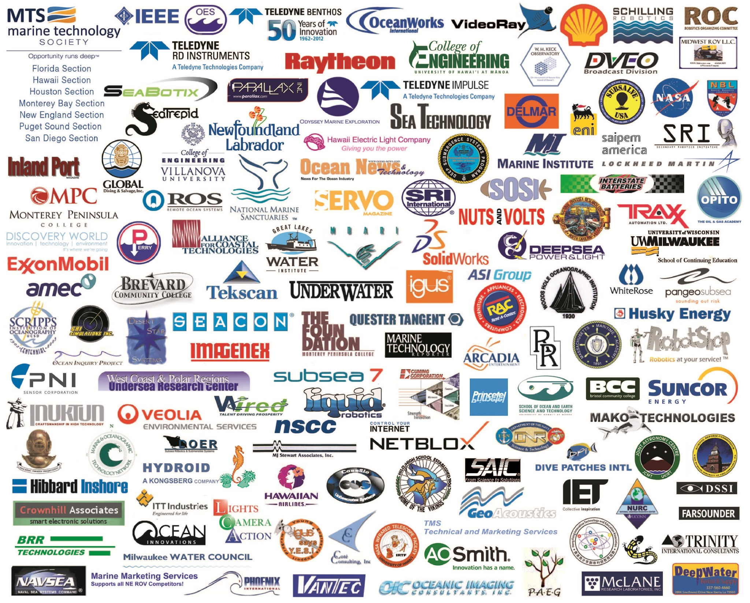
- Tel-Test
- Jeffrey Knack
- Parents of team members
- MATE
Local Team Supporters:
- Jeffery Knack – Team Mentor and Instructor
- The Administration of Cornerstone Academy
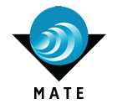
- Alex and Nadia Angerhofer, Emily Hurlston, Kimberly Knack, Tim and Connie Davis, Steve and Michelle Maule, Larry and Lorri Goodall, Greg Spencer, Manuel Angerhofer, and Ed and Betsy Gillman

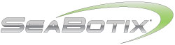

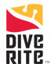

Tel-Test

Appendices

Pneumatic Schematic
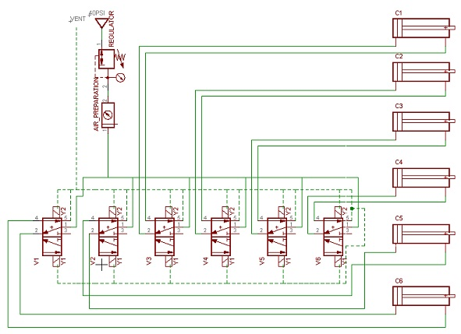

This schematic represents the airflow through our pneumatic system. R2 is the pressure regulator in line with the compressor, and R1 is our air preparation, which de-moisturizes the air. The line then feeds into the 6 double action solenoid valves. The output of the 6 valves are then distributed to our various pneumatic cylinders. The dotted line is our air drain, which feeds back up to the surface.
Fiber-optics Software
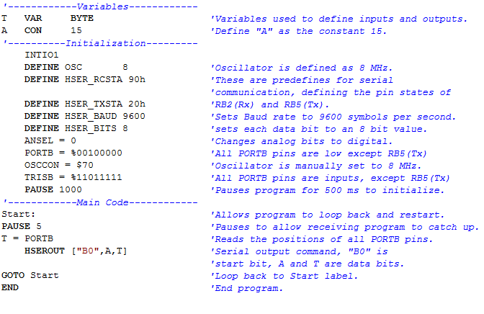
Joystick Control Program

Thruster Control Program
