Cornerstone Electronics Technology and Robotics I Week 8
Transistors and Comparators

- Administration:
  - Prayer
- Semiconductor Diodes:
  - Semiconductor Diode Symbol:

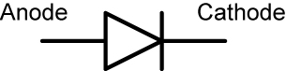

Figure 1: Diode Symbol

  - Diode Markings: The cathode is always identified by a ring, dot or some other mark.

Figure 2: Diode Markings

  - Two properties of diodes:
    - First, a diode is a device designed to permit current flow in one direction (from left to right in the symbol above) and to block flow in the other direction.
      - Forward Biased: In this orientation, once a small potential is applied to the diode, current will flow through the diode.

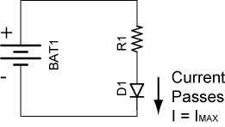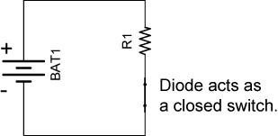

Figure 3: Forward Biased Diode Figure 4: Switch Analogy

      - Reversed Biased: Now reverse the polarity of the diode. A very small current (called leakage current) flows through the diode which can be measured in microamperes (μA). The current is practically blocked by the diode (I = 0) until the voltage is raised to the breakdown voltage.

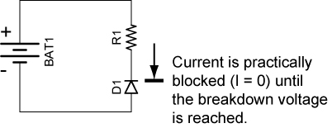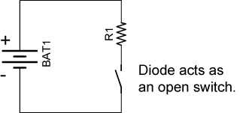

Figure 5: Reversed Biased Diode Figure 6: Switch Analogy
    - The second property of diodes is that they have a voltage drop. Typical voltage drops for different types of diodes are as follows:
      - Normal silicon diodes: 0.6 – 0.7 volts



Figure 7: Silicon Diode Symbol

      - Schottky diodes: 0.1 – 0.2 volts



Figure 8: Schottky Diode Symbol

      - LEDs: 2 – 3 volts (depends upon the color)

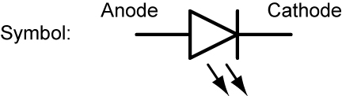

Figure 9: LED Symbol

      - Zener diodes: In the "forward" direction (right to left), no current will flow until the voltage across the diode is about 0.7 volts (as with a normal diode). Zener diodes will also allow current to flow from the left to right if the voltage approaches the "zener" voltage. Zener diodes are available in many different voltages, commonly from 1.2 to 200 volts.



Figure 10: Zener Diode Symbol

  - Structure: A semiconductor diode is made of P-type and N-type semiconductors that are fused together. The P-type material is deficient in electrons (thus the positive charge) and the N-type material has a surplus of electrons (negative charge). In the illustration below, if the diode is forward biased it will permit current to flow from right to left; if it is reversed biased; it will practically stop the current.



Figure 11: Simplified Diode Structure

Web site that details the behavior of the PN junction:
http://www.electronics-tutorials.ws/diode/diode_3.html

  - 1N400X Diode Family:
    - The 1N400X diodes are a popular 1.0 amp general purpose rectifier family.
    - Rather than writing 1N4001 – 1N4007 to specify the 1N400X family, we simply write 1N400X where X = 1, 2, 3, 4, 5, 6 or 7.
    - Similarly, X is used in other component families such as the Microchip 16F87X family, where X = 3, 4, 6, or 7.
    - The table below shows the blocking voltages of each of the members of the 1N400X family:

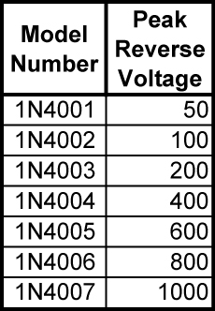

Table 1: 1N400X Diode Family

    - See a 1N400X family datasheet at: http://www.fairchildsemi.com/ds/1N%2F1N4001.pdf

- Transistor Switches:
  - A transistor is an example of an “active” electronic component. An active component injects power into a circuit. A transistor produces an output signal that has more power than the input signal. It is able to increase the power of a signal because it injects power from an electrical power source that is separate from the signal (Figure 12). A passive component has no power gain, in fact, they often cause power to be lost (example: resistor).

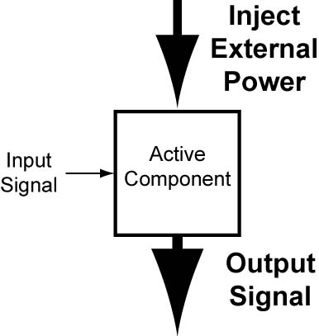

Figure 12: An Active Electronic Component Injects Power into a Circuit
  - Perform Transistors and Comparators Lab 1- LM393N Current Limitations.
  - Lab 1 revealed the current capability limitations of the LM393 comparator. Because most chips use their output pins only to send signals to other circuit devices, this problem has been solved. This lesson will employ a bipolar transistor as the solution to this problem.
  - PNP and NPN Bipolar Transistors:
    - Bipolar transistors are made of N-type and P-type semiconductor materials similar to diodes, but they have three layers and two junctions. Bipolar transistors are current amplifying or current regulating devices that control the amount of current flowing through them in proportion to the amount of biasing current applied to their base terminal.
    - Basic construction of PNP and NPN transistor (three layers, two junctions):

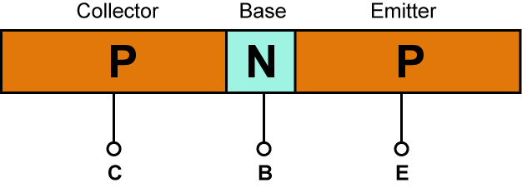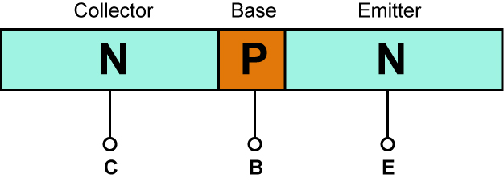

Where C = Collector
B = Base
E = Emitter

Figure 13: Simplified PNP and NPN Bipolar Transistor Structure

    - The principle of operation of the two transistor types (NPN and PNP) is exactly the same, the only difference being in the biasing (base current) and the polarity of the power supply for each type.
    - PNP and NPN Transistor Equivalent Diode Models: Two discrete diodes connected back to back will not function as a transistor. The models serve only to help visualize the structure of a transistor. The two PN junctions must be formed on a single wafer of silicon.

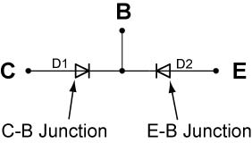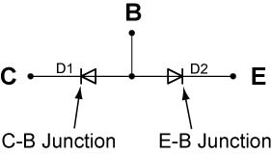

Figure 14: PNP Equivalent Circuit Figure 15: NPN Equivalent Circuit
    - Schematic Symbols:

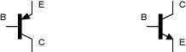

Figure 16: PNP Transistor Figure 17: NPN Transistor

      - For a PNP transistor, the arrow points toward the base; for the NPN transistor, the arrow points away from the base (NPN – “Not be Pointing iN”). The arrow points toward the direction of conventional current flow - toward ground.
      - Transistors are current controlling devices. A very small current flowing through the base (say 1 mA) can control a larger current flowing through the collector/emitter junction (may be 100 mA). See the Figures 18 and 19 below.

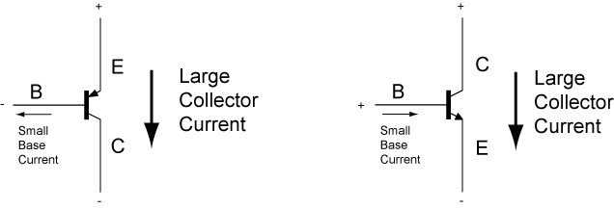

Figure 18: PNP Current Figure 19: NPN Current

Note that in the NPN transistor, the base current flows into the base while in the PNP transistor, the base current flows out of the base.

    - Pinouts for PNP and NPN transistors (TO-92 package) that we use:

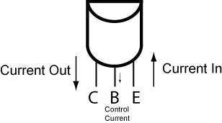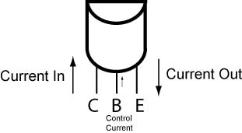

Figure 20: PNP Transistor Lead Layout Figure 21: NPN Transistor Lead Layout

    - Current in Bipolar Transistors (NPN and PNP):

I_{E} = I_{C} + I_{B}

Where: I_{E} = Emitter current
I_{C} = Collector current
I_{B} = Base current

    - Amplification or Gain (β):

β = I_{C}/I_{B}, I_{C} = β I_{B}

Where: β = Amplification
I_{C} = Collector current
I_{B} = Base current

    - The gain won't be identical even in transistors with the same part number. The gain also varies with collector current and temperature.
    - See: http://www.learnabout-electronics.org/bipolar_junction_transistors_05.php
    - Show samples.
  - Transistors as Switches: Both the NPN & PNP type bipolar transistors can be made to operate as an "ON/OFF" type solid state switch for controlling high power devices such as motors, solenoids, or lamps.
    - On/Off switching in a transistor is controlled by the biasing of the transistor’s base-to-emitter junction.
      - If the base-to-emitter junction is forward biased, the transistor turns on. The low resistance between the collector and emitter permits current to flow similar to a closed switch (see the illustrations below).
      - When a transistor is on, it is driven into saturation, i.e., the base bias voltage is increased to such a point that any further increase in bias voltage will not cause any further increase in current through the collector and emitter. The base current is high enough to give a collector-emitter voltage of near 0 volts resulting in maximum collector current flowing; the device is switched fully on (Figures 22 and 23).

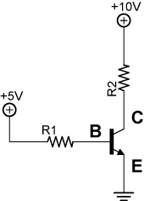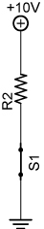

Figure 22: NPN B-E Junction Figure 23: Analogous Closed
Forward Biased Switch Circuit
      - A transistor is not a perfect switch. Even in saturation there will be a voltage across the transistor between the collector and the emitter. This voltage is known as Vce(sat). This will usually range between .3V and 1V, depending on the voltage and currents. In many circuits Vce(sat) can be ignored.
      - If the base-to-emitter junction is reversed biased, the transistor turns off. The high resistance between the collector and emitter stops current flow similar to an open switch. See Figures 24 and 25 below.
      - When a transistor is off, it is driven into cutoff, i.e., the base bias voltage is decreased to such a point that it stops current through the collector and emitter.

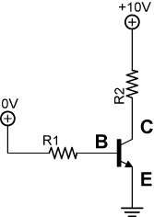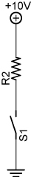

Figure 24: NPN B-E Junction Not Figure Figure 25: Analogous Open
Forward Biased Switch Circuit

See applets: http://www.falstad.com/circuit/e-pnp.html
http://www.falstad.com/circuit/e-npn.html

    - The transistor isn't a perfect switch. When in the off state, there is a small current that flows (measured in μA) and when on it has a small voltage drop.

  - Load placement for NPN and PNP transistor switches:
    - If the transistor is simply acting as a switch in our application, is it critical how the load R2 and the transistor switch are arranged? Can the load be placed between the emitter and ground rather than between the power supply and collector? After all, in the analogous circuit in Figure 27, the switch could be placed on either side of the load since the load and the switch are in series.

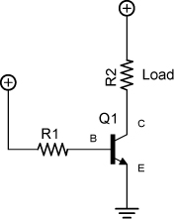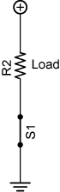

Figure 26: Proper Load Placement Figure 27: Analogous Switch for NPN Transistor Circuit

In other words, are the two circuits below electrically equivalent? The answer is no.

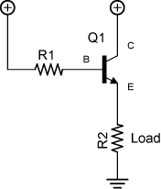

Figure 28: Load between the Power Figure 29: Load between the Emitter
Supply and Collector and Ground

    - The problem with the load being placed between the emitter and ground is that current flows through load R2 which creates a voltage drop across the load (Figure 29). This raises the voltage at the emitter which causes the base current to decrease which reduces the current through the transistor. The collector-emitter voltage then rises, diminishing the performance of the transistor switch. The load should be placed between the power supply and collector in a NPN transistor switch circuit (Figure 28).
    - Likewise, the load should be placed between the collector and ground for a PNP transistor switch. See the circuit in Figure 32.

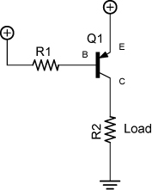
Figure 30: Proper Load Placement Figure 31: Proper Load Placement
for NPN Transistor for PNP Transistor

    - Perform Transistors and Comparators Lab 2 – NPN and PNP Transistor Load Placement
    - Perform Transistors and Comparators Lab 3 – NPN Transistor Switch Circuit Application.

- Voltage Comparators:
  - Voltage Comparators:
    - A comparator circuit is used to compare two voltage inputs and determine which is the larger of the two.
    - A comparator is a device whose output is HIGH when the voltage on the positive (+) input is greater than the voltage on the negative (-) input and LOW when the positive input voltage is less than the negative input voltage. This is true regardless whether the comparator is set up for inverting or non-inverting operation. See Figure 32.

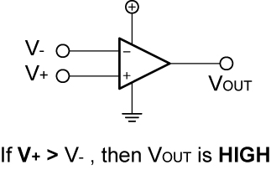
Figure 32: Basic Relationships for a Comparator

For example:

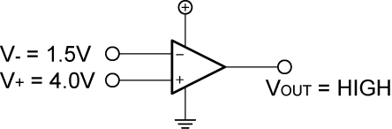

Figure 33: Example of Basic Relationships for a Comparator

    - Inputs into a comparator can be an analog voltage; the output is digital.
    - Two Basic Comparator Operations:
      - Inverting Operation: V_{REF} (the reference voltage) assigned to the positive input. When V_{IN} (the input voltage) exceeds V_{REF}, the output V_{OUT} goes from HIGH to LOW.

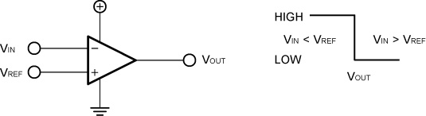

Figure 34: Basic Inverting Operation

The inverting operation can be represented in another graphical form:

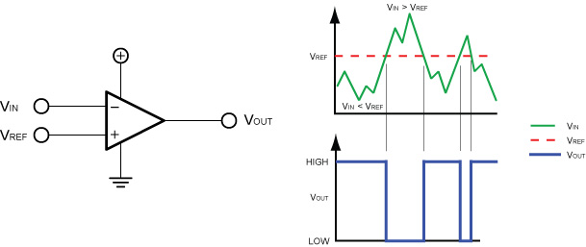

Figure 35: Basic Inverting Operation

        - In other words, the comparator set for inverting operation makes the following decisions:

If V_{IN} < V_{REF}, then the output voltage is HIGH and

If V_{IN} > V_{REF}, then the output voltage is LOW

        - Remember, in the inverting mode of operation, V_{REF} is connected to the + input.

      - Non-inverting Operation: V_{REF} (the reference voltage) assigned to the negative input. When V_{IN} exceeds V_{REF}, the output V_{OUT} goes from LOW to HIGH.

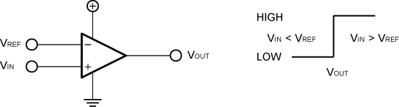

Figure 36: Basic Non-inverting Operation

The non-inverting operation can be represented in another graph:

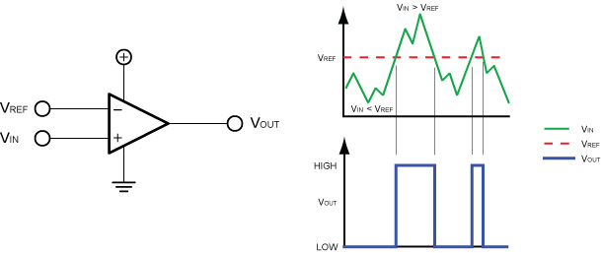

Figure 37: Basic Non-inverting Operation

        - The comparator set for non-inverting operation makes the following decisions:

If V_{IN} < V_{REF}, then the output voltage is LOW and

If V_{IN} > V_{REF}, then the output voltage is HIGH

  - Chip as a Source and as a Sink:
    - Chip as a Source: In Figure 38 below, when the pin connected to R1 goes HIGH, the chip connects the source voltage (+9V) to the load (the LED), similar to the switch in Figure 39.

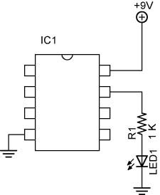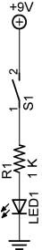

Figure 38 - Chip Acting as a Source Figure 39 - Chip Acts as Switch S1

    - Chip as a Sink: In Figure 40, when the pin connected to the LED goes LOW, the chip connects the load to ground, similar to the switch in Figure 41.

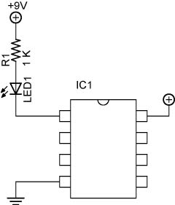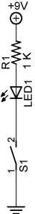

Figure 40 - Chip Acting as a Sink Figure 41 - Chip Acts Similar to Switch S1

  - 741 Op Amp:
    - A 741 op amp can be used to function as a comparator.
    - The 741 functions as a comparator when it is operated in an open-loop mode, that is, there is no feedback resistor.
    - The output varies from full on to full off with very small changes in the input voltage due to the high gain.
  - LM393 Dual Comparator:
    - Comparators are specifically designed for high-speed switching when matched up to an op amp.
    - LM393 consist of two independent voltage comparators designed to operate from a single power supply over a wide voltage range.
    - LM393 datasheet:
http://www.fairchildsemi.com/ds/LM/LM393.pdf
    - LM393 Characteristics:
      - Two independent voltage comparators
      - Single power supply, 2V – 36V
      - Operate over a wide range of voltages, up to about 36 V
      - Low input offset voltages in the mV range. This means that the LM393 can compare voltages that are very close to each other.
      - Like many older chips, the LM393 cannot source as much current as it can sink. The Fairchild LM393 typically sinks 18 mA. The terminology source and sink is from the water analogy, where water comes out of the source and then goes into the sink.
    - Comparator Pull-up Resistor:
      - If you refer to the datasheet for the LM393, the schematic reveals that the comparator uses an internal transistor whose collector is connected to the output and whose emitter is connected to ground. To enable the LM393 to have a high output state (when V₊ > V₋), the comparator output must be connected to a positive voltage source through an external pull-up resistor. If the pull-up resistor is not present, then the output voltage “floats”, meaning it is not tied to any known voltage level.
      - Value: The pull-up resistor must be small enough to drive the load connected to the comparator output, yet large enough to limit the power consumption. Below are two examples of pull-up resistors used in two different applications.

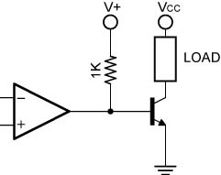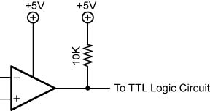

Figure 42: Power Switching and TTL Logic Circuit Applications
      - Pin Layout:

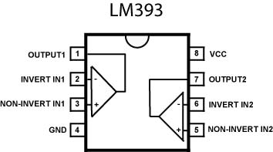

Figure 43: Pinout of LM393

The semi-circle notch in the chip locates pin 1.

      - Perform Transistors and Comparators Lab 4 – LM393N Comparator
      - Perform Transistors and Comparators Lab 5 – LM393 Circuit Application – Leak Detector

  - Other web references:
    - http://www.techitoutuk.com/knowledge/electronics/buildingblocks/opamp/index.html
    - http://www.technologystudent.com/elec1/opamp3.htm
    - http://www.uoguelph.ca/~antoon/gadgets/741/741.html
    - http://booksbybibin.14.forumer.com/a/ic741-tutorial_post38.html
Electronics Technology and Robotics I Week 8
Transistors and Comparators Lab 1 – LM393N Current Limitations

- Purpose: The purpose of this lab is to acquaint the student with the current limitations of the LM393 voltage comparator.

- Apparatus and Materials:

  - 1 – Solderless Breadboard with 9 V Power Supply
  - 1 – Digital Multimeter
  - 1 – Gearhead Motor, HNGH12-1324Y-R
  - 1 – 150 Ohm Resistor
  - 3 – Yellow LEDs
  - 3 – Green LEDs

- Procedure:
  - Measure and record the maximum current used by the gearhead motor. Use a DMM that saves the maximum current value. See schematic below.
  - Measure and record the current to power three series yellow and then three green LED’s.
  - Total the maximum currents of the components.

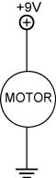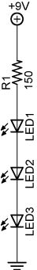

  - Review the attached data sheet for the LM393 comparator. Note the typical Output Sink Current value. Record and determine the difference.

- Results:

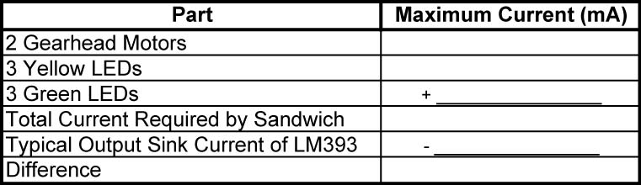

- Conclusions:
  - Does the LM393 provide sufficient current output to handle the motor and LED load requirements?



Electronics Technology and Robotics I Week 8
Transistors and Comparators Lab 2 – NPN and PNP Transistor Load Placement

- Purpose: The purpose of this lab is to demonstrate that the placement of the load in a NPN transistor switch is critical.

- Apparatus and Materials:

  - 1 – Solderless Breadboard with 9 V Power Supply
  - 2 – Digital Multimeters
  - 1 – 2N2222A NPN Transistor
  - 1 – SPST Switch
  - 1 – 470K Resistor
  - 1 – 1K Resistor
  - 1 – LED

- Procedure:
  - Build the first NPN test circuit. Note the placement of the load (the resistor R2 and the LED). Measure and record the collector, emitter, and base currents. Also measure and record the collector-emitter voltage.
  - Now move the load to the emitter side of the transistor and measure and record all three currents again and the collector-emitter voltage.

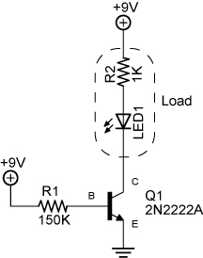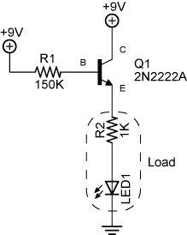

NPN Transistor as a “Low Side” Switch NPN Transistor as a “High Side” Switch
- Results:
  - Load connected to collector: Load connected to emitter:

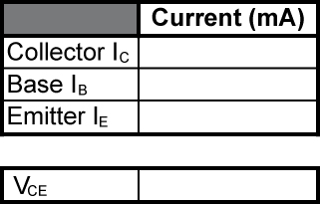

- Conclusions:
  - Insert your results in the circuits below:

Load connected to collector: Load connected to emitter:

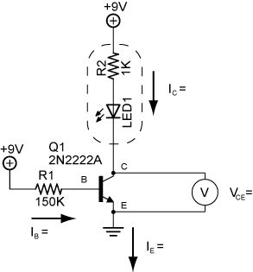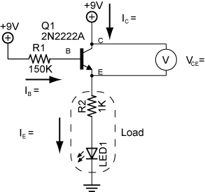

  - If the 2N2222A NPN transistor is serving as a switch, what problem does the collector-emitter voltage cause in the right circuit?

  - Which circuit functions better as a switch? Why?

  - Draw a PNP transistor circuit showing the proper position for the load.

- Sample Readings:
  - Load connected to collector: Load connected to emitter:

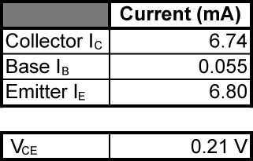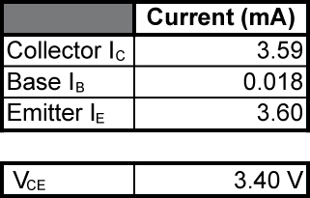

Electronics Technology and Robotics I Week 8
Transistors and Comparators Lab 3 – NPN Transistor Switch Circuit Application

- Purpose: The purpose of this lab is to demonstrate a practical use of a transistor switch.

- Apparatus and Materials:

  - 1 – Solderless Breadboard with 9 V Power Supply
  - 1 – Digital Multimeter
  - 1 – 2N2222A NPN Transistor
  - 1 – 10K Ω Resistor
  - 1 – Photoresistor
  - 2 – 470 Ω Resistor
  - 1 – LED

- Procedure:
  - Wire the following circuit on a breadboard.
  - Vary the amount of light entering the photoresistor using a flashlight.
  - Measure and record the highest and lowest voltage readings at Point A, V_{A}, with respect to ground.
  - Also measure and record the voltage at Point A when the LED just lights.

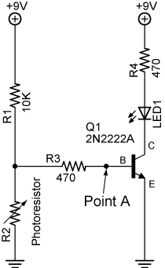

- Results:

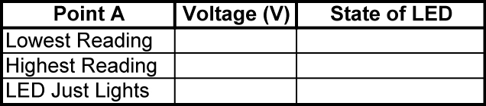

Electronics Technology and Robotics I Week 8
Transistors and Comparators Lab 4 – LM393N Comparator

- Purpose: The purpose of this lab is to acquaint the student with the LM393N comparator and its inverting and non-inverting modes.

- Apparatus and Materials:

  - 1 – Solderless Breadboard with 9 V Power Supply
  - 2 – Digital Multimeters
  - 1 – LM393N Comparator
  - 2 – 25 K Potentiometers
  - 2 – 1 K Ω Resistors
  - 2 – LEDs

- Procedure:
  - Build Circuit 2. Wiring Diagram 1 may assist in the assembly of the circuit.
  - In this test, let pins 2 and 5 be the reference voltage (V_{REF}). Adjust R₁ to set pins 2 and 5 to about 4.5 V.
  - Adjust R₂ so that the voltage input (V_{IN}) into pins 3 and 6 varies from 0 to 9V. If V_{IN} is less than V_{REF} are the LEDs on or off? If V_{IN} is more than V_{REF} are the LEDs on or off? Record your results.
  - At what voltage does the LED change state? Record your results.
  - LM393N Pinout:

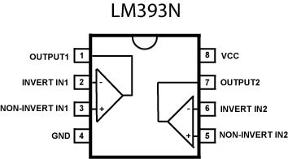

  - Always use the IC extractor when removing ICs.

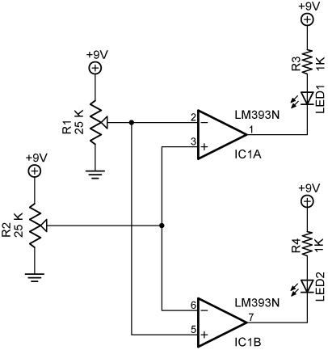

Circuit 2

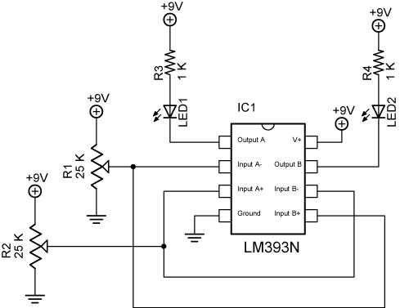

Wiring Diagram 1

- Results:
  - Pins 2 and 5 reference voltage (V_{REF}): __________V

  - Pins 3 and 6 (V_{IN}) less than V_{REF}: LED1 on or off LED2 on or off

  - Pins 3 and 6 (V_{IN}) more than V_{REF}: LED1 on or off LED2 on or off

  - V_{IN} where the LED changes state? __________V

- Conclusions:
  - If Pin 5 of IC1B is set as V_{REF}, what mode is IC1B in? Inverting or non-inverting?

- Light Sensor Robotic Car Using an LM393:

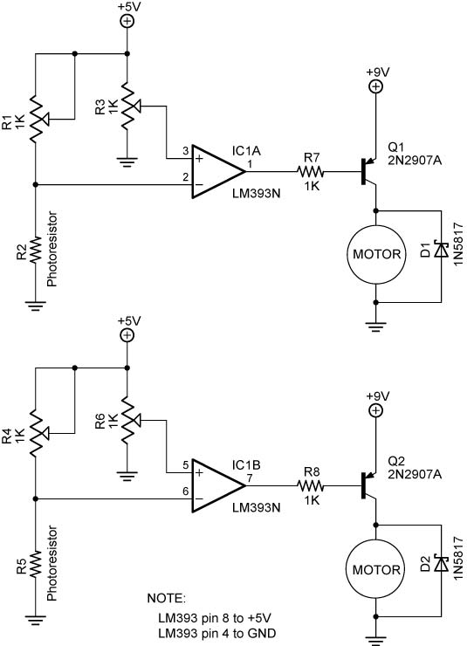
Electronics Technology and Robotics I Week 8
Transistors and Comparators Lab 5 – LM393 Circuit Application – Leak Detector

- Purpose: A simple circuit in an underwater pressure canister can alert an Remotely Operated Vehicle (ROV) pilot to a potential disastrous water leak. This lab offers a circuit that detects water leaks by using an LM393 comparator.

- Apparatus and Materials:
  - 1 – Solderless Breadboard with 9V Power Supply
  - 2 – Digital Multimeters
  - 1 – LM393 Comparator
  - 1 – 25K Potentiometer
  - 3 – 10K Resistors
  - 1 – 10K Resistor
  - 1 – LED
  - 1 – 10’ Solid Wire Pair

- Procedure:
  - Build the circuit shown below.
  - Using the potentiometer, adjust the reference voltage such that the LED lights when the bare wire pair is submerged in water.
  - Connect a DMM to Pins 2 and 3 of the LM393.
  - Record your reference voltage on Pin 3 in the results.
  - Now record the voltage on Pin 2 when the LED illuminates.

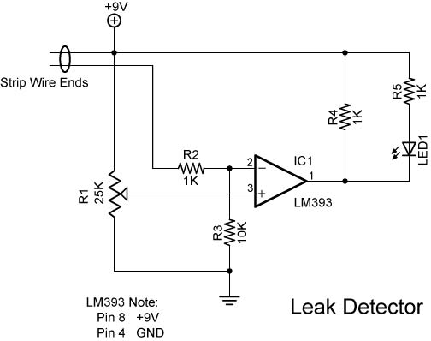
- Results:

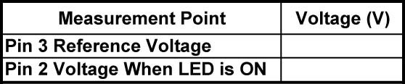

- Conclusions:
  - Does the comparator act in an inverting or non-inverting operation?

