Electronics Technology and Robotics I Week 5
Resistors and Potentiometers

- Administration:
  - Prayer
  - Turn in quiz
  - Using two switches, design a circuit that correspond to an AND gate.
- Resistors:
  - Function: Resistors restrict the flow of electric current, for example a resistor is placed in series with a light-emitting diode (LED) to limit the current passing through the LED. They convert electrical energy into mechanical energy (heat).
    - Resistors are used to:
      - Provide a voltage drop
      - Provide a current limit
      - Dissipate (converting) electrical energy
      - Some electrical components have resistance that varies with temperature or light. They serve as sensors used in various applications.
  - When used in DC circuits the voltage drop produced is measured across their terminals as the circuit current flows through them because they obey Ohm's Law.
  - A largerer value in ohms represents a larger resistance.
  - Fixed Resistors:
    - Examples and symbol with the value of its resistance given in Ohms, Ω:

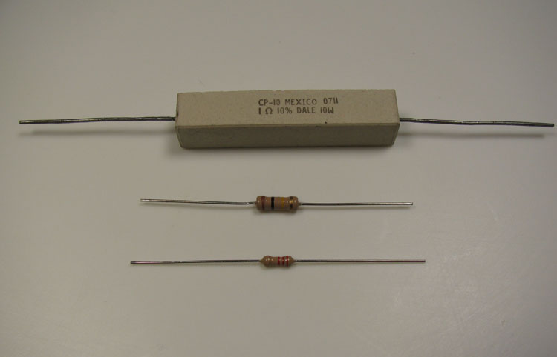
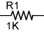

¼, ½, and 10 Watt Resistors Resistor Symbol w/ Value of 1000 Ohms

  - Varieties: There are many different resistor types and they are produced in a variety of forms because their particular characteristics and accuracy suit certain areas of application, such as high stability, high voltage, high current etc, or are used as general purpose resistors where their characteristics are less of a problem.
    - Carbon composite resistor: Made of carbon dust or graphite paste, low wattage values.
    - Film or cermet resistors: Made from conductive metal oxide paste, very low wattage values.
    - Wire wound resistors: Metallic bodies for heatsink mounting, very high wattage ratings.
    - Semiconductor Resistors: High frequency/precision surface mount thin film technology.
    - See: http://www.electronics-tutorials.ws/resistor/res_1.html
  - SIP and DIP Resistors Networks:
    - Single In-line Package (SIP) Resistor Networks:

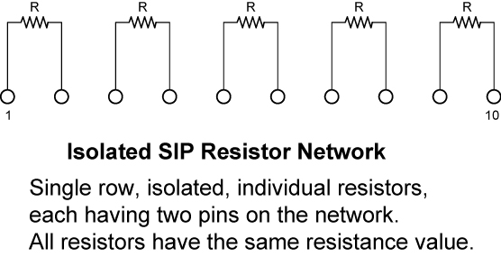
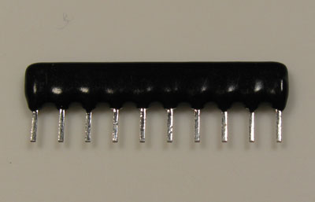

SIP Package
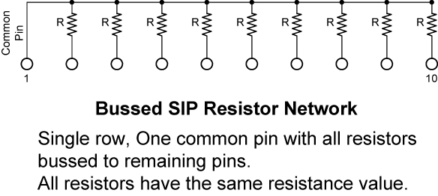
    - Dual In-line Package (DIP) Resistor Networks:

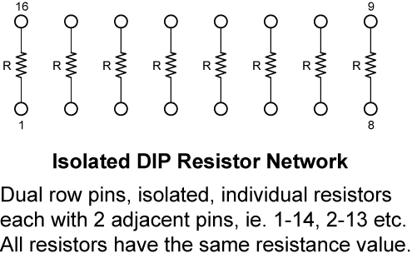

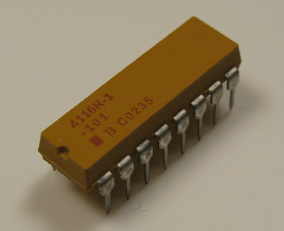

100 Ohm DIP Package

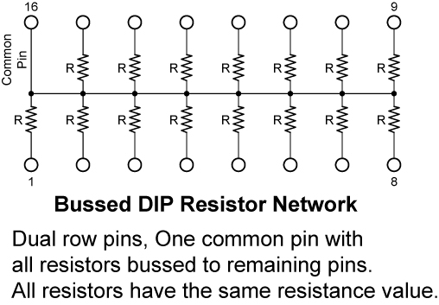
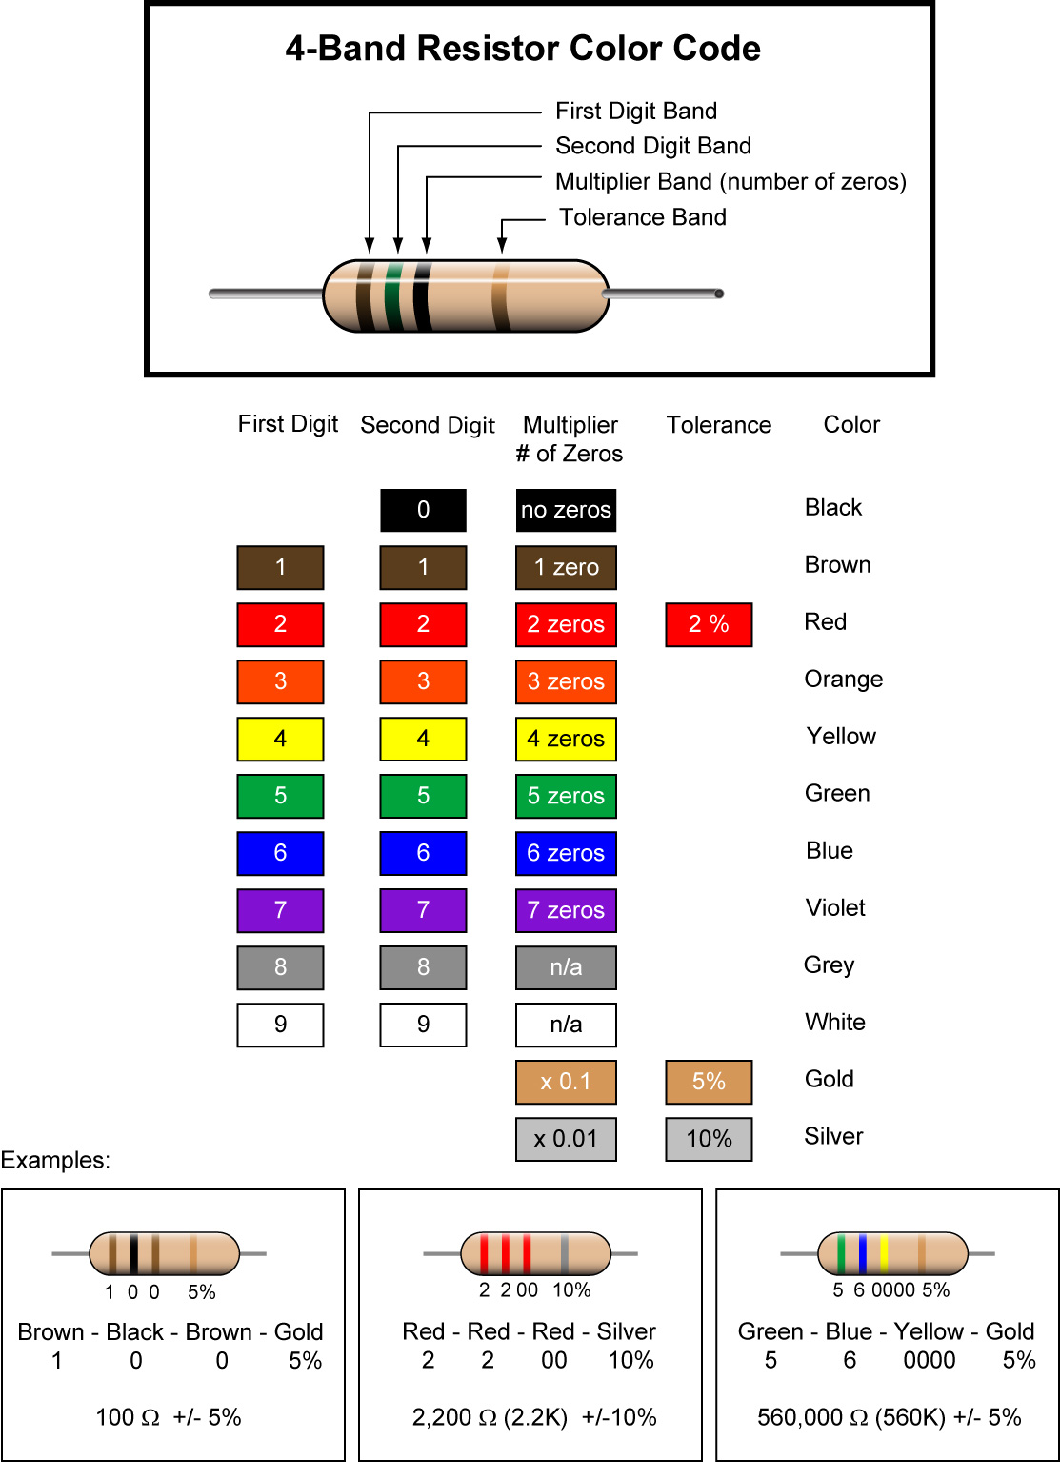

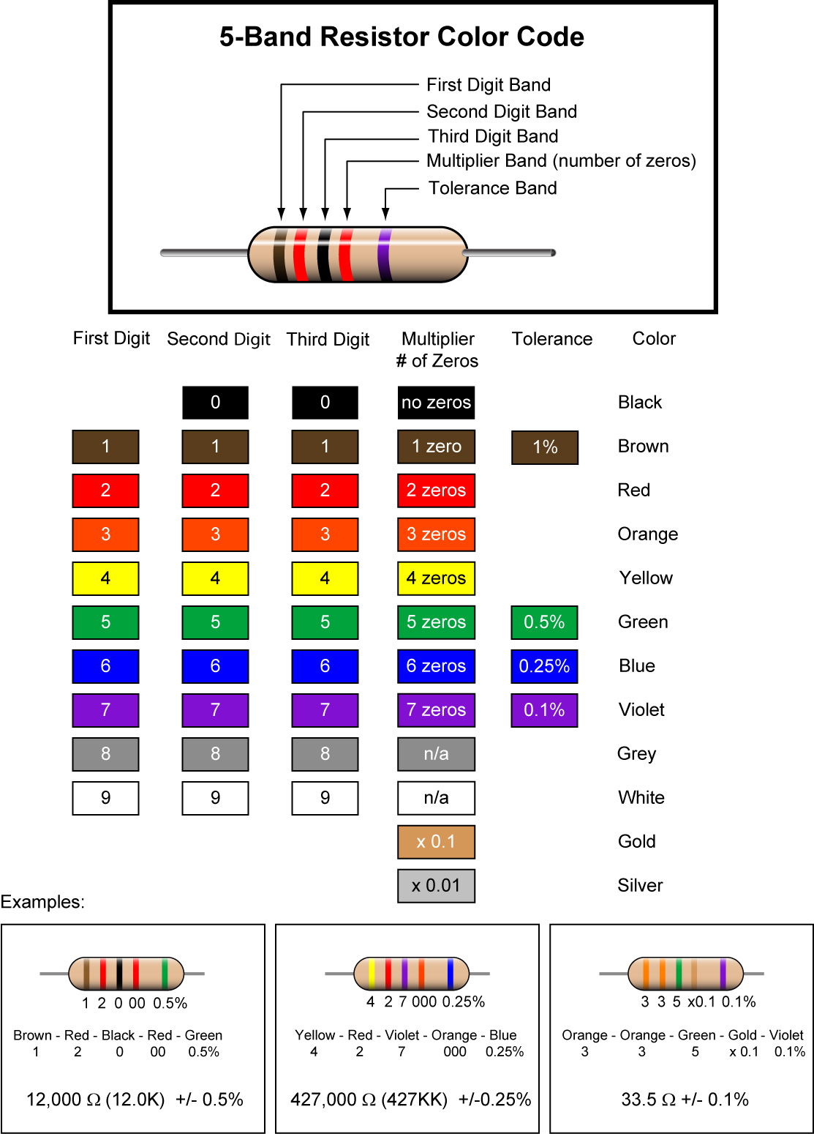

  - See resistor color code applet:
    - http://www.dannyg.com/examples/res2/resistor.htm
  - Percentage and Tolerance Calculations:
    - Percent means "out of 100 or per 100." For example, instead of saying "30 out of every 100 professional basketball players are female," we can say "30% of professional basketball players are female."
    - 1% of anything is one hundredth part of it.
    - Here are three ways to write the same thing:
25% = 25/100 = 0.25
To convert percent to a decimal, move the decimal to the left 2 places.
    - Find 10% of 470:
      - First change 10% to a decimal by moving the decimal point 2 places to the left.

10% = 0.10

      - Then multiply,

0.10 x 470 = 47

      - 10% of 470 is 47
    - Find the upper and lower limits for a 470 Ω resistor with a 10% tolerance:
      - The allowable resistance within tolerance can be from 470 Ω + 10% to 470 Ω – 10%.
      - From above, 10% of 470 is 47
      - Upper Limit: 470 Ω + 10% = 470 Ω + 47 = 517 Ω
      - Lower Limit: 470 Ω – 10% = 470 Ω – 47 = 423 Ω
      - Therefore the range for a 470 Ω resistor with a 10% tolerance is from 423 to 517 ohms.
  - Perform Resistors and Potentiometers Lab 1 – Resistor Color Code
  - Resistor Failures:
    - If the power dissipated is more than the resistor can safely dissipate, the resistor may depart from its nominal resistance value and may become damaged by overheating.
    - Excessive power dissipation may raise the temperature of the resistor to a point where it burns out, which could cause a fire in adjacent components and materials. Complete failure is an open circuit; they do not create a short circuit.
  - Power Rating of Resistors (Watts):
    - Not only is the resistance value in ohms important when choosing a resistor, but you must choose a resistor that does not become too hot when current is flowing through it. The resistor’s wattage value (or power rating) must exceed the power it must dissipate. The wattage in a resistor is the maximum amount of heat energy it can safely dissipate without damage.
      - Demonstration: use a 150 ohm ½ watt and ¼ watt resistors with various currents from a robust power supply. Note how the heat from the resistors varies. Verify the value of the resistor as the voltage increases.
    - A resistor’s larger size signifies a higher wattage rating. Resistors carrying large currents must be physically large so the heat can radiate quickly to the surrounding air.
      - Demonstration: use a small (1/4 watt) and a larger (10 watt) resistor, both having a resistance of 10 ohms. The current through each resistor will be the same. Note the variation in heat given off by the two resistors.
    - If a resistor operates at an elevated temperature, it can change its resistance value and even burn out to create an open circuit.
    - Wire-wound resistors are larger than carbon resistors and have a higher wattage rating.
    - The power formulas are covered in Lesson 10 Energy and Gears. See: http://cornerstonerobotics.org/curriculum/lessons_year1/ER%20Week10,%20Energy,%20Gears.pdf
  - Resistance Decade Boxes:
    - A resistance decade box or resistor substitution box is a unit that can provide one resistor within a wide range of values. It contains resistors of many values, with one or more mechanical switches which allow any one of various discrete resistances offered by the box to be dialed in. Usually the resistance is accurate to high precision, ranging from laboratory/calibration grade accuracy of 20 parts per million, to field grade at 1%. Inexpensive boxes with lesser accuracy are also available.
  - Complete Resistors and Potentiometers Lab 2 – Resistors and Current
  - Complete Resistors and Potentiometers Lab 3 – Making a Resistor

- Potentiometers:
  - Potentiometers: A potentiometer is a type of variable resistor that is used in circuits having low power. They are used to divide voltage and they come with three terminals.
  - Symbol:

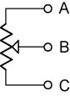

    - The resistance between A and C is constant and the value of the potentiometer.
    - The resistance between A and B & B and C changes according to the position of the wiper.
  - Construction:

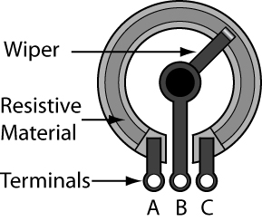

Basic Potentiometer Construction
  - Moving the wiper of a potentiometer:

In the figures below, the resistance R_{AC} remains 100 Ω in all three cases. R_{AB} and R_{BC} change as the wiper rotates.

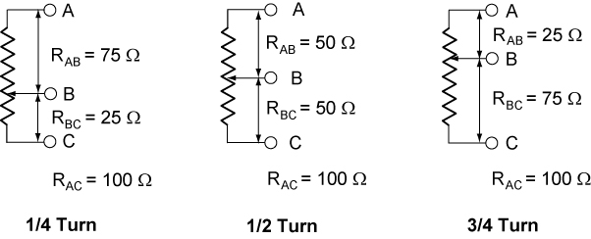

If 10.0 volts is applied to the two end terminals A and C, the voltage on terminal B varies from 0 to 10.0 volts.

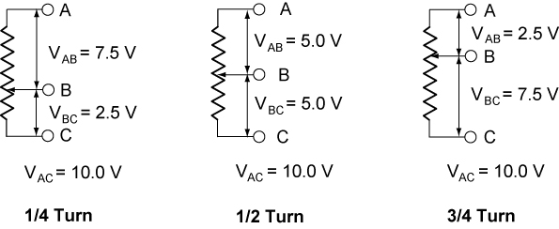

  - The value printed on a potentiometer is the maximum value (R_{AC}).
  - Show samples
  - Tripots (trimmer potentiometers or trimmers):
    - Small potentiometers with or without knobs.
    - Wear out after as little as one hundred turns.
    - Single vs. multi-turn tripots
    - Values:
      - The first two numbers of the printed value are the two digits of the value. The third digit of the printed value is the number of zeros to add to the end of the first two digits. For example, a tripot labeled 221 has a value of 220 ohms; a tripot labeled 123 has a value of 12,000 ohms.
  - Complete Resistors and Potentiometers Lab 4 – Potentiometers
  - Rheostats: A 2 terminal variable resistor
    - Symbol:

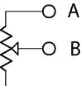

    - Any three-terminal potentiometer can be used as a two-terminal variable resistor, by not connecting to the third terminal.
    - It is common practice to connect the wiper terminal to the unused end of the resistance track.

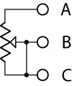

    - Complete Resistors and Potentiometers Lab 5 – Rheostats
  - Thermistor:
    - A thermistor is a type of resistor with resistance varying according to its temperature
    - A main advantage of thermistors for temperature measurement is their extremely high sensitivity.
    - Another advantage of the thermistor is its relatively high resistance.
    - The major tradeoff for the high resistance and sensitivity of the thermistor is its highly nonlinear output and
relatively limited operating range.
    - They are used in temperature measuring circuits.
    - Complete Resistors and Potentiometers Lab 6 – Thermistors and Bend Sensor

Electronics Technology and Robotics I Week 5
Resistors and Potentiometers Lab 1 – Resistor Color Code

- Purpose: The purpose of this lab is to acquaint the student with the resistor color code and tolerance calculations.

- Apparatus and Materials:

  - 10 – Fixed Resistors Labeled 1 – 10

- Procedure:
  - Using the resistor color code, determine the value of 10 resistors and record the values in the table below.
  - Calculate the limits that are within tolerance
  - Measure the resistance of each resistor and compare with the coded value.

- Results:

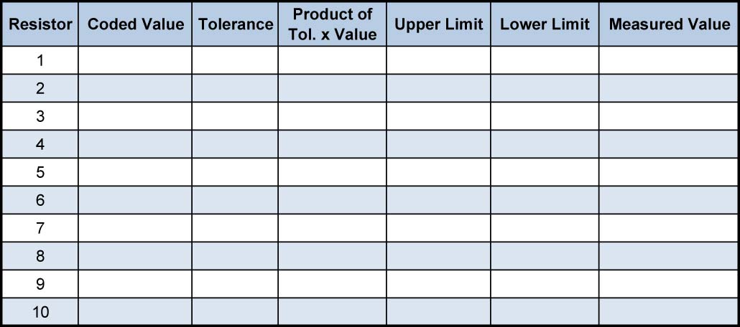

- Conclusions:
  - Are the measured values of each resistor within the tolerance limits?

Electronics Technology and Robotics I Week 5
Resistors and Potentiometers Lab 2 – Resistors and Current

- Purpose: The purpose of this lab is to demonstrate to the student that resistors restrict current and that an increase in resistance increases the voltage drop across the resistor.

- Apparatus and Materials:

  - 1 – Breadboard with 9 V Supply
  - 3 – Digital Multimeters
  - 1 – 1, 10, 22, 47, 68, and 100 Ohm Resistor
  - 1 – 7.5 V Lamp with Lamp Base
  - 1 – SPDT Switch

- Procedure:
  - Assemble the circuit below on the breadboard using 1, 10, 22, 47, 68, and 100 ohm resistors as R1.
  - Measure the current for each change in resistor value.
  - Calculate the voltage drop across R1 using Ohm’s law.
  - Now measure the voltage drop across R1 and the lamp.
  - Compare the calculated voltage drop across R1 with the measured value.
  - Add the measured voltage drops across R1 and the lamp to get the total measured voltage drop.
  - Compare the total measured voltage drop with the measured source.
  - Note the brightness variation in each case.

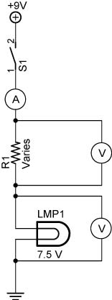

- Results:

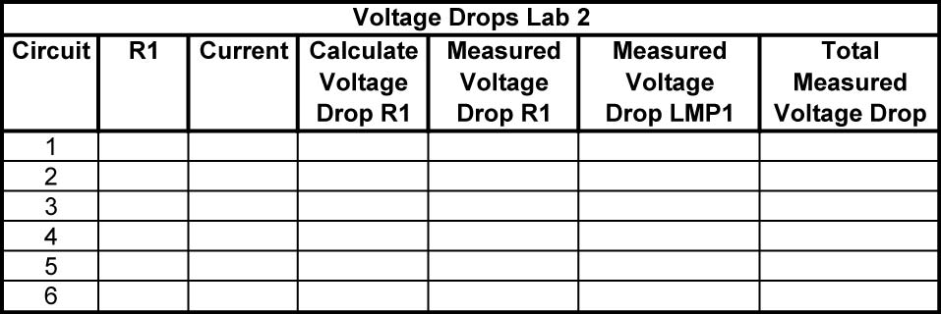

- Conclusions:
  - Is the calculated voltage drop across R1 close to the measured voltage drop across R1?

  - As the value of R1 is increased, what happens to the voltage drop across R1?

  - As the value of R1 is increased, what happens to the brightness of the lamp? Why?

Electronics Technology and Robotics I Week 5
Resistors and Potentiometers Lab 3 – Making a Resistor

- Purpose: The purpose of this lab is to demonstrate to the student that carbon is a suitable material to make resistors.

- Apparatus and Materials:

  - 1 – Digital Multimeter
  - 1 – Piece of 5” x 8” Index Card
  - 1 – #2 Pencil

- Procedure:
  - Using a standard No. 2 pencil draw about a 7” long line on the blank side of the index card. Mark the 0” and 6” points about a half of an inch in from the ends of the line. It should look like this:

  - Place all pencil filings from your work into a wastepaper basket.
  - In 1 minute using only the #2 pencil, make the line thicker and/or wider to give you the lowest resistance possible between the 0” and 6” points. Don’t forget to make the end points as thick as the rest of the line.
  - The instructor will measure the resistance between the two end points after the 1 minute time limit.

Electronics Technology and Robotics I Week 5
Resistors and Potentiometers Lab 4 – Potentiometers

- Purpose: The purpose of this lab is have the student read tripot values and to help the student understand the function of a potentiometer.

- Apparatus and Materials:

  - 7 – Tripots furnished by the instructor
  - 1 – Digital Multimeter
  - 1 – 5 K Ohm Potentiometer

- Procedure:
  - Read and record the labeled values of 7 tripots. Measure the resistance of each tripot using a DMM and record its value.
  - Testing potentiometers:
    - Test for maximum resistance of the potentiometer with a DMM, and compare with value printed on the side of the potentiometer.
    - Turn the potentiometer shaft and then flip the DMM leads. How does the maximum resistance value of the potentiometer react?
    - Using the DMM, measure and record the resistance R_{AB}, R_{BC}, and R_{AC} at three different positions of the potentiometer.

- Results:
  - Tripot Values:

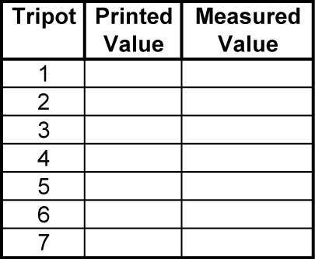

  - Testing potentiometers:

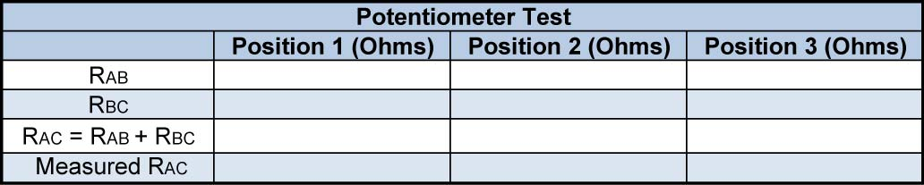

- Conclusions:
  - In the potentiometer test, how does R_{AC} relate to R_{AB} and R_{BC}?

  - Is R_{AC} consistent in all three positions?

Electronics Technology and Robotics I Week 5
Resistors and Potentiometers Lab 5 – Rheostats

- Purpose: The purpose of this lab is to help the student understand the function of a rheostat.

- Apparatus and Materials:

  - 1 – Breadboard with a 9 V Power Supply
  - 1 – 25 K Ohm Potentiometer
  - 1 – 470 Ohm Resistor
  - 1 - LED

- Procedure:
  - Variable brightness LED circuit:
    - Wire each circuit below, adjust R1, and compare the results.

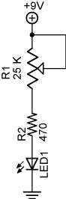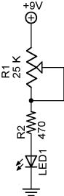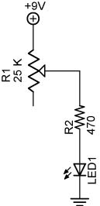

Circuit 1 Circuit 2 Circuit 3

- Results:

- Conclusions:
  - Does it matter which of the three circuits is used to control the LED?

  - What is the purpose of the 470 ohm resistor?

Electronics Technology and Robotics I Week 5
Resistors and Potentiometers Lab 6 – Thermistor and Bend Sensor

- Purpose: The purpose of this lab is to acquaint the student with the basic operation of a thermistor.

- Apparatus and Materials:
  - 1 – Lab Thermometer
  - 1 – Lab Beaker
  - 1 – DMM
  - 1 – Breadboard with a switch to a 9 V Power Supply
  - 1 – Bend Sensor
  - 1 – 10 K Ohm Thermistor
  - 1 – 10 K Ohm Resistor
  - 1 – 50 K Ohm Potentiometer
  - 1 – 1 K Ohm Resistor
  - 1 – 741 Op Amp Integrated Circuit
  - 1 - LED

- Procedure:
  - First, measure the resistance of the thermistor as it is taken from room temperature and placed in a beaker filled with ice water. Note the changes in resistance as it cools.
  - Now using a 10 K thermistor, wire the thermistor circuit found below.
  - At room temperature, adjust R3 until the LED turns off. Place the thermistor between your fingers to heat it up and to turn on the LED.
  - If the LED remains off, reverse the connections to pins 2 and 3 which will reverse the operation.
  - Now substitute the bend sensor and readjust R3 until the LED turns off. Flex the bend sensor.

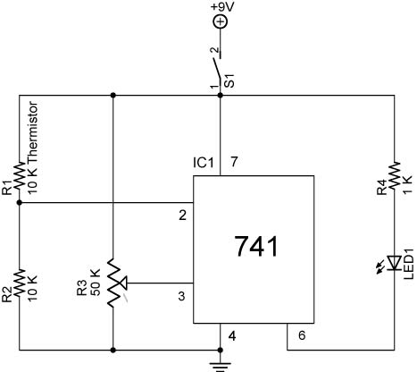

Thermistor Used in an Op Amp Comparator Circuit

