Electronics Technology and Robotics I Week 4
Lighting, Switches, and Soldering
- Administration:
  - Prayer
  - Turn in quiz
- Lighting:
  - Lamp Symbol:

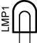

  - Incandescent lamp: The current flows through a tungsten filament within a lamp filled with an inert gas.
  - Halogen lamp: Similar to the incandescent lamp except halogen gas replaces the inert gas. The tungsten filament lasts longer in the halogen gas environment.
  - Fluorescent lamp: The tube is coated with a phosphor which glows when the mercury vapor inside the lamp produces ultraviolet light.
  - Mercury vapor: It requires a long starting time.
  - Neon lamp: Requires a transformer to produce voltages of 10,000 volts or more to create a current through the neon gas.
  - LED lamp: Very low wattage.
  - Lumens: A term used to measure the amount of light generated in a light bulb or a lighting system.
    - Typical lumen ratings:
      - 60 Watt bulb: 830 lumens (14 lm/wt)
      - 4’ Fluorescent T8 bulb (32 watts): 2850 - 3100 lumens (89-97 lm/wt)
  - Web references: http://www.kpsec.freeuk.com/components/lamp.htm
- Light Emitting Diodes:
  - Example and Symbol:

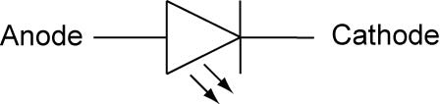

Example Symbol

  - Light emitting diodes are semi-conductors that give off infrared and visible light when electrical current is applied in the correct direction.
  - The primary use of an LED is an indicator device. The LED can tell the user that power is present in that part of the circuit or it can be used to help troubleshoot a computer program by indicating when a segment of code is executed.
  - Connections:
    - An LED should never be connected directly to a battery or power source. A current limiting resistor must be in series with the LED. See the section below on calculating the value of resistor in an LED circuit.
    - The anode must be connected toward the positive side of the battery and the cathode toward the negative side of the battery.
  - Bi-colored LEDs: A bi-colored LED is two LEDs wired with one forwards and one backwards in a single LED package. See schematic below:
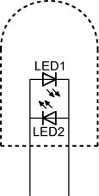
  - Tri-colored LEDs: A tri-colored LED is two LEDs wired in the following manner:
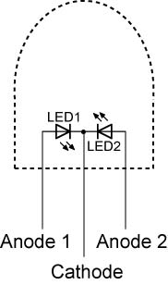

Tri-colored LED

    - The most common type of tri-colored LED has a red and green LED wired in one package with three leads.
    - The term tri-colored derives from the fact that when both the red and green LEDs are lit their colors mix as yellow.
  - Advantages of an LED:
    - Most operate at low voltages and currents, such as 2 volts and 20 mA.
    - LED’s have a fast switching time, on the order of 10 ns (10 nanoseconds, .00000001 sec.)
    - LED’s have a narrow spectrum of light giving relatively pure light.
  - LED sizes and shapes:
    - “T” refers to bullet shape

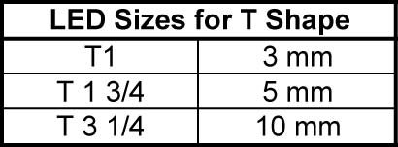

  - LED colors:
    - Electromagnetic Spectrum

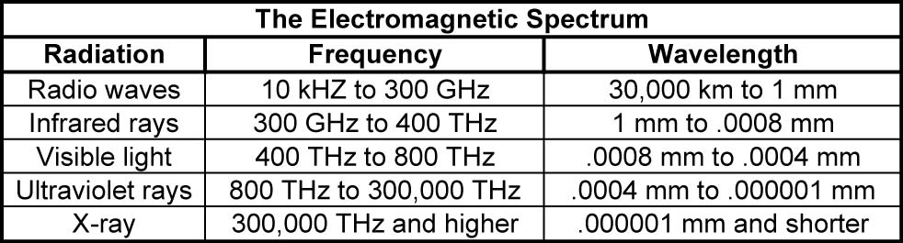

See the wavelengths of individual visible colors below.

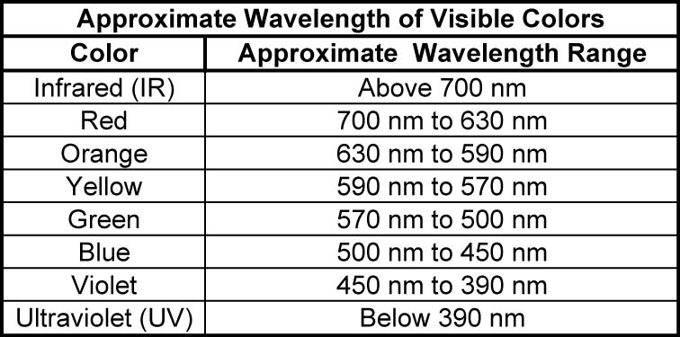

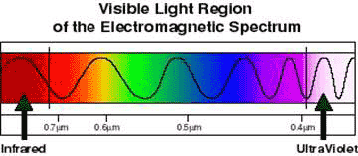

See electromagnetic wavelength applet: http://www.colorado.edu/physics/2000/waves_particles/index.html

  - Calculating the value of resistor in an LED circuit:
    - To calculate the value of the series resistor we need to know the diode forward voltage and current at its connections. The necessary data can be obtained from a catalogue or the LED data sheet.
    - See LED Resistor Calculator applet at: http://www.daycounter.com/Calculators/LED-Tutorial-Calculator.phtml

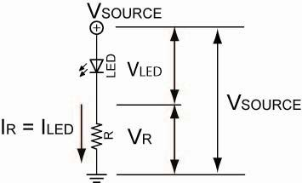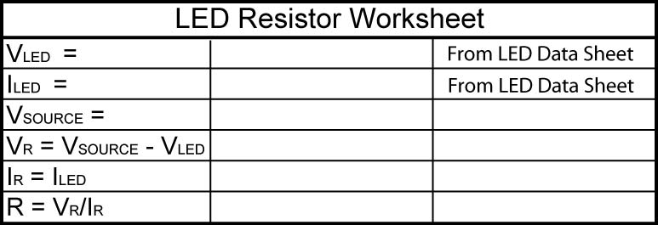

For Example; If V_{SOURCE} = 12 V
V_{LED} = 2 V
I_{LED} = 30 mA

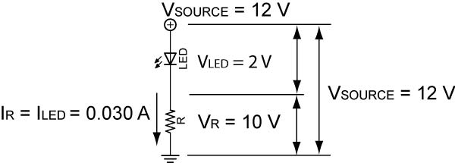

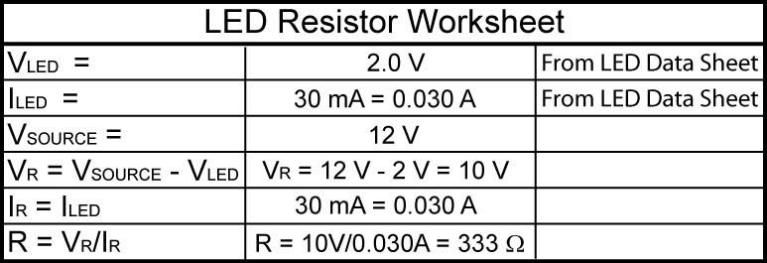

Since 333 Ω is not a standard value, we can use a 330 Ω resistor as this application is not critical of values.

  - Complete Lighting, Switches, and Soldering Lab 1 – Forward/Reverse Bias
- Common Circuit Devices:
  - Switches: Control the on and off flow of electrons through a circuit.
    - The electrical circuit within a switch is described in terms of poles and throws (see the symbols and photos on the next page).
      - A single-pole (SP) means that the switch provides one path for the electrons flow and
      - Single-throw (ST) means the switch controls only one circuit.
        - SPST switch symbol:

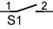

      - A single-pole double-throw switch (SPDT) has only one common connection point that can complete two different circuits. See symbol below.
        - On your breadboard, wire a SPDT switch to turn on a separate LED when you slide the tab to each side of the switch. Don’t forget the current limiting resistor.
        - Wire the 3-way switch (SPDT) circuit below and flip the switches:

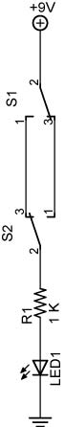

        - See: http://www.rkm.com.au/ANIMATIONS/animation-three-way-switch.html
      - A double-pole double-throw switch (DPDT) has two common connection points and can provide two circuit paths simultaneously.
        - Using a DPDT switch, wire a DC motor such that the motor changes direction, that is wire a DPDT switch to reverse the polarity of a DC motor.

Basic Switch Symbols and Corresponding Photos

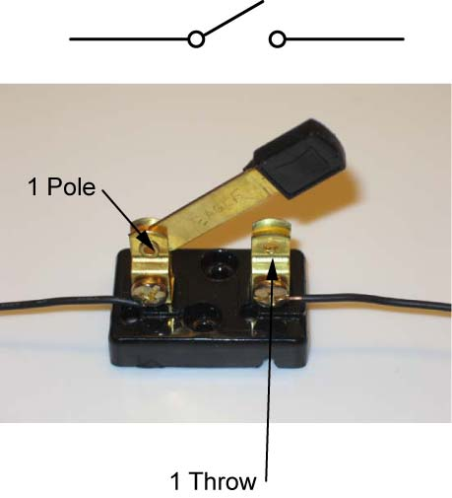 | 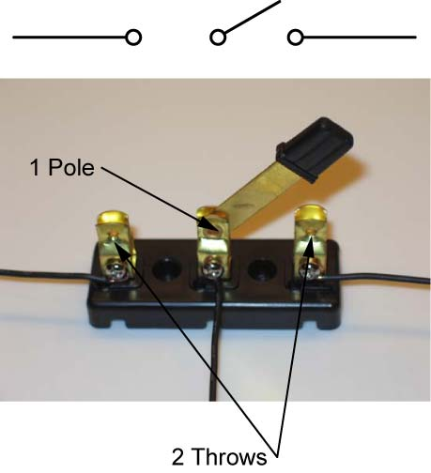
SPST Switch and Symbol | SPDT Switch and Symbol

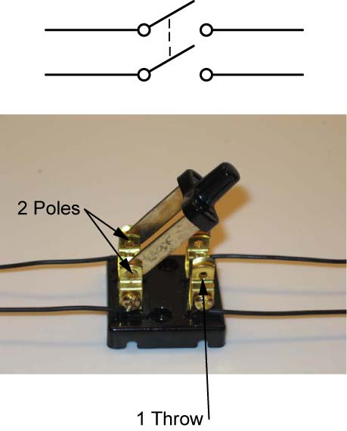 | 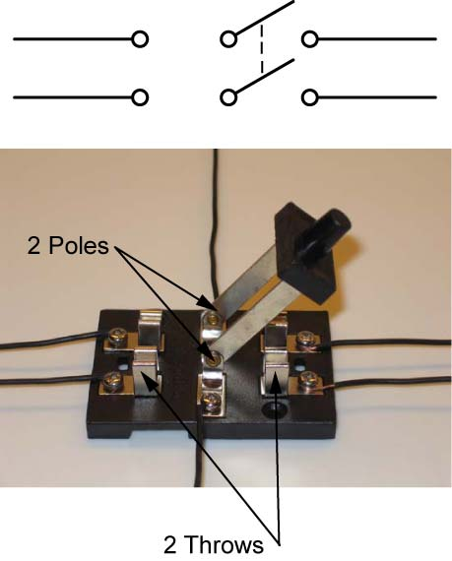
DPST Switch and Symbol | DPDT Switch and Symbol

        - 3PDT switch example and symbol:
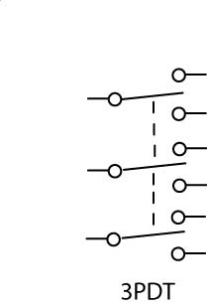

        - 4PDT switch example and symbol:
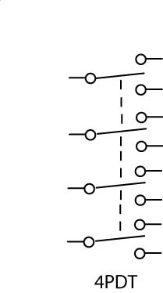

      - Samples
      - Momentary switches:
        - Momentary switches are called that because they only make contact while they are being pressed.
        - Normally open (NC) and normally closed (NO)
        - Demonstrate samples and symbols:

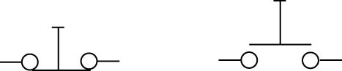

Normally Closed (NC) Normally Open (NO)

        - ROV switches as an example
        - Wire LED circuit and determine whether the momentary switches are NO or NC.
    - Switch Ratings:
      - Ampacity rating
      - Voltage rating
      - Demonstrate switch failure
    - High side and low side switching:
      - In low voltage electronics, the position of the voltage source, the switch, and the load makes little difference. Since they are in a series circuit, the components can be rearranged without changing the performance of the circuit.
      - In higher voltage electronics, the wrong switch placement can be hazardous or even lethal. Examine the low side switch circuit below. One side of the power source is tied to earth while the other is at a dangerously high voltage (HOT). Since the switch is open, no current flows through the load so there is no voltage drop across the load (V_{LOAD} = I_{LOAD} x R_{LOAD}, I_{LOAD} = 0A therefore V_{LOAD} = 0V). The worker sees the switch in the off position and thinks he is safe to work on the equipment (load). Unfortunately, he stands on the ground which is at the same potential as the grounded side of the power source and touches the HOT load or connecting wires. Current flows through the unsuspecting worker resulting in a serious shock.
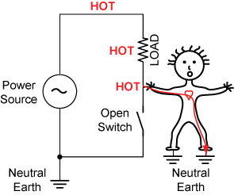

Low Side Switch

      - Relocating the switch to the high side eliminates the hazard. With no voltage drop across the load, the load and the connecting wires are at the voltage of neutral earth thus eliminating any hazardous potential. See below.

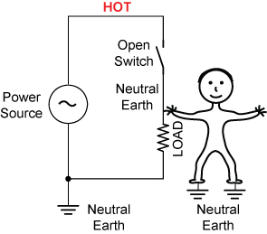

High Side Switch
    - Other Web References: http://www.kpsec.freeuk.com/components/switch.htm
  - Connectors:
    - Solderless terminals
    - Molex
    - Banana
    - BNC
    - Others
  - Circuit Protection Devices:
    - Circuit protection devices are an essential part of a power distribution system to prevent fire or damage. When too much current flows through a wire, it may overheat and be damaged or even start a fire.
    - Fuses:
      - Symbol:
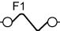
      - The fuse is a metal strip or wire which can carry a stated current. If the current rises above this value the fuse will melt.
      - If the fuse melts (blows) then there is an open circuit and no current can then flow thus protecting the equipment or circuit by isolating it from the power source.
      - In our laboratory, one fuse protects the power supply from overload for six students. If all six students were connected to the power supply, how would you determine which student had a short circuit if the fuse blew? See the figure below.
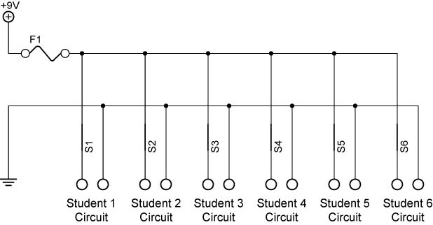
    - Circuit Breakers:
      - A circuit breaker is found in an electrical service panel and is an electrical device used to protect the electrical wiring from an overloaded (overcurrent) condition when exposed to more electrical current than it is designed to handle.
      - Unlike the fuse which is rendered useless when it blows, the circuit breaker is not damaged when it “trips”, and can be reset.
    - Complete Lighting, Switches, and Soldering Lab 2 – Fuses
- Electronic Soldering and Connecting:
  - Soldering is the process of melting solder onto the desired joints to connect the joint materials together both electrically and physically. Soldered joints are not capable of taking a lot of stress or movement.
  - Show examples
  - A good soldering job requires:
    - Clean conductors, parts, and joints
    - Solder
    - Flux
    - Heat
  - Safety precautions:
    - To avoid burns, always assume the tip is hot and never touch the tip when it is hot.
    - Safety goggles are required when working with a soldering iron.
    - Keep your soldering iron away from all flammable materials.
    - Always return the iron to the soldering iron stand, do not lay it on the workbench.
    - Be sure the hot soldering tip and heater do not come into contact with the electric power cord. The plastic flex cord will melt if touched by a hot iron and there is a serious risk of an electric shock.
    - Before making any adjustment, such as removing or replacing a tip, make sure the station is unplugged and cool.
    - Do not dip the soldering iron into any liquid.
    - Always work in a well ventilated room.
    - Always have the soldering iron plugged into a soldering station.
    - After use, unplug the soldering station and allow the tip to cool before storing.
    - Thoroughly wash your hands with soap and water after each soldering session.
  - Soldering equipment:
    - Solder wire and flux
      - The solder we will use is a mixture of tin, lead, antimony, silver, and bismuth alloys. See MSDS at: http://www.radioshack.com/graphics/uc/rsk/Support/MSDS/6400013A_MSDS.pdf
      - Rosin flux core solder; flux is inside the hollow of the solder
        - Flux is a chemical that dissolves oxides on metals during soldering. Flux suspends oxides in solution and floats it to the top.
        - Never use acid core solder on any electronic circuits. The acid is highly corrosive and will eat through many components.
      - Use solder with a diameter of 0.022 - 0.040 inches for nearly all circuit soldering.
    - Electronic soldering irons:
      - Soldering irons for electronics are low-wattage from 25 to 40 watts. Use a small conical or chisel tip.
      - Tip temperature range from 600 to 900 degrees F. Tip temperatures from 700 to 800 degrees F are preferred.
    - Soldering guns
    - Butane torches
    - Soldering sponges:
      - Special sponges with distilled water are used to periodically clean iron tips.
    - Helping hands
    - Desoldering bulb and tool
    - Braided wire
    - Heat sinks
  - Steps in soldering:
    - Setup equipment at a location with adequate ventilation and away from combustible materials.
    - Moisten sponge with distilled water.
    - Put on personal safety equipment, i.e., goggles.
    - Plug in soldering iron; wait 2 – 5 minutes.
    - Remove all foreign materials from materials to be connected using solvents, sandpaper, or steel wool. Do not rely on flux to clean your connection materials.
    - Make a good mechanical connection by wrapping wires around each other or around a terminal.
    - Hold the soldering iron like a pencil near the base of the handle.
    - Touch both parts to be soldered with the soldering iron tip.
    - Use the soldering iron to heat the joint, not the solder. A small amount of fresh solder on the tip will help conduct heat to the joint faster. Feed the solder into the joint. The solder should be heated by the joint so it will flow into the connection, resulting in a stronger joint. Do not apply too much solder or move the connection before it cools.
    - Remove the solder, then the iron, while keeping the joint still.
    - The two key factors in quality soldering are time and temperature.
      - Time: The solder should melt within a second for normal PC board connections and within two seconds for most other connections.
      - Temperature: The tip temperature should be about 100 degrees F above the solder melting point. For melting points of different solder alloys, see: http://www.rfcafe.com/references/electrical/solder.htm
    - Inspect the joint. When solder flows freely throughout a connection, it tends to form concave shapes; with insufficient heat solder does not flow freely and forms convex shapes or blobs. See diagrams at: http://downloads.solarbotics.com/pdf/solderingtutorial.pdf
    - Do not create a solder bridges. A solder bridge is an undesired connection made by excess solder between two connections.
    - Keep the iron’s tip clean and shiny by wiping off old solder and debris on the damp sponge.
    - On electrical and electronic components avoid too much heat. A heat sink can be used to dissipate away from the component.
    - After soldering, remove any remaining flux with a cotton swab dipped in isopropyl or denatured alcohol.
    - Tinning the iron tip for storage: Always apply a generous amount of solder to your tip just before or immediately after you turn the soldering iron off to protect the tip from oxidation.
    - If a tip becomes oxidized, dip it into sal ammoniac (ammonium chloride) and then wipe it clean with a rag. Sal ammoniac is somewhat corrosive.
  - Other Soldering “Don’ts:
    - Do not apply the solder that will form the joint on the iron tip before touching the connection. The flux in the solder will dissolve before it can clean the connection.
    - Do not run a soldering iron at high temperatures for a long period of time when not in use.
    - Do not file a nickel or iron clad soldering iron.
  - Cold solder joints:
    - This happens when one of the parts is not heated sufficiently for the solder to adhere.
    - Also, do not hold your iron too long on a connection; this will weaken your joint.
    - Do not try to “paint” or dab the solder onto the wire or connection.
  - Tinning:
    - When you apply solder to a part before you make a solder connection, you are tinning the part.
    - Example of old Sandwich breadboard PCB.
  - Perform Lighting, Switches, and Soldering Lab 3 – Tinning a Wire
  - Perform Lighting, Switches, and Soldering Lab 4 – Soldering Component PC Boards
  - Perform Lighting, Switches, and Soldering Lab 5 – Soldering Components to a PC Board
  - Desoldering:
    - Used when a part must be removed.
    - The PC Board is more important than the component that is being removed. Always, sacrifice a component before risking damage to the PC board. It is much easier and less costly to replace a component then to try to repair or replace a damaged pc board.
  - Perform Lighting, Switches, and Soldering Lab 6 – Desoldering Components on a PC Board
Electronics Technology and Robotics I Week 4
Lighting, Switches, and Soldering Lab 1 – Forward/Reverse Bias

- Purpose: The purpose of this lab is to acquaint the students with forward and reverse bias of LEDs.

- Apparatus and Materials:

  - 1 – Breadboard with 9 V Battery
  - 2 – Digital Multimeters
  - 1 – 470 Ohm Resistor
  - 1 – Red LED

- Procedure:
  - Wire Circuits 3 and 4
  - Record the results and write your conclusions

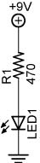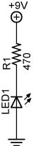

Circuit 3 Circuit 4
Forward Biased Reversed Biased

- Results:

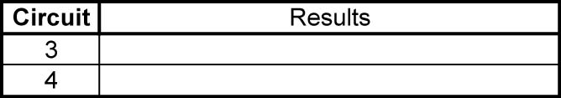

- Conclusions:

Electronics Technology and Robotics I Week 4
Lighting, Switches, and Soldering Lab 2 – Fuses

- Purpose: The purpose of this lab is to acquaint the student with the function of a fuse.

- Apparatus and Materials:

  - 1 – DC Power Supply
  - 1 – 0.25 A Fuse (Radio Shack #270-1002)
  - 2 – 7.5 V Lamps
  - 2 – Lamp Holders
  - 2 – Digital Multimeters
  - 1 – Knife Switch
  - Alligator Leads

- Procedure:
  - Wire the circuit below using alligator leads.
  - Insert the Lamp 1 only and adjust the DC power supply to bring the lamp to the 7.5 V rating. Record the current reading when the lamp is at 7.5V.
  - Insert Lamp 2 lamp and adjust the DC power supply to bring both lamps to their 7.5 V rating. Watch the current readings as you increase the voltage.
  - If necessary, add a third lamp in parallel to “blow” the fuse.
  - Write your conclusions

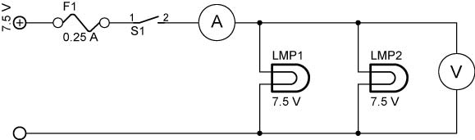

- Results:

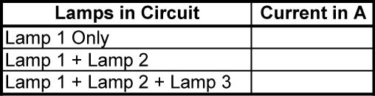

- Conclusions:

Electronics Technology and Robotics I Week 4
Lighting, Switches, and Soldering LAB 3 – Tinning a Wire

- Purpose: The purpose of this lab is to tin the end of a stranded wire.

- Apparatus and Materials:

  - 1 – Soldering Iron and Holder with Moistened Sponge
  - 1 – 0.022 Resin-Core Solder
  - 1 – 0.50 Resin-Core Solder
  - 1 – Wire Cutting Pliers
  - 1 – Wire Strippers
  - 1 – Helping Hands
  - 2 – 5 cm #22 Gauge Stranded Wires

- Procedure:
  - Follow all safety precautions.
  - Turn on the soldering iron.
  - Moistened the sponge with distilled water.
  - Cut a two pieces of stranded wire about 5 cm long.
  - Stripe 1 cm of insulation from all ends of the wires.
  - Place the ends of one wire into the helping hands. The bare wire should be free of the alligator clip.
  - Clean the soldering iron tip off on the sponge.
  - Hold the soldering iron against the bare wire.
  - Apply a small amount of fresh 0.022 solder between the soldering iron tip and the bare wire to help conduct heat to the wire faster.
  - As the wire heats, apply more solder to the wire away from the tip of the soldering iron.
  - The solder should be heated by the wire so it will flow into the stranded wire.
  - After the bare portion of the wire is soldered, continue to hold the soldering iron against the wire for about a half of a second then pull away.
  - Inspect the tinned wire for:
    - Shiny surface
    - Wire strands – they should be visible
    - Excess insulation damage
  - Tin the other end of the wire of the wire.
  - Tin both ends of the other wire.
  - Tinning the tool tip: Just after turning the soldering iron off, apply a generous amount of 0.050 solder to your soldering iron tip.

Electronics Technology and Robotics I Week 4
Lighting, Switches, and Soldering LAB 4 – Component PC Boards

- Purpose: The purpose of this lab is to solder to a component PC board.

- Apparatus and Materials:

  - 1 – Soldering Iron and Holder with Moistened Sponge
  - 1 – 0.022 Resin-Core Solder
  - 1 – 0.50 Resin-Core Solder
  - 1 – Wire Cutting Pliers
  - 1 – Wire Strippers
  - 1 – Helping Hands
  - 1 – Component PC Board
  - Miscellaneous Wires and Components

- Procedure:
  - Follow all safety precautions.
  - Turn on the soldering iron.
  - Moistened the sponge with distilled water.
  - Clean the component leads and component PC board with rubbing alcohol.
  - Tin the end of a wire.
    - Insert the end of the wire through a hole in the component PC board.
  - Clean the soldering iron tip off on the sponge.
  - Hold the soldering iron against the copper pad and the wire.
  - Apply more solder directly to the wire and copper pad. Stop applying solder after the connection looks like a miniature volcano.
  - Don't move the wire or the connection for a few seconds to allow the solder to cool.
  - Practice with other wires and components.
  - Tinning the tool tip: Just after turning the soldering iron off, apply a generous amount of 0.050 solder to your soldering iron tip.

Electronics Technology and Robotics I Week 4
Lighting, Switches, and Soldering LAB 5 – Soldering Components to a PC Board

- Purpose: The purpose of this lab is to solder components to a PC board.

- Apparatus and Materials:

  - 1 – Soldering Iron and Holder with Moistened Sponge
  - 1 – 0.022 Resin-Core Solder
  - 1 – 0.50 Resin-Core Solder
  - 1 – Wire Cutting Pliers
  - 1 – Wire Strippers
  - 1 – Helping Hands
  - 2 – 5 cm #22 Gauge Stranded Wires
  - 2 – 5 cm #22 Gauge Solid Wires
  - 5 – Resistors
  - 1 – PC Board

- Procedure:
  - Follow all safety precautions.
  - Turn on the soldering iron.
  - Moistened the sponge with distilled water.
  - Clean the component leads with rubbing alcohol and the PC board with steel wool.
  - If needed, tin the component leads.
  - Insert the component leads through the holes of the PC board.
  - To hold the component in place while you are soldering, you may want to bend the leads on the bottom of the board at about a 45 degree angle.
  - Place the PC board into the helping hands.
  - Bring the soldering iron tip so that it rests against both the component lead and the board.
  - Apply a small amount of fresh 0.022 solder between the soldering iron tip and the component lead and solder pad to help conduct heat to the connection faster.
  - Allow the component lead and solder pad to heat up for about one second.
  - Feed the 0.022 solder to the component lead and solder pad, but not the tip of the iron.
  - Once the surface of the pad is completely coated, stop adding solder and remove the soldering iron. The soldered connection should look like a miniature Hershey kiss, not a rounded ball.
  - Don't move the wire or the connection for a few seconds to allow the solder to cool.
  - If the connection looks like a rounded ball, remove the solder by following the instructions in Lab 4 and resolder.
  - Cutoff the excess wire on the leads.
  - Inspect the PC board for:
    - Cold solder joints
    - Solder bridging across the conductive pathways, or traces.
Electronics Technology and Robotics I Week 4
Lighting, Switches, and Soldering LAB 6 – Desoldering Components on a PC Board

- Purpose: The purpose of this lab is to remove solder from a soldered connection on a PC board.

- Apparatus and Materials:

  - 1 – Soldering Iron and Holder with Moistened Sponge
  - 1 – Electric Desoldering Tool (Electronix Express # 060848) http://www.elexp.com/sdr_0848.htm
  - 1 – 0.022 Resin-Core Solder
  - 1 – 0.50 Resin-Core Solder
  - 1 – Helping Hands
  - 1 – PC Board from Lab 3

- Procedure:
  - Follow all safety precautions.
  - Plug in the electric desoldering tool.
  - Place the PC board from Lab 3 into the helping hands.
  - Set the pump by pushing the plunger down until it locks.
  - Insert the tip of the desoldering tool over the lead to be desoldered.

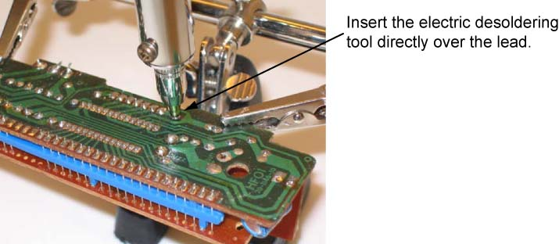

  - Heat the joint and push the button on the pump to release the plunger.
  - The pump will need empting occasionally.
  - Resolder the lead.
  - Tinning the tool tip: Just after turning the soldering iron off, apply a generous amount of 0.050 solder to your soldering iron tip.
Wiring a DPDT Switch to Reverse the Polarity of a DC Motor:

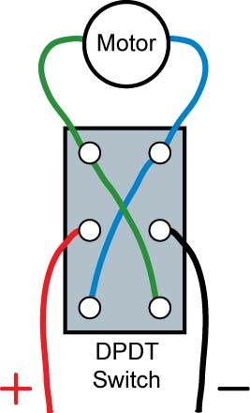

Option 1
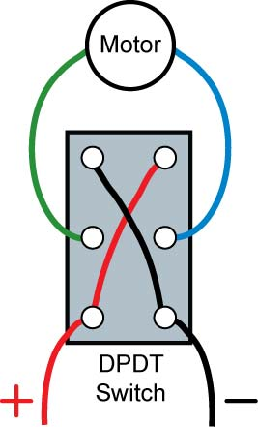

Option 2

      - gg

