Electronics Technology and Robotics I Week 3
Schematics, Conductors, and Insulators

- Administration:
  - Prayer
  - Review measuring voltage, current, and resistance w/ DMM
- Electrical Diagrams:
  - Schematic Diagrams: A schematic diagram is a shorthand way to draw an electric circuit. It is a diagram that illustrates components (electrical parts) and how they are connected to each other. Symbols are used to represent circuit components and lines are used to represent wires or connections.
  - Other diagrams include block diagrams and wiring diagrams
    - Block diagrams show major electrical systems are related.

Block Diagram of a DC Power Supply

    - Wiring diagrams are used to help with the actual circuit wiring.

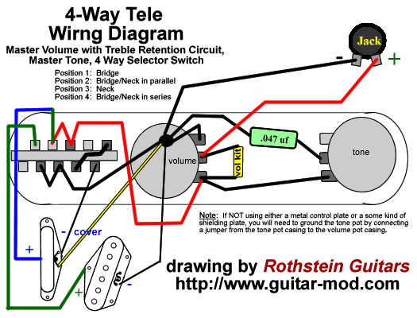

Wiring diagrams Show the Component Parts in Pictorial Form

  - Example of an electrical circuit and the corresponding schematic diagram:

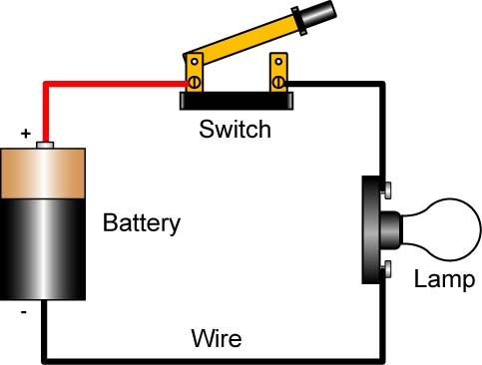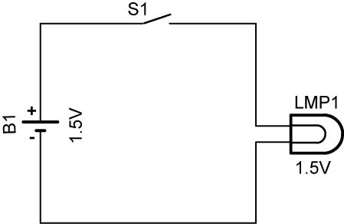

Drawing of the Circuit Schematic Diagram of the Circuit

    - Note that each component has its individual designation, i.e., B1, S1, and LMP1.
    - Also note that the value of the component is given where applicable.
    - In a schematic drawing, the distance between components does not represent the actual distance when wiring the components.
    - Show polarity (+ and -) for components that have polarity. This will be covered more in later lessons.
  - General Rules and Hints for Schematics: (From: http://opencircuitdesign.com/xcircuit/goodschem/goodschem.html)
    - Wires connecting are indicated by a heavy black dot; wires crossing, but not connecting, have no dot.
    - Wires and components are aligned horizontally or vertically, unless there's a good reason to do otherwise.
    - Label pin numbers on the outside of a symbol, signal names on the inside.
    - All parts should have values or types indicated; it's best to give all parts a label, too, e.g., R7 or IC3.
    - In general, signals go from left to right
    - Put positive supply voltages at the top of the page, negative at the bottom.
    - Don't attempt to bring all wires around to the supply rails, or to a common ground wire. Instead, use the ground symbol(s) and labels like +Vcc to indicate those voltages where needed.
    - It is helpful to label signals and functional blocks and show waveforms; in logic diagrams it is especially important to label signal lines, e.g., RESET' or CLK.
    - It is helpful to bring leads away from components a short distance before making connections or jogs.
    - Leave some space around circuit symbols

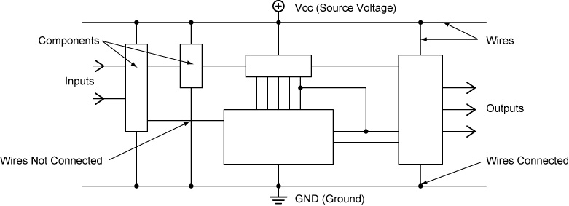

General Layout of a Schematic Drawing

  - Another way to show voltage source and ground:
    - In order to make schematics cleaner and easier to read, the battery symbol is left out all together from the schematic and voltage source and ground symbols are substituted. This really cleans up a large schematic where lots of parts are connected to the voltage source and ground.
      - A voltage source may be drawn as shown in the following examples:

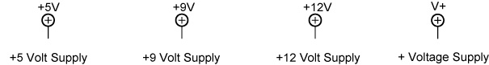

      - A earth ground may be represented by the following symbol:

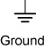

This symbol may also be used to indicate a point in a circuit that is the common reference voltage (0V) from which all other voltages are measured.

    - Example of a schematic using a voltage source and ground:

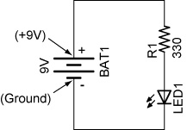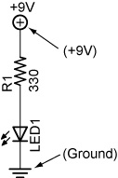

Schematic with Equivalent Schematic Using
Battery Symbol +9V Supply and Ground Symbols

The equivalent schematic serves the same function as the schematic with a battery. In both schematics, the 330 ohm resistor is connected to the positive terminal of the battery and the cathode of the LED is connected to the negative terminal. The LED will light in both circuits.
  - In Class Examples:
    - Example 1: From the schematic below, draw in the components on the solderless breadboard.

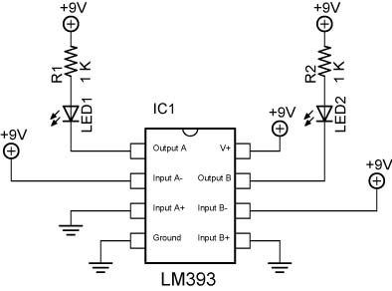

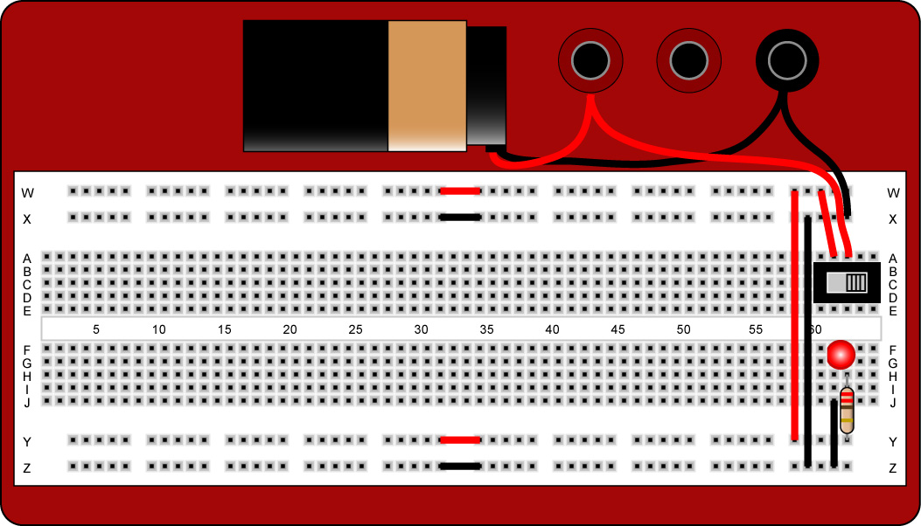

    - Example 2: From the photo, draw the schematic.

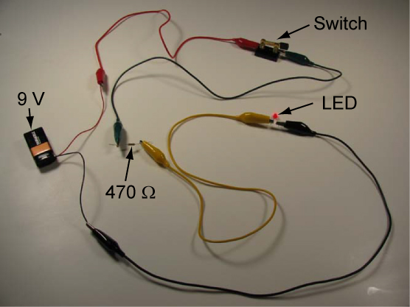

    - Example 3: From the photo, draw the schematic.

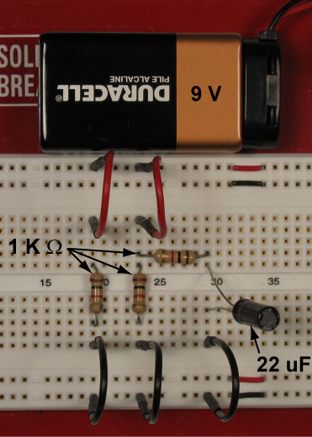

- Perform Schematics, Conductors, and Insulators Lab 1 – Drawing Schematics.
- Perform Schematics, Conductors, and Insulators Lab 2 – Bounce1.
- Internet References:
  - http://www.efundies.com/guides/fundamentals/intro/how_to_read_schematics/how_to_read_schematics_page_1.htm
  - http://www.efundies.com/guides/fundamentals/intro/common_schematic_symbols/common_schematic_symbols_page_1.htm
  - http://opencircuitdesign.com/xcircuit/goodschem/goodschem.html

- Conductors and Insulators:
  - Resistivity: Resistivity is the resistance (in ohms) to the flow of current exhibited by a certain length of material.

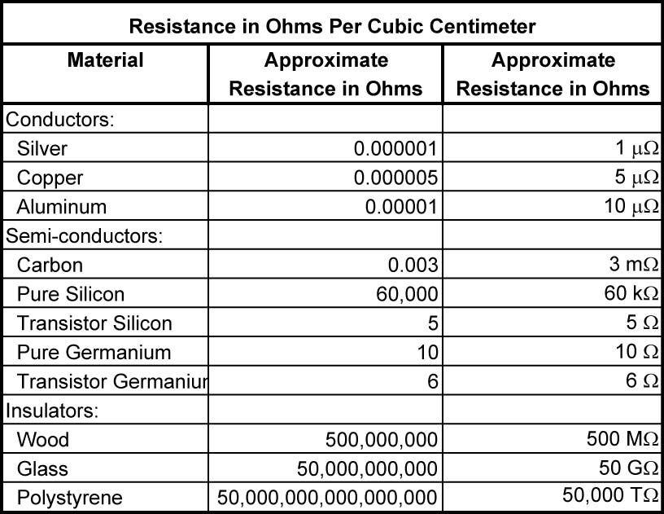

  - Conductors: A low resistance material through which electrical electrons can easily flow. The conduction of electricity is done by transferring electrons from one atom to the next atom in the conductor. The speed of this transfer approaches the speed of light, 186,000 miles/second. The electrons themselves are not traveling at the speed of light, but the effect of all of the electrons from one end of a conductor to the other end appears to approach the speed of light.
    - Electricity is always looking for a conductor!
    - The body as a conductor: Do not allow electrical current to pass through from one hand to another or from one hand to your feet. This current will pass through your heart which may prove fatal. (Stoneridge nail story).
    - Common Conductors:
      - Copper -- 2nd
        - Used in many wiring applications
        - Reasonable cost
        - Flexible
        - Easy to make into wire
        - Good corrosion resistance
      - Gold -- 3rd
        - Precious Metal
        - Very expensive
        - Does not corrode
        - Seldom used as a wire
        - Used to plate (coat) connectors in electronic devices
      - Aluminum -- 4th
        - Abundant metal
        - Reasonable cost
        - Flexible
        - Light weight
        - Corrosion problems / reacts with other metals
        - Used in large wire sizes - power lines and service entrance cable
        - Electrical wire # 4 and larger is usually aluminum and stranded.
        - Pound for pound aluminum is a better conductor than copper.
      - Tungsten-- Poor
        - Rare metal
        - Used to make light-bulb filaments
        - High melting point
        - Poor conductor
    - Types of Conductors:
      - Hookup wire
      - Ribbon wire
      - GRU wire samples
    - Solid vs. Stranded:
      - When electricity flows through a wire, it mostly flows on the surface of the wire, not through the middle. This means that a "wire" of a given size that made up of many smaller strands can carry more power than a solid wire - simply because the stranded wire has more surface area. This is why battery cables in your car and welding cables are made up of many very fine strands of smaller wire - it allows them to safely carry more power with less of that power being dissipated as heat. Almost all automotive wiring is stranded while almost all house wiring is solid.
    - Burn #30 ga in series with # 18 ga wire using three motors in parallel.
    - Conductor Sizes:
      - American Wire Gauge (AWG): A system of wire sizes developed over 100 years ago.
        - Demonstrate wire gauge.
        - The larger the wire size, the smaller the AWG number.
        - Common wire sizes we’ll be using are #12 through #28
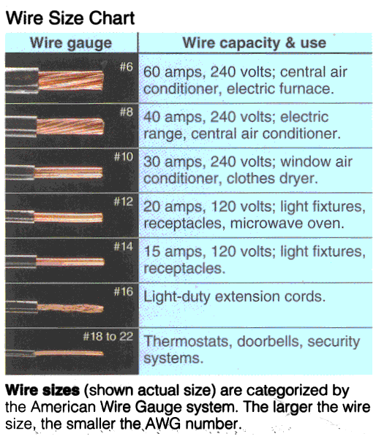

      - Electrical Cables:
        - A group of two or more wires enclosed in a metal, rubber, or plastic sheath is called a cable.
        - The sheath protects the wire from damage.
        - Metal conduit also protects wires, but is not considered a cable.
      - Four factors that affect conductor resistance (Know these):
        - Cross section area of a conductor; the larger the cross-section area, the lower the resistance.
          - See table below
        - Type of material; resistance varies for different conductor materials. See table above
        - Length of the conductor; the longer the conductor, the higher the resistance.
          - Verify with demonstration
        - Temperature of the conductor material; the higher the conductor temperature, the higher the resistance.
          - Verify with demonstration
      - Resistances per 1000’: Using the table below, determine the voltage drop in a 300’ extension cord of #22 copper wire if a saw is pulling 10 amps. Do the calculation if the wire is copper.

Resistance per 1000' @ 25º Celsius
Gauge | Material | Resistance/1000'
 |  | (in Ohms)
10 | Copper | 1.018
10 | Aluminum | 1.616
14 | Copper | 2.575
14 | Aluminum | 4.08
18 | Copper | 6.51
18 | Aluminum | 10.3
22 | Copper | 16.46
22 | Aluminum | 26.2
26 | Copper | 41.62
26 | Aluminum | 66.4

      - For a complete listing of AWG wire gauges and copper wire, see: http://www.daycounter.com/Calculators/AWG.phtml
  - Insulators: A material with few or no free electrons which will not let electrons flow freely. Insulators provide a protective coating around a conductor.
  - Semi-conductors, materials that have conductivity between conductors and insulators.
  - Is air a conductor or an insulator?

- Related Web Sites:
  - http://www.allaboutcircuits.com/vol_1/chpt_12/index.html
  - http://www.ieee.org/portal/cms_docs_iportals/iportals/education/preuniversity/tispt/pdf/lessons/condinsul.pdf#search=%22conductor%20insulator%20lesson%22
- Electricity and Electronics, Section 3.2, Special Conductor Pathways Continued:
  - Breadboards were covered in Week 2.
  - Printer Circuit Boards (PCB): A printed circuit board is an insulated board where copper foil paths and connection pads provide electrical paths for current to flow.
    - Demonstrate difference between general purpose and custom PCBs.
    - Perform Schematics, Conductors, and Insulators Lab 3 – Photofabrication of PCB
  - Chassis: Components mounted on a metallic surface uses the metal as a pathway for circuits.
    - Use vehicle as an example.
Electronics Technology and Robotics I Week 3
Schematics, Conductors, and Insulators Lab 1 – Drawing Schematics

- Purpose: The purpose of this lab is to have the student practice drawing schematics.

- Apparatus and Materials:

  - 1 – Digital Multimeter
  - 7 Circuits Provided by the Instructor

- Procedure:
  - Draw schematics for the 7 circuits displayed.
    - In Circuit 6, measure the voltage between Point A and ground. Compare it to the source voltage.

Source Voltage = ___________________________

Point A to GND = ___________________________

    - Use the integrated circuit (IC1) below when drawing Circuit 4, the electronic cricket.
  - Component Symbols Needed:

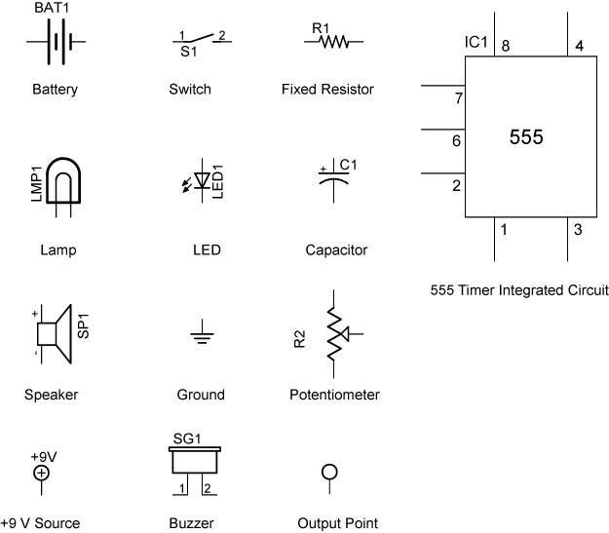
Seven Circuit Schematics

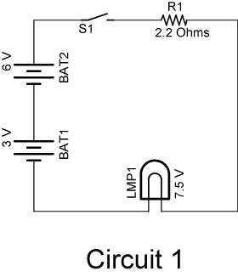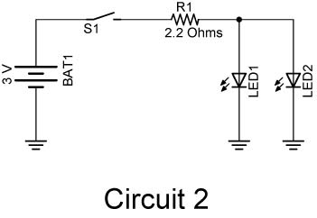

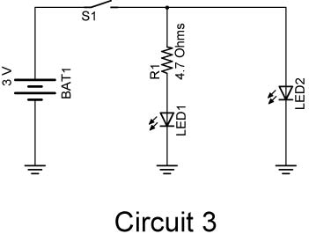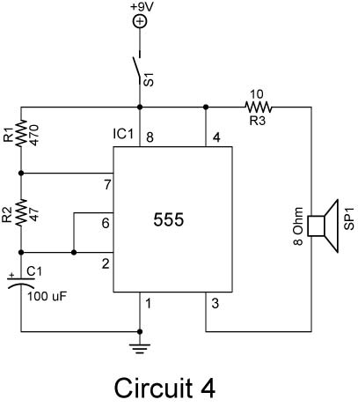

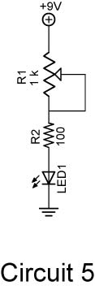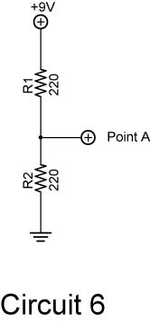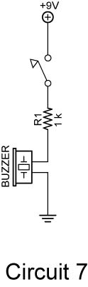

Electronics Technology and Robotics I Week 3
Schematics, Conductors, and Insulators Lab 2 – Bounce1.pbp

- Purpose: The purpose of this lab is to have the student practice wiring a circuit from a schematic drawing.

- Apparatus and Materials:

  - 1 – Breadboard with +5 V Power Source
  - 1 – PIC16F88 with PicBasic Pro Program: http://www.cornerstonerobotics.org/code/bounce1.pdf
  - 1 – 4.7 K Resistor DIP
  - 8 – LEDs
  - 8 – 100 Ω Resistors

- Procedure:
  - Wire the circuit Bounce1:

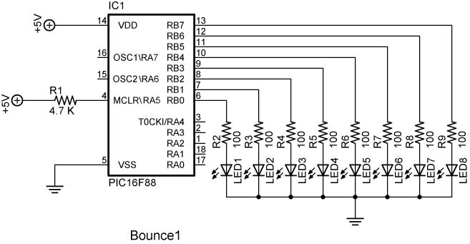
Electronics Technology and Robotics I Week 3
Schematics, Conductors, and Insulators Lab 3 – Photofabrication of PCB

- Purpose: The purpose of this lab is to acquaint the student with:
  - PCB layout using dry transfers, and
  - The process of chemical photofabrication.

- Apparatus and Materials:

  - 1 – Solderless Breadboard
  - 1 – 1/32” Presenitized Copper-Clad Single Sided Circuit Board (Allied Electronics #661-0595 (18"x12" x 1/32"))
  - PC Transfers
  - 1 – M.G. Chemicals Etchant Process Kit M.G. Cat #416-E (Electronix Express # 03416E); (http://www.mgchemicals.com/products/416e.html)
  - 1 – M.G. Chemicals Exposure Kit M.G. Cat #416-X (Electronix Express # 03416X); (http://www.mgchemicals.com/products/416x.html)
  - M.G. Chemicals Developer M.G. Cat #418 (Electronix Express # 03418500ML); (http://www.mgchemicals.com/products/418.html)
  - M.G. Chemicals Ferric Chloride Etchant, M.G. Cat #415 (Electronix Express #03151L(1Liter) or #034154L(4 Liter)); (http://www.mgchemicals.com/products/415.html)
  - 4 – Red LED’s
  - 1 – SPDT 0.1” Center Mini Slide Switch (Electronix Express #17SLDH251)
  - 1 – Phoenix Terminal Blocks 0.2” (Allied Electronics #70055287)

- Procedure:
  - Wire the circuit in the schematic below.
    - Measure the voltage drop across the battery and each LED. Record the results in Table 1.
    - In the conclusions, compare the total voltage drop of the LEDs with the battery.
    - Add another LED to the series and observe the results. Now add a sixth LED to the series and observe the results. What does this reveal about LEDs?
  - Photofabrication of the printed circuit board (PCB):
    - Using dry transfers, layout the circuit on a copper-clad PC board.

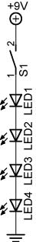

    - Use the MG Chemical process guide to etch a presenitized copper-clad single sided circuit board:
      - MG Chemicals instructions for complete prototyping process website: http://www.mgchemicals.com/techsupport/photo_inst.html Pay special attention to the warnings listed on this website.
      - Use the Exposure Kit to expose the PC board for a minimum of 5 minutes, preferably 10 minutes.
      - Develop the board in one part developer to ten parts tepid water. Lightly brush the resist with a foam brush. Development should be completed within one to two minutes.
      - Immediately neutralize development action by rinsing the board with water.
      - Etch your board using the Etching Kit and the ferric chloride etchant. An ideal etching temperature is 50°C (120°F).
      - See illustrated process at: http://www.mgchemicals.com/techsupport/photo_demo.html

- Results:

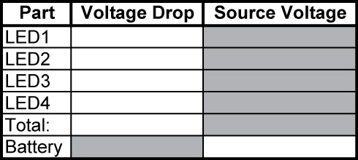

Table 1

- Conclusions:

- Sample PCB Layout:

