Electronics and Robotics I Week 23
Sonar Car 1 – Servo Positioning

- Administration:
  - Prayer
- PicBasic Pro Programs Used in This Lesson:
  - General PicBasic Pro Program Listing: http://www.cornerstonerobotics.org/picbasic.php
  - Lab 1 servo1 as .pdf file: http://www.cornerstonerobotics.org/code/servo1.pdf
- Introduction:
  - Obstacle Avoidance: This series of four sonar car lessons walk you through the software development for the sonar car. In general, the car is designed to make its way through an obstacle without hitting an obstacle or wall. The sonar car to takes 7 ultra-sonic distance readings, chooses the longest distance reading of the seven, and then rotates the car in the direction of the longest distance reading before traveling forward. For example in Figure 1 below, the sonar car should determine that direction 4 is the longest distance reading at its current position and it should rotate in that direction and then move forward.

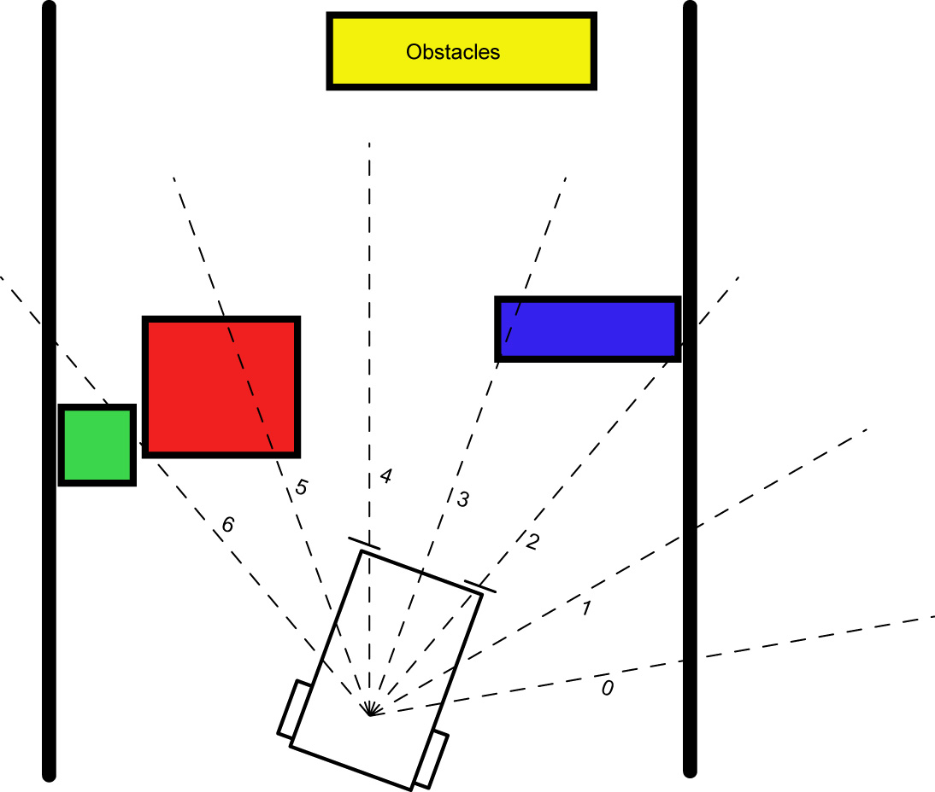

Figure 1

PicBasic Pro Review:
  - PULSOUT:
Format:

PULSOUT Pin, Period

Explanation:
Generates a pulse on Pin of specified Period. The pulse is generated by toggling the pin twice, thus the initial state of the pin determines the polarity of the pulse. Pin is automatically made an output. Pin may be a constant, 0 - 15, or a variable that contains a number 0 - 15 (e.g. B0) or a pin name (e.g. PORTA.0). The resolution of PULSOUT is dependent upon the oscillator frequency. If a 4MHz oscillator is used, the Period of the generated pulse will be in 10us increments. If a 20MHz oscillator is used, Period will have a 2us resolution. Defining an OSC value has no effect on PULSOUT. The resolution always changes with the actual oscillator speed.
Examples:

PULSOUT PORTB.5,100 ‘ Send a pulse 1 msec long (at 4MHz) to RB5

PULSOUT 2,200 'Send a pulse 2 msec long to RB2.

  - FOR..NEXT:
Format:

FOR Count = Start TO End {STEP {-} Inc}
{Body}
NEXT {Count}

Explanation:
The FOR..NEXT loop allows programs to execute a number of statements (the Body) some number of times using a variable as a counter. Due to its complexity and versatility, FOR..NEXT is best described step by step:
1) The value of Start is assigned to the index variable, Count. Count can be a variable of any type.
2) The Body is executed. The Body is optional and can be omitted (perhaps for a delay loop).
3) The value of Inc is added to (or subtracted from if “-” is
specified) Count. If no STEP clause is defined, Count is
incremented by one.
4) If Count has not passed End or overflowed the variable type, execution returns to Step 2.
If the loop needs to Count to more than 255, a word-sized variable must be used.
Examples:

FOR i = 1 TO 10 ‘ Count from 1 to 10
N = N+1
NEXT i ‘ Go back to and do next count

FOR B2 = 200 TO 100 STEP -1 ‘ Count from 200 to 100 by -1
PULSOUT 2,B2 ' Send position signal to servo
PAUSE 20 ' Pause 20 msec
NEXT B2 ‘ Go back to and do next count

Nesting:
A For..Next loop can be placed inside another FOR..NEXT loop; this is called nesting. Nesting is embedding one object (one FOR..NEXT loop) in another object of the same type (another FOR..NEXT loop).

FOR i = 1 TO 2

FOR j = 1 TO 10
HIGH 0
LOW 1
PAUSE 500
Note: The FOR…NEXT j loop must be nested entirely within the FOR…NEXT i loop.
LOW 0
HIGH 1
PAUSE 500
NEXT j

HIGH 2
PAUSE 500
LOW 2

NEXT i

- Power Supplies for Digital Circuits Review:
  - Digital circuits require power supplies that provide a stable source of power to all circuit components.
  - Even though our circuits are powered from a voltage regulator, motors and servos can disrupt the proper operation of the PIC microcontroller.
  - Make certain that the servo power supply is separate from the PIC power supply, i.e., have two +5V regulated power supplies. Otherwise, if the servo spikes the single power line supplying power to both the servo and the PIC, the 16F88 may reset.
- Servos Review:
  - A servo is a special motor used to provide control for a desired rotational position through the use of feedback.
  - Most servos have a position range of 180 degrees.
  - A hobby servo is typically used to provide actuation for various mechanical systems such as the steering of a RC car, the flaps on a RC plane, or the rudder of a RC boat.
- Servo Connections:

Black = Ground
Red = +5 to +6 dc volts
White/Orange = Control wire (Futaba uses a white wire)

- Servo Pulse Signal Widths:
  - Pulse width for full counterclockwise position:

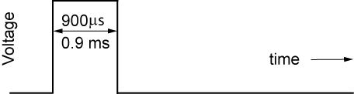

0.9 ms Pulse Width
  - Pulse width for center position:

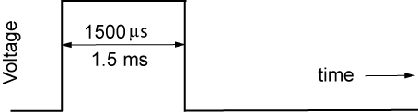

1.5 ms Pulse Width

  - Pulse width for full clockwise position:

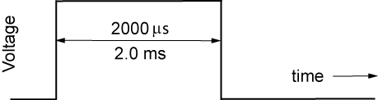

2.0 ms Pulse Width
  - Servo Motor Pulse Intervals:
    - The period of one servo pulse cycle is typically 20 ms.

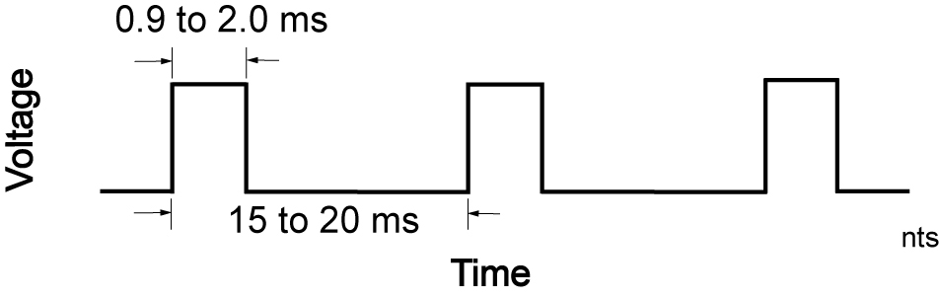
  - Perform Servo Positioning LAB 1 – Set Servo into Starting Position
  - Perform Servo Positioning LAB 2 – Pan Servo Across the Front of the Servo Car

Electronics and Robotics I Week 23
Sonar Car 1 – Servo Positioning
LAB 1 – Set Servo into Starting Position

- Purpose: The purpose of this lab is to set the servo on the sonar car into the starting position.

- Apparatus and Materials:

  - 1 – Sonar car with Sonar Car Circuitry 1 & 2 on breadboard – see schematics below.

- Procedure:
  - You can import servo1.pbp to provide the basic program code. You will need to make modifications to this program. See: http://cornerstonerobotics.org/code/servo1.pbp.
  - Save the imported program as sonar_car1.pbp. You will keep adding to this program in the coming weeks until your sonar car is fully functional.
  - Give the output pin PORTB.6 the name servo_pin. It can be assigned a name using the VAR command. This pin will send the program signal to the servo.
  - Using the PULSOUT command, set the Period to 70. Remember the format for PULSOUT is: PULSOUT Pin, Period
  - Shorten the time to move the servo by reducing the FOR..NEXT loop to 20 loops.
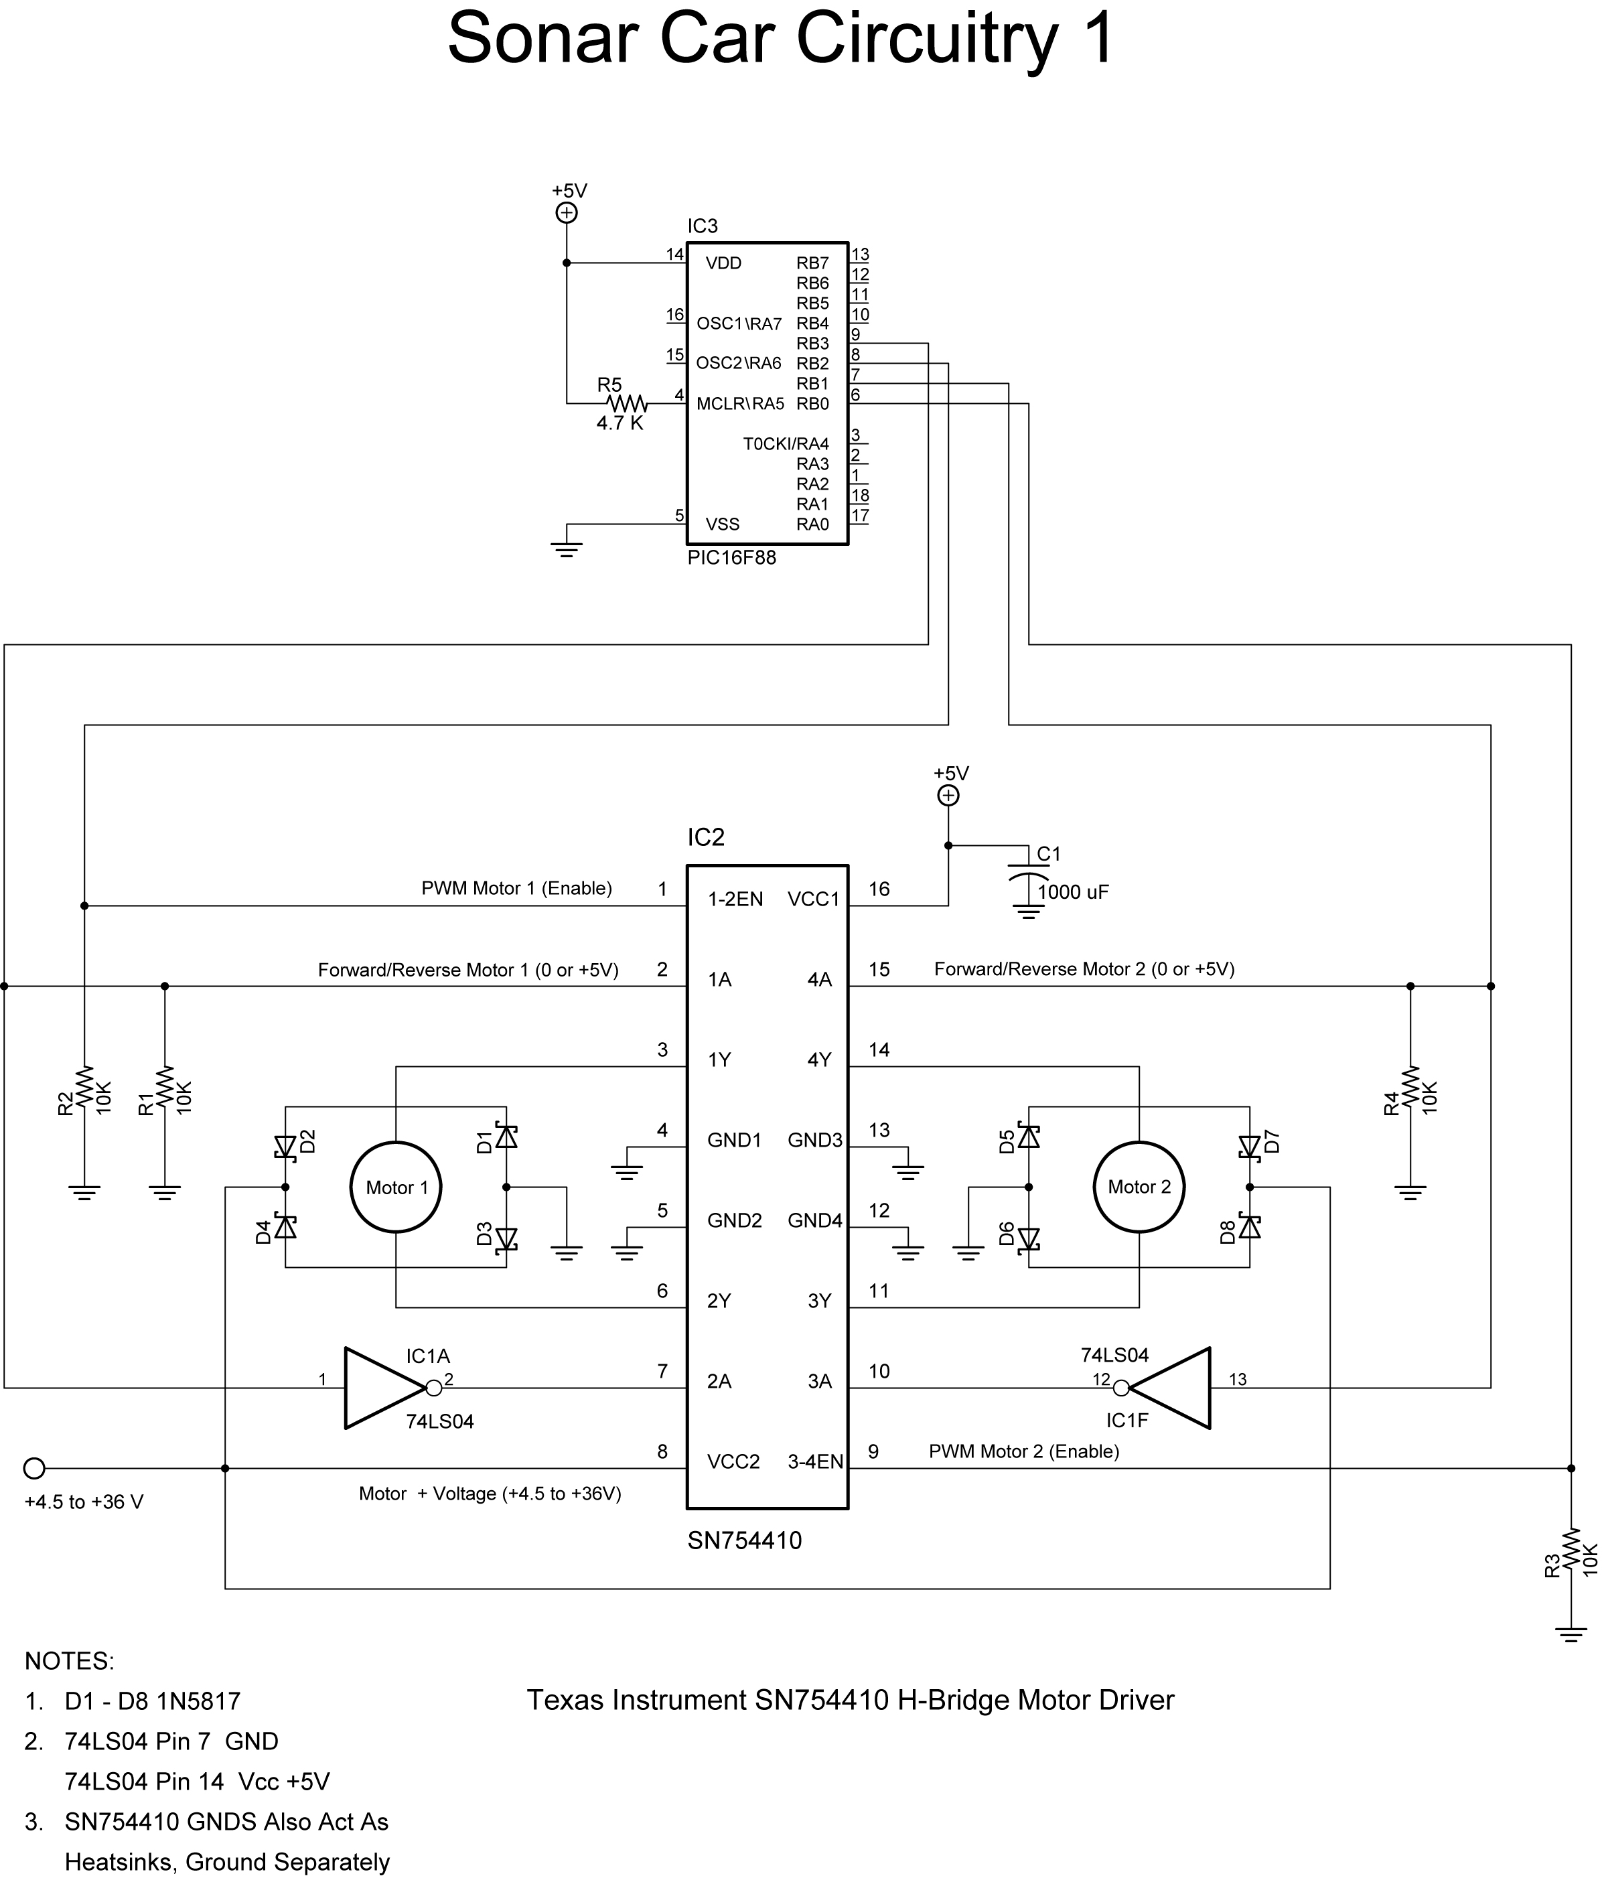
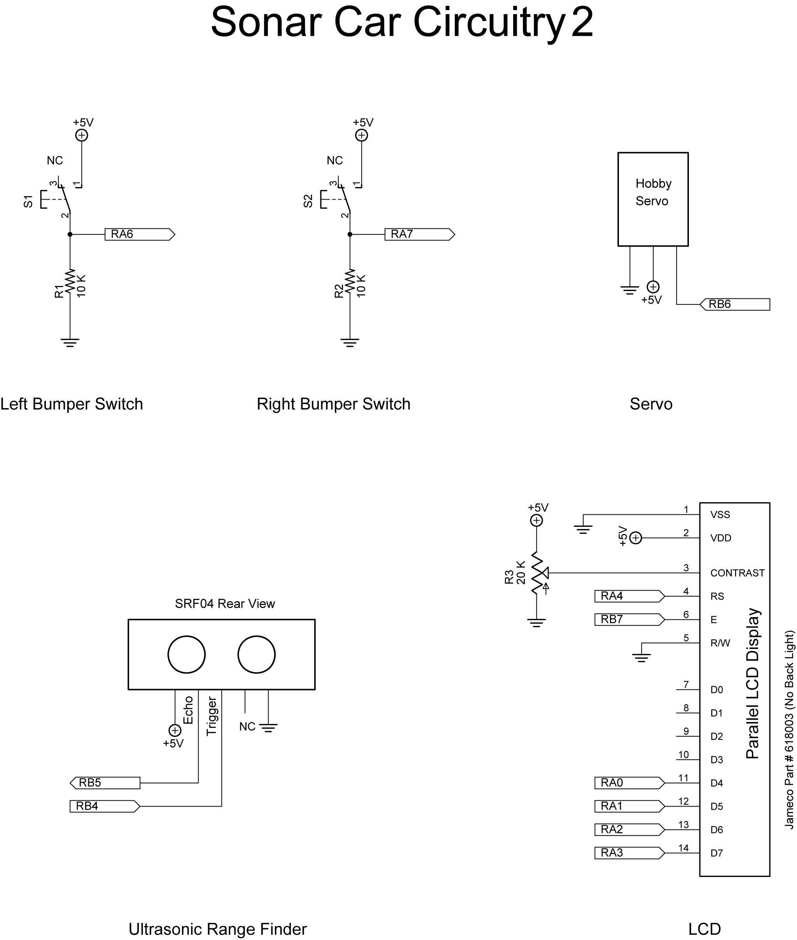

Electronics and Robotics I Week 23
Sonar Car 1 – Servo Positioning
LAB 2 – Pan Servo across the Front on the Sonar Car

- Purpose: The purpose of this lab is to make the servo pan across the front of the sonar car in six discrete steps.

- Apparatus and Materials:

  - 1 – Sonar car with Sonar Car Circuitry 1 & 2 on breadboard – see schematics in Lab 1.

- Procedure:
  - Declare the following variables

p0 VAR BYTE ' BYTE to store servo pulse period
c0 VAR WORD ' WORD for counter

  - Start the servo at the position generated by Period = 70 (see Lab 1) and then rotate through to Period = 208 in 6 discrete steps. Hint: Nest two FOR..NEXT loops.
  - Shorten the time to move the servo to each new position by reducing the FOR..NEXT loop to 15 loops.
  - Set up a loop to make the servo return to the starting position and then pan across the front of the car again. The

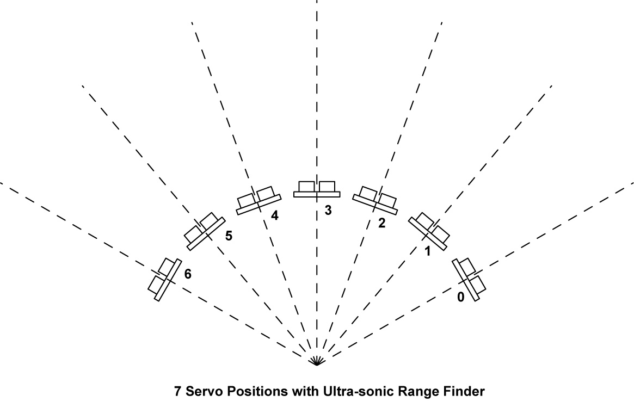

  - Compare your program to sonar_car_a.pbp. See: http://cornerstonerobotics.org/code/sonar_car_a.pbp

