Electronics Technology and Robotics I Week 1
Simple Circuits and Solderless Breadboards

- Administration:
  - Prayer
  - Bible Verse
  - Handout lab manuals
- Introduction: Unlike mechanical systems where you are familiar with the quantities like friction, springs, mass, speed, etc., electricity and electronics are based upon unfamiliar quantities like current, voltage, resistance, capacitance, etc. This makes it more difficult to relate to and understand. You will have to work with these electrical quantities before you will gain some comfort with them.
In this session, we will start with a look at the micro, i.e. the small details of matter and then work with the macro, i.e. dealing with the large scale behavior of electrostatics.
- Electricity and Electronics, Section 1.1, The Nature of Matter:
  - Atom: The smallest form of an element is known as the atom.
  - Atomic Structure:
    - Introduction: We will use the Bohr model of atomic structure. The model which was developed by Danish scientist Niels Bohr states that an atom consists of a nucleus at the center and electrons orbiting around the nucleus much like the planets orbit around the sun. See Bohr model applet: http://www.germane-software.com/~dcaley/atom/Atom.html
    - Nucleus: The nucleus is the center of the atom which contains the protons and neutrons. See: http://education.jlab.org/atomtour/listofparticles.html
    - Protons: Protons are positively charged particles contained in the nucleus. The mass of a proton is about 1800 times that of an electron.
      - Atomic Number: The atomic number equals the number of protons in the nucleus.
    - Neutrons: Neutrons are uncharged particles contained in the nucleus. The mass of a neutron is about the same as a proton.
    - Electrons: Electrons are the basic particles of negative charge that whirl in orbits around the nucleus. Sometimes the orbits are called rings or shells. See applet: http://www.lon-capa.org/~mmp/applist/coulomb/orbit.htm
      - In an atom, the number of electrons in orbit equals the number of protons in the nucleus; therefore the number of negative charges equals the number of positive charges. In this state, the atom is electrically balanced or neutral.
      - See: http://www.colorado.edu/physics/2000/applets/a2.html
http://www.rkm.com.au/ANIMATIONS/Uranium-atom.html
      - Ionization: The removal or addition of an electron from or to a neutral atom so that the resulting atom (called an ion) has a positive (+) or negative charge (-). An ion is an atom that is not electrically neutral. A positive ion has had an electron removed, while a negative ion has gained an electron.
      - In electricity and electronics, the most important part of an atom is the electrons because they can be stripped off an atom to produce electricity.
      - Electronics is about controlling electrons with components such as resistors, diodes, capacitors, transistors and integrated circuits to produce the result we want, which in our case is controlling the behavior of robots.
- Electricity and Electronics, Section 1.2, Static Electricity:
  - Terms and definitions:
    - Static: Static means at rest.
    - Static Electricity: Static electricity deals with the accumulation of charge rather than charge in motion. Static electricity is a charge that stays on a nonconductive material. Static electricity deals with electrical happenings which involve HIGH VOLTAGE at low current.
      - Balloon and salt and pepper demonstration
      - Electrostatic experiments do not work well in the humid Florida climate.
    - Law of Charges: Like charges repel each other and unlike charges attract each other.
    - Electrostatic Field: The force field surrounding a charged body is called the electrostatic field. An electrostatic field is like a magnetic field except the forces in the field are created by charges not magnetism. The field is made up of imaginary lines coming from charges which represent lines of force.
      - Drawing with lines of force
      - Lines point from positive to negative
      - See: http://www.falstad.com/emstatic/
Electrostatic Game:
      - See: http://mw.concord.org/modeler1.3/mirror/electrostatics/mazegame.html
  - Van der Graaf demonstration
    - The highest potential sustained by a Van de Graaff accelerator is 25.5 MV.
    - A rule of thumb for breakdown potential of air is about 20,000 volts per inch.
      - The breakdown potential of paper is about 350,000 volts per inch.
      - The breakdown potential of a vacuum is infinite volts per inch.
    - See: http://www.magnet.fsu.edu/education/tutorials/java/vandegraaff/index.html

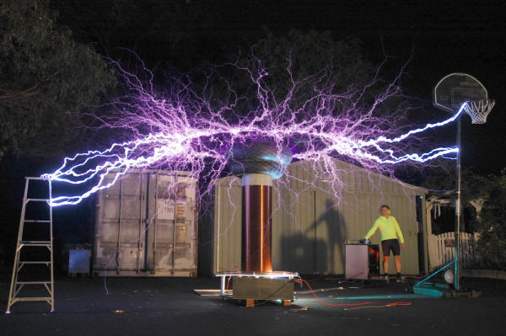

  - Related web sites:
    - http://www.sciencenetlinks.com/lessons.cfm?BenchmarkID=4&DocID=234
    - http://www.sciencemadesimple.com/static.html
    - http://en.wikipedia.org/wiki/Van_de_Graaff_generator
    - http://www.school-for-champions.com/science/static.htm

- Robot Building for Beginners, Chapter 1:
  - Four Disciplines of Robotics:
    - Electrical Engineering:
      - Circuits
      - Sensors
    - Mechanical Engineering
      - Body
      - Gearing
      - Moving parts
    - Computer Science:
      - Pseudo-intelligent behavior, decision making
    - Arts:
      - Style
      - Expression
  - Parts of a Robot:
    - Electric Power:
      - Power source
      - Power regulation
    - Brains:
      - Robots without brains
        - Remote control
        - Joystick
      - Microcontroller chip
        - Top choice for brains
    - Sensors:
      - Touch sensor demonstration
      - Light sensor demonstration
      - Temperature probe demonstration
      - Infrared detection demonstration
      - Sonar demonstration
    - Action and Feedback:
      - Movement with motors and wheels or legs
      - Indicator lights and sounds so operator can view status of robot
    - Body
      - Frame for robot
  - Sandwich web site:
      - http://www.robotroom.com/Sandwich.html
- Basic Electrical Circuit:
  - An electrical circuit provides a path for electron flow from the source of electricity through the circuit components and connections and then back to the source. The word circuit is from the Latin word circuitus, a going around.
  - A basic electrical circuit consists of three main parts: the source, conductor, and load.

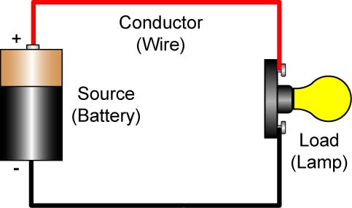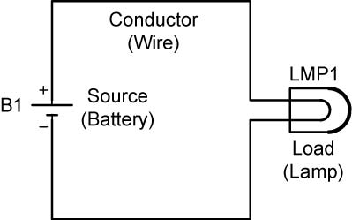

A Simple Circuit Schematic Diagram of the Simple Circuit

Figure 1: An Example of the Three Main Parts of a Simple Circuit and the Schematic Diagram of the Circuit

    - Illustration of the Three Basic Electrical Circuit Parts Plus a Control Device:

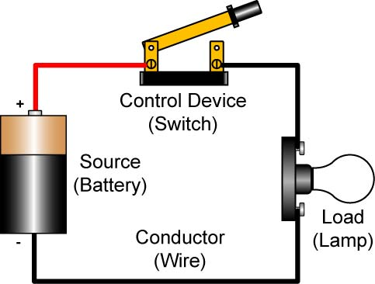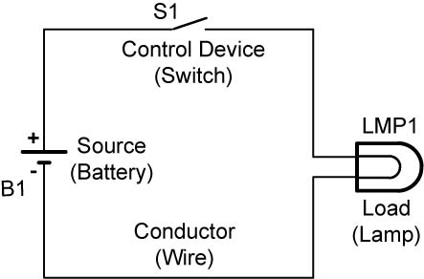

Simple Circuit Schematic Diagram of Simple Circuit

Figure 2: Three Main Electrical Circuit Parts with a Control Device Added

    - Source: The source provides the electrical potential energy (called voltage) to the circuit. The source can be a battery, electrical outlet, solar panel, or even potatoes.

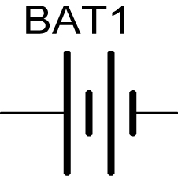

Figure 3: Battery Symbol

    - Load: The load converts the electrical energy to some other form of energy such as heat, light, motion, or magnetism (resistor, lamp, motor, and bell). This is the part of a circuit that performs work.

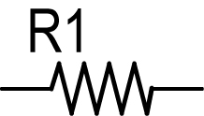

Figure 4: Resistor Symbol

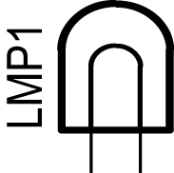

Figure 5: Lamp Symbol

    - Conductor: The conductors are the wires between the source and the load which are made up of a low resistance material through which electrons can easily flow.
      - The symbol for wire is a line.
    - A fourth part is a control device like a switch or a fuse which is not required for the circuit to work, but provides a safety and practical function of turning a circuit on and off.

Figure 6: Switch Symbol

  - Three Basic Circuit Conditions:
    - Open Circuit, a broken path therefore, no current flow.

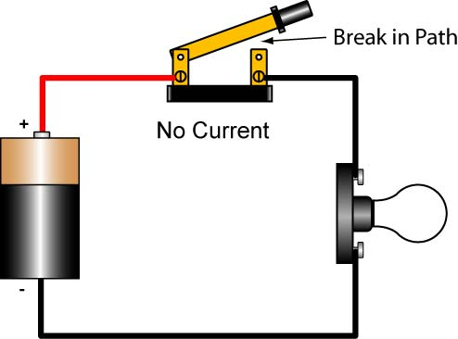

Figure 7: Open Circuit with Broken Path

    - Closed Circuit, an unbroken path for current from a source to a load and back to the source. In general, if the circuit works, then it is a closed circuit.

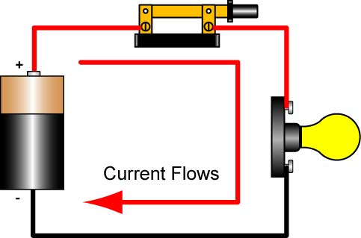

Figure 8: Closed Circuit

    - Short Circuit, an unwanted circuit condition where the current bypasses the load causing damage to the circuit.

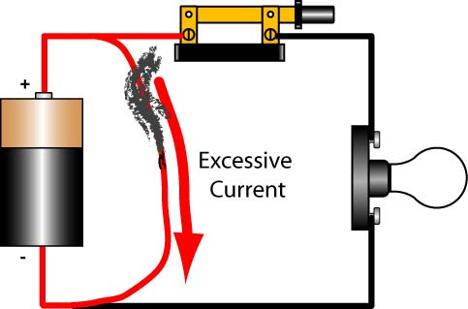

Figure 9: A Short Circuit Can Cause Damage to the Circuit

  - Perform Simple Circuits and Breadboards LAB 1 – Wiring Simple Circuits
- Terms and Definitions:
  - Unit of Measure: A precise quantity used to state magnitudes of other quantities of the same kind (length, time, mass, etc.).
  - The three most basic units in electricity are voltage, current, and resistance. To help understand these terms an analogy using water will be used. The voltage is equivalent to the water pressure, the current is equivalent to the flow rate, and the resistance is like a restriction in the pipe size.
  - Voltage (Units in Volts, V): In general terms, voltage can be thought of as a pressure that is exerted on electrons which causes them to move or flow in a conductor. If we compare electric current to water flowing through a pipe, then voltage would be analogous to water pressure. If a pipe has the same water pressure at both ends, no water flows. For water to flow through a pipe, it is necessary to have a difference in water pressure (measured in psi) between the two ends (Figure 10). With higher water pressure, more water is forced through a pipe in a given time.

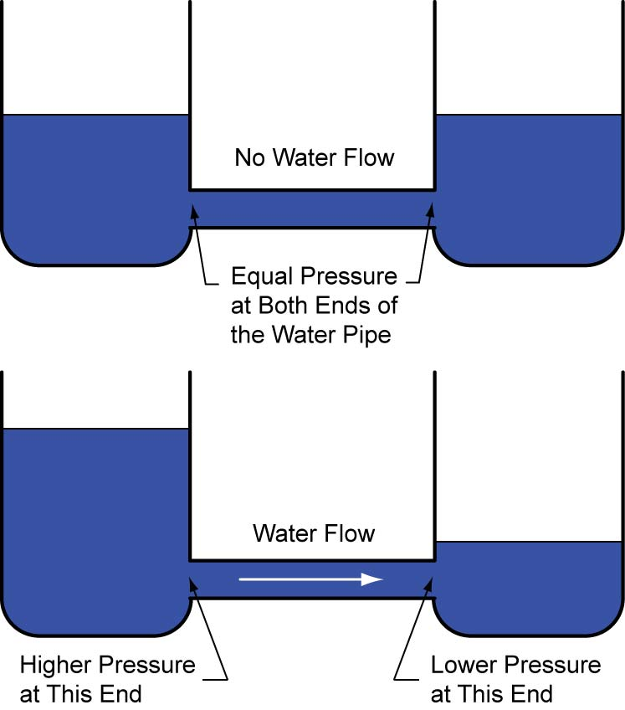

Figure 10: Difference in Pressure Creates Water Flow in a Pipe
Similarly, for electrical current to flow, it is necessary to have a difference in electrical potential (measured in volts) between the two ends of a component. See Figure 11. With higher voltage, more electrons are pushed through a wire in a given time.

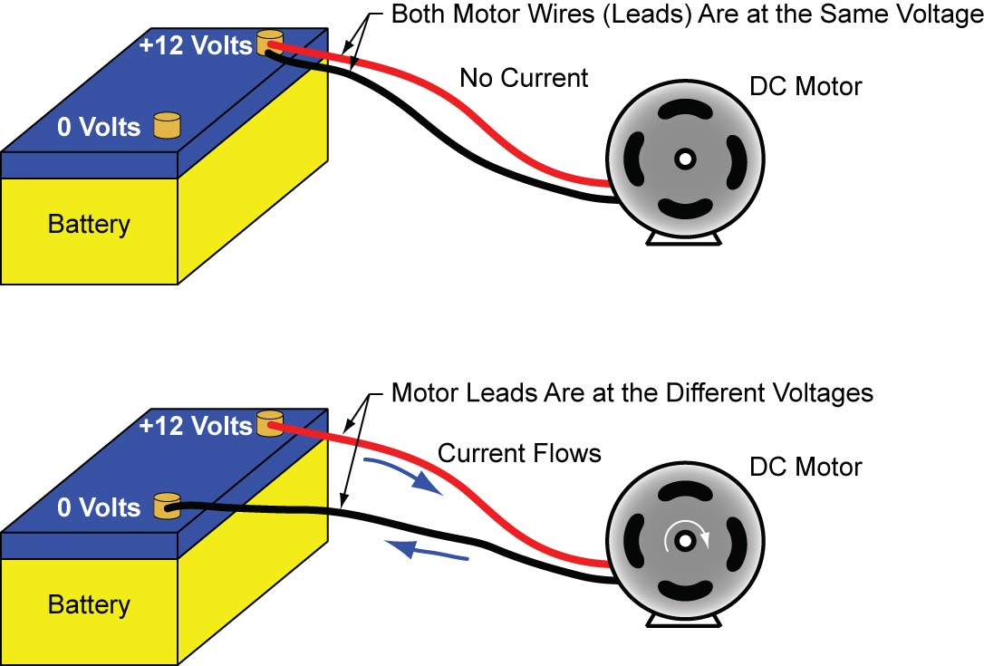

Figure 11: A Difference in Voltage Creates Electrical Current through the Motor

The voltage between two points in a circuit is a short name for the electrical force that would drive an electric current between those two points (Figure 12).

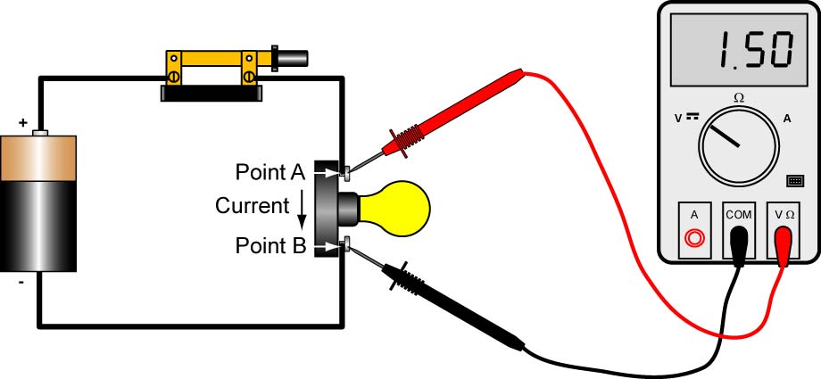

Figure 12: 1.5 Volts (Electromotive Force) Measured between Points A and B Drives the Current between those Points

Voltage is represented by the letter V or E.
    - See:
    - http://web.engr.oregonstate.edu/~traylor/ece112/lectures/voltage_electromotive_force.pdf
    - http://www.upscale.utoronto.ca/IYearLab/Intros/DCI/Flash/WaterAnalogy.html
    - http://www.mste.uiuc.edu/murphy/WaterTower/default.html
    - http://www.howstuffworks.com/water.htm
  - Current (Units in Amperes, A): In our water analogy, electrical current in a conductor corresponds to the flow of water in a pipe. In electrical circuits, current is the flow of electrons or charge passing a given point per unit of time. The direction of the current will be covered later in this lesson. Current is represented by the letter I.

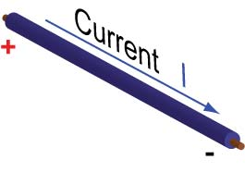

Figure 13: Electrical Current in a Conductor

  - Resistance (Units in Ohms, Ω): Resistance in water flow is represented by a constriction or obstruction that will produce a pressure drop (Figure 14).

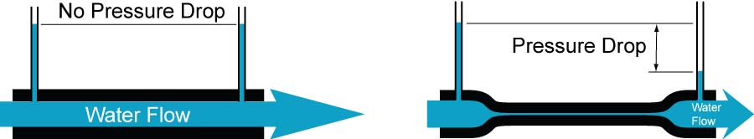

Pipe with No Constriction Pipe with Severe Constriction and Pressure Drop

Figure 14: A Constriction in a Water Pipe Produces a Pressure Drop and Reduces the Water Flow

Resistance in electrical circuits is the opposition to flow of electrons which produces a voltage drop. Resistance is represented by a resistor.

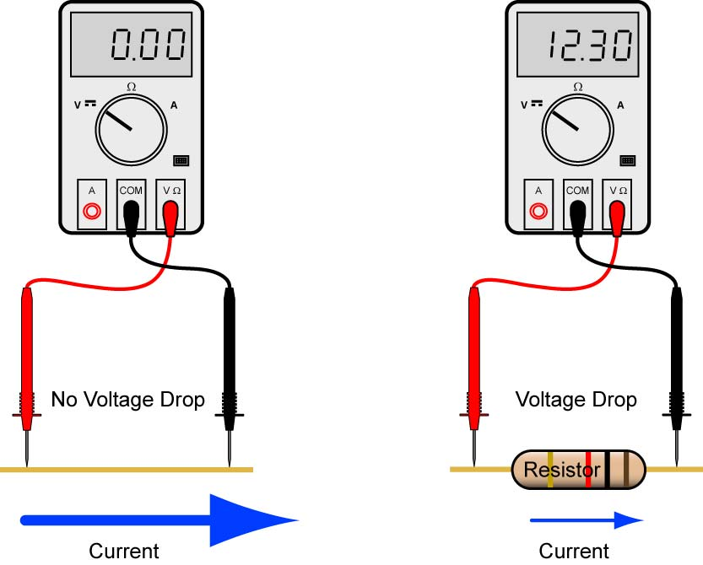

Wire with No Resistor Wire with Resistor and Voltage Drop

Figure 15: A Resistor in an Electrical Circuit Produces a Voltage Drop and Reduces the Current

Resistance is used to control the amount of voltage and/or current in a circuit. Resistance is represented by the letter R.

Review of the Water Flow and Electrical Current Analogy:

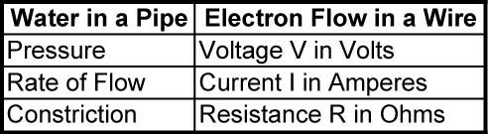
  - Conductor: Conductor is a material that has many free electrons and permits the free flow of electrons, i.e., very low resistance. Conductors will conduct electric current readily with little energy applied.
  - Insulator: An insulator is a material with few free electrons so electrons move poorly, i.e., very high resistance. Insulators require a large amount of energy to conduct a very small electrical current. See Figure 16.

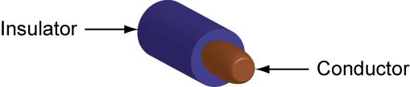

Figure 16: Conductor and Insulator in a Wire

    - Show examples of conductors and insulators.
  - Direct Current (DC): Direct current is current that flows in one direction, whether steady or in pulses. Direct current has definite fixed polarity as in a battery. The positive terminal of a battery is labeled by the + symbol and the negative terminal is labeled by the – symbol (Figure 16).

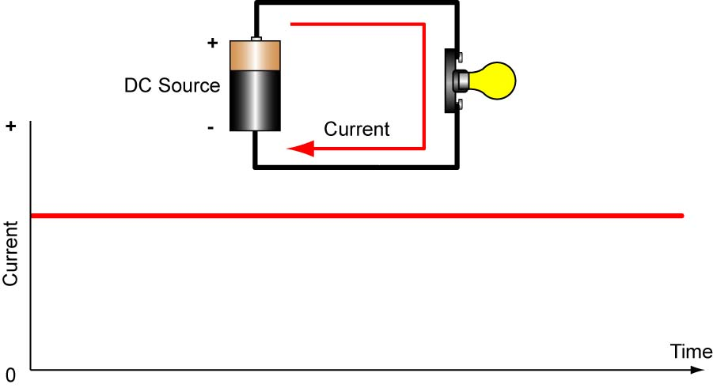

Figure 17: Direct Current Flows in One Direction

  - Alternating Current (AC): Alternating current flows in both directions and has no fixed polarity.

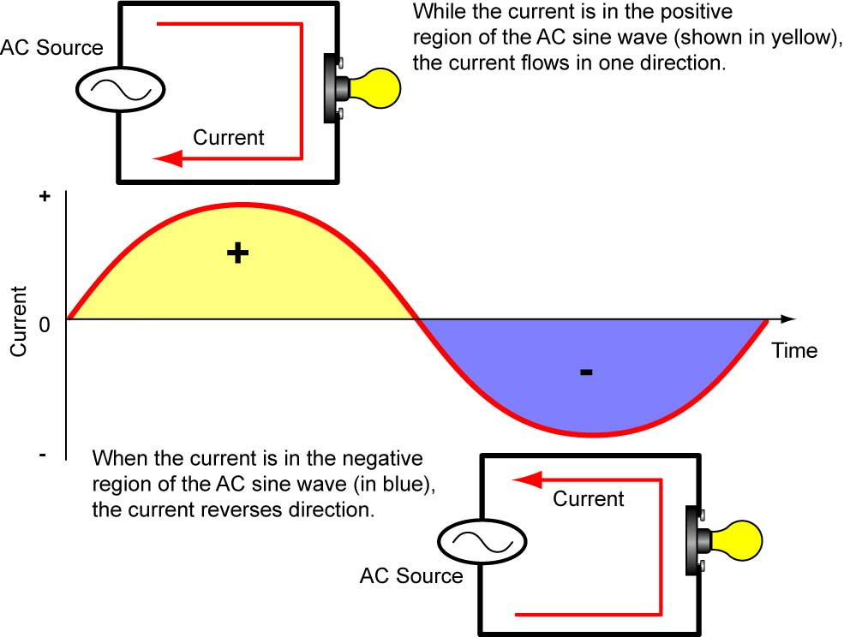

Figure 18: Direction of Alternating Current

    - Demonstration of DC and AC on an oscilloscope using a battery, signal generator, piezo buzzer, and an LED.
      - Steady DC
      - Pulsating DC
      - Sine, square, triangular, and sawtooth waveforms
  - Electron Flow: Electron flow identifies electrons as the charge carrier for current. Electron flow states that current flows out of the negative terminal (a surplus of negative charge) through the circuit and into the positive terminal (a deficiency of negative charge).

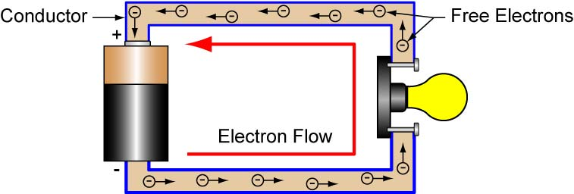

Figure 19: Electron Flow – Current Flow from Negative to Positive

  - Conventional Current Flow: An old theory attributed to Ben Franklin that assumes all current consists of moving positive charges. The fact is that the electrical charges moving are really the negatively charged electrons. Generally it doesn't matter that the assumed electric charge moves in the opposite direction that it actually does because in most cases positive charges flowing one direction is equivalent to negative charges flowing in the opposite direction. Conventional flow concludes that current flows from the positive terminal (a surplus of “positive” charge) through the circuit and into the negative terminal (a deficiency of “positive” charge). Since conventional flow is followed by most electrical engineers, we will use conventional flow to define the direction of current.

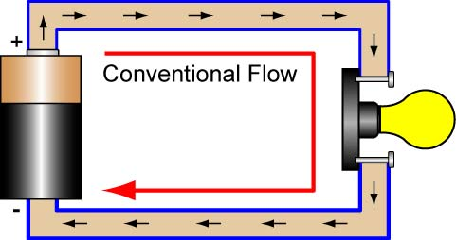

Figure 20: Conventional Flow – Current Flow from Positive to Negative

  - Series: A circuit where the components are connected end to end in a chainlike manner. There is only one pathway for the current to flow. See Figure 21.

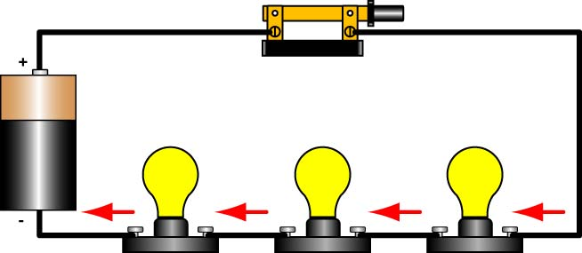

Figure 21: Three Lamps in Series with One Current Pathway

  - Parallel: A circuit where two or more components are connected so current can flow through one component without having first to flow through another component. It is a circuit where there are Y’s or branching in the wiring. Another way of saying it is that a parallel circuit is one that has more than one pathway for the current to flow.
      - Memory aid: ll in parallel

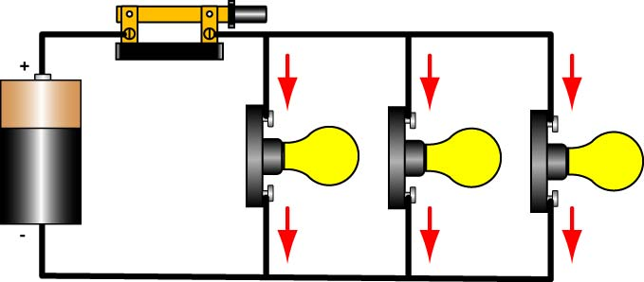

Figure 22: Three Lamps in Parallel with Three Current Pathways

  - Voltage sources and/or loads can be in series or in parallel or a combination of both.
  - Sample Circuit:

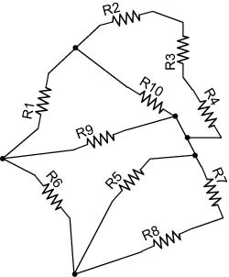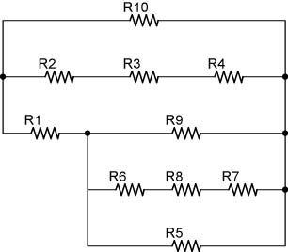

Are These Two Circuits Electrically Equivalent? If Not, Why?

- Basic Electronics Circuits:

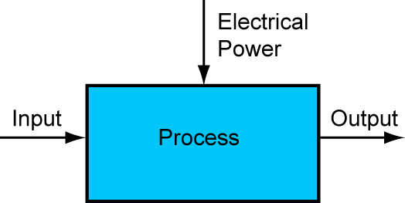

  - Basically, electronic circuits process input signals to produce output signals that are more useful to us. The process uses electronic components powered by electricity to convert an input signal into a changed output signal. For example in the circuit below, the input signal voltage varies in an analog or continuous manner. The components in the blue box (the process) convert the signal to a digital signal (either on or off) which either turns the Light Emitting Diode (LED) on or off; there is no gradual dimming of the LED.

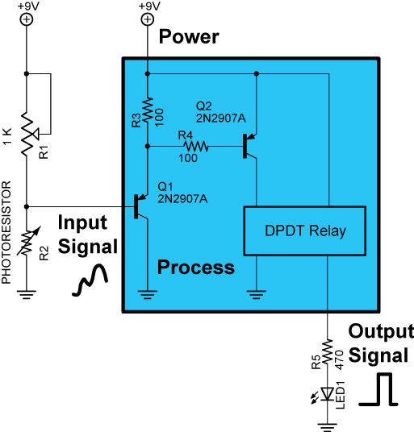

- Robot Building for Beginners, Chapter 3, Safety
  - Safety will be the number one priority for the robotics class. Hazards must be immediately reported to an adult who is attending the session.
  - Potential Dangers in Robotics:
    - Burns and fires during soldering and installing heat-shrink tubing.
    - Spark or ignition sources from batteries.
    - Possible bodily harm during drilling, cutting, filing, or milling.
    - Chemical exposure in solder, glues, developers, etchants, and electrical components.
    - Eye injury during drilling, cutting, soldering, stripping, and snipping.
  - Instructions and labels:
    - Read and follow the manufacturer’s instructions provided with equipment.
    - Read Material Safety Data Sheets, (MSDS), before using or handling chemicals.
  - Personal protection:
    - Safety glasses:
      - Whenever we are using tools or chemicals in the shop area, safety glasses will be required.
    - Clothing and shoes:
      - Loose clothing is not permitted in the shop area.
      - Long pants are required in the shop area.
      - Shoes and socks must be worn in the shop area.
      - Shoes made of leather or synthetic leather is preferable.
    - Hair:
      - Long hair must be pulled and held back.
    - Ventilation:
      - Use fans to disperse harmful fumes, e.g. soldering.
  - Wash before eating:
    - After soldering, painting, sanding, or handling chemicals or metals, wash hands thoroughly with soap and water.
  - Related web sites:
    - http://www.allaboutcircuits.com/vol_1/chpt_3/1.html

- Solderless Breadboards:
  - Solderless breadboards are commonly used in experimentation or to make a prototype of a circuit before the circuit is soldered or made in mass production.
    - Experimental Prototype Circuit on Breadboard:

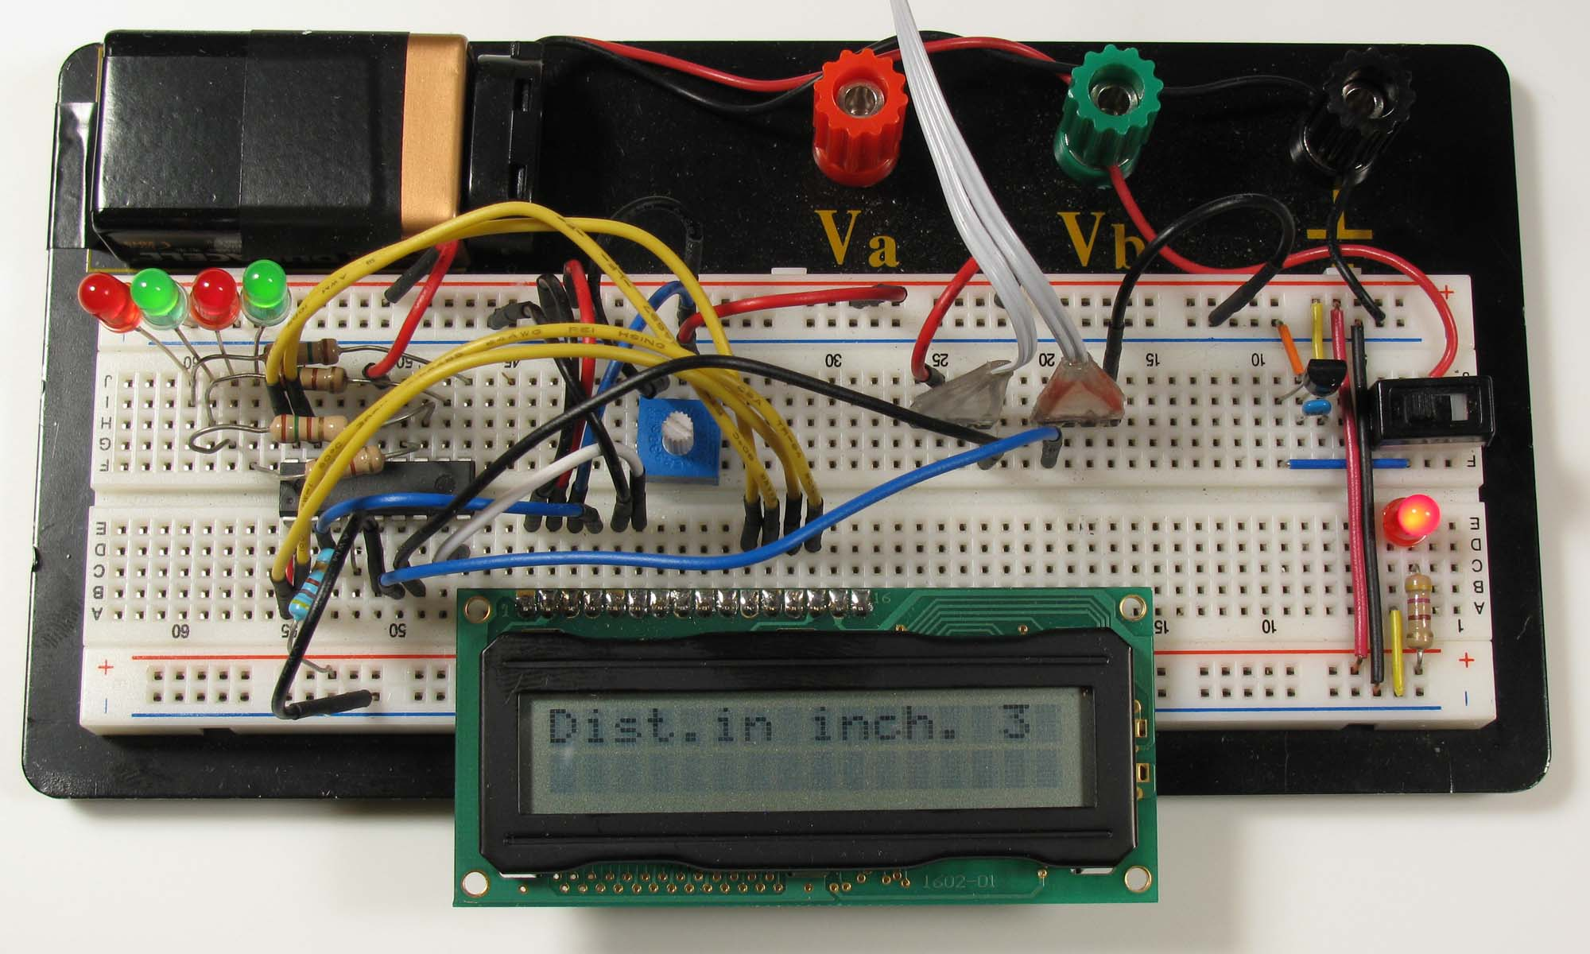

LCD Prototype Circuit on Solderless Breadboard

  - Typical Breadboard:
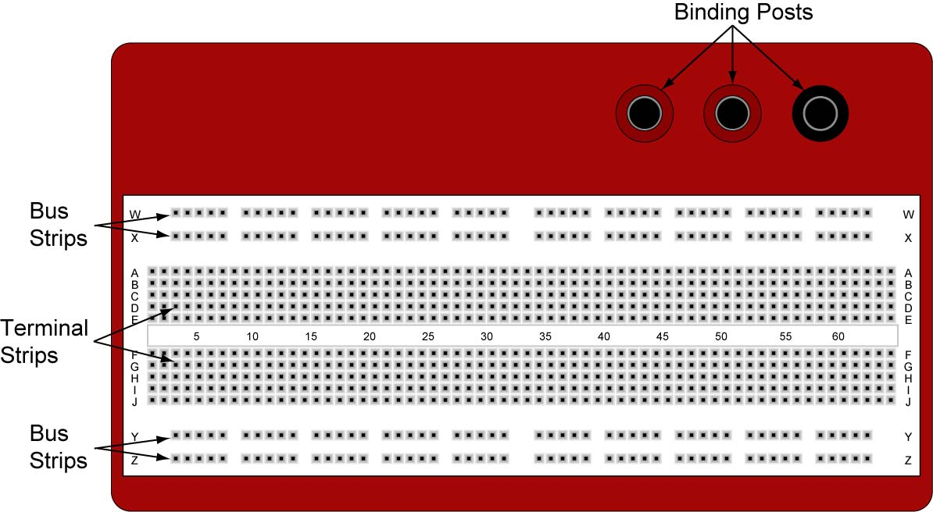

840 Pin Solderless Breadboard (http://www.digikey.com/ #922309-ND)

  - Binding Posts: Provides a way to connect an external power supply.
  - Terminal Strips: Holds the components. Five contact points in a row on each side of the notch are electrically connected.
  - Bus Strips: Provides power to the electronic components. A bus strip usually contains two columns, one for ground and one for a supply voltage.

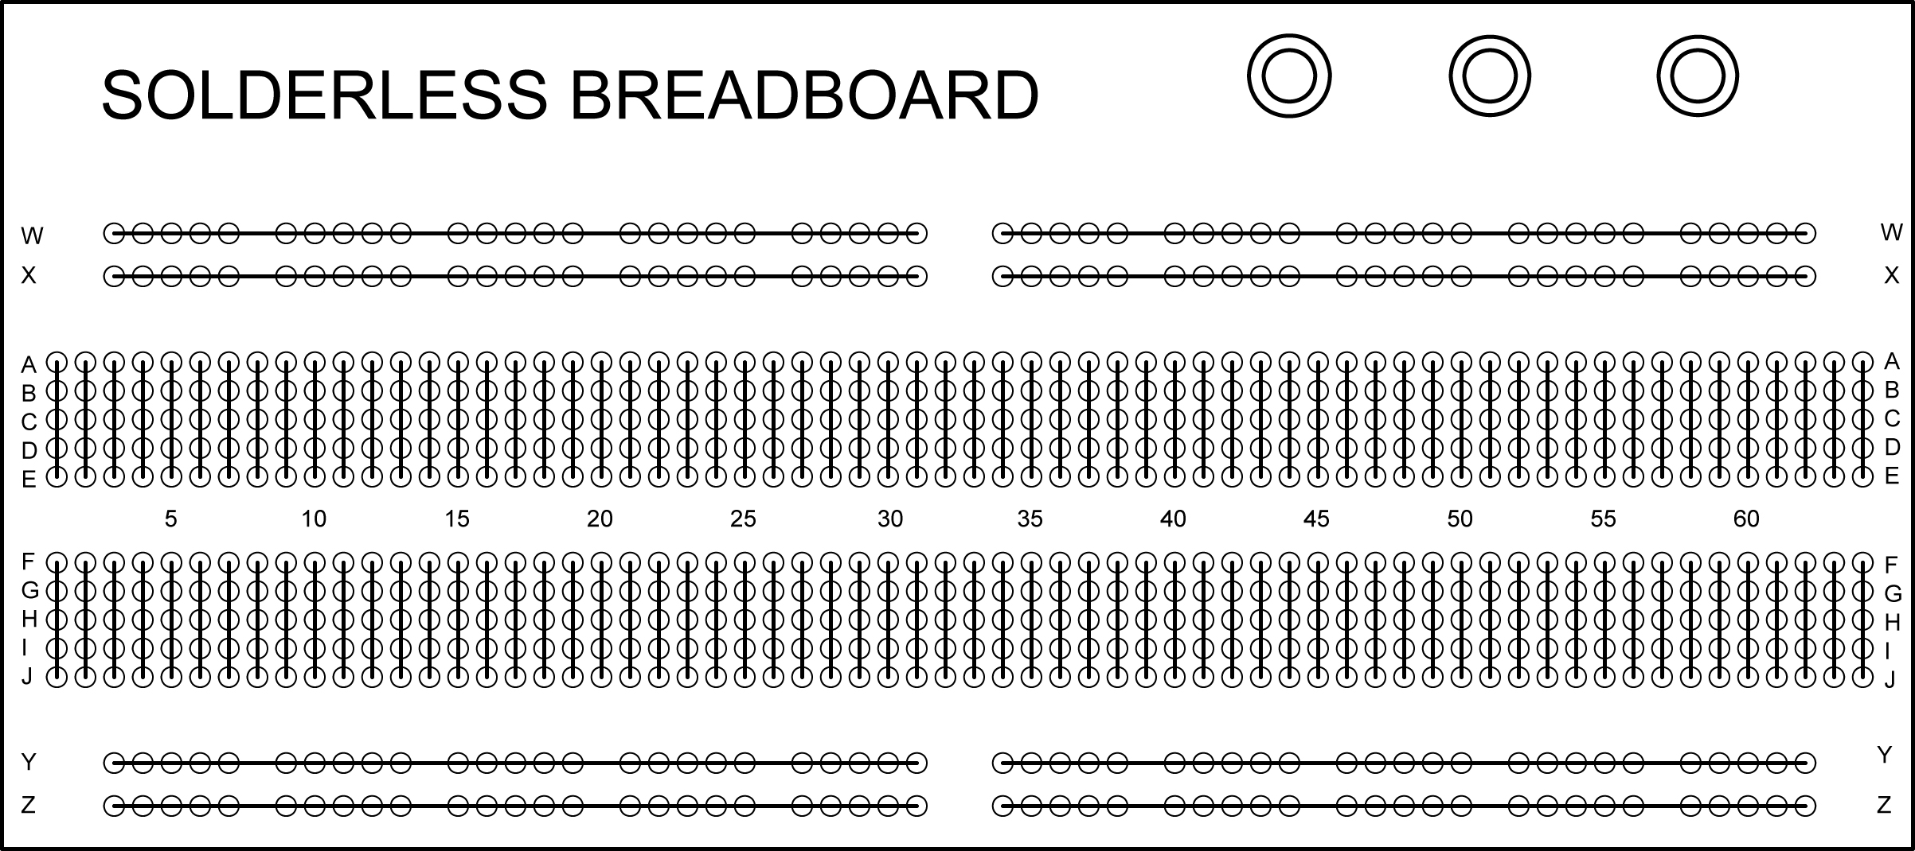

Diagram Showing Contact Points that Are Electrically Connected

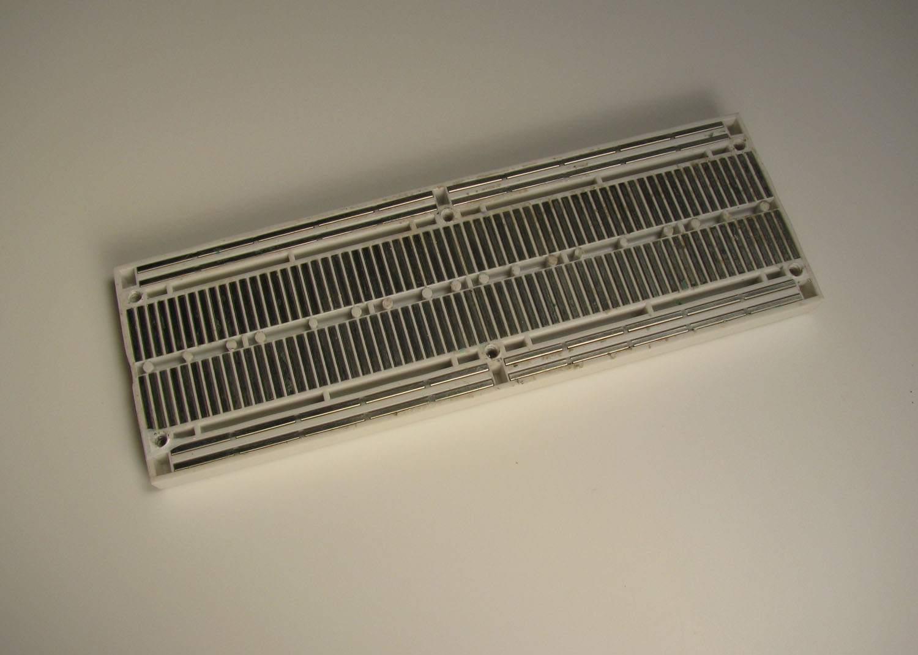

Underside of Solderless Breadboard Showing Contact Point Connections

  - Center notch is spaced to fit DIP (Dual In-line Package) integrated circuit. See below:

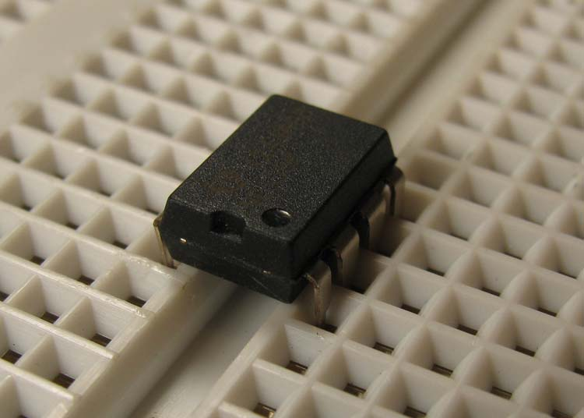

DIP Inserted over Center Notch

  - Pin Spacing: The spacing between the contact points is typically 0.1” (2.54 mm). The spacing over the center notch is 0.3” (7.62 mm),
  - Jumper Wires:
    - Homemade: Jump wire material for home-made wires should usually be 22 AWG (0.33 mm²) solid wire.
    - Jumper Wires:
      - Jumper kits come in assorted lengths of pre-stripped/preformed 22 AWG solid wire. (http://www.jameco.com #19290)
      - Reinforced Jumper Wires: Pin ends are reinforced for durability. Jameco stocks three lengths: 50 mm/1.97”, 100 mm/3.94”, and 200 mm/7.87”. (http://www.jameco.com #126360, 126342, and 126325 respectively)

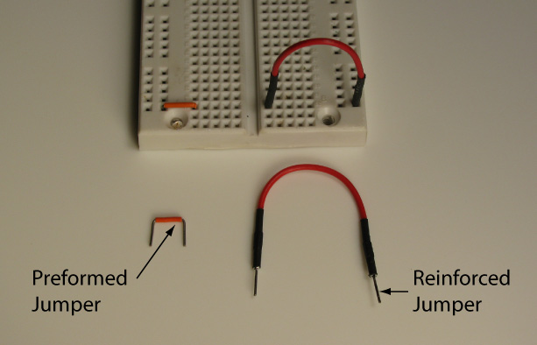

Commercial Jumper Wires

    - 0.100" Male Headers: Provides a way to connect electrical components. Headers may be soldered directly to the component or they may be soldered to component wires and encased in hot glue. See photos below.

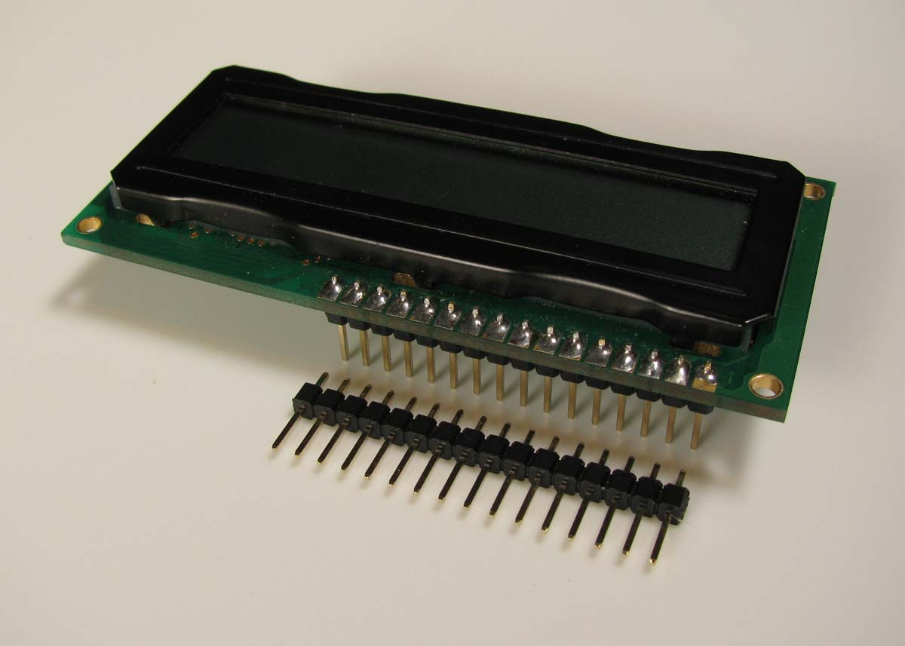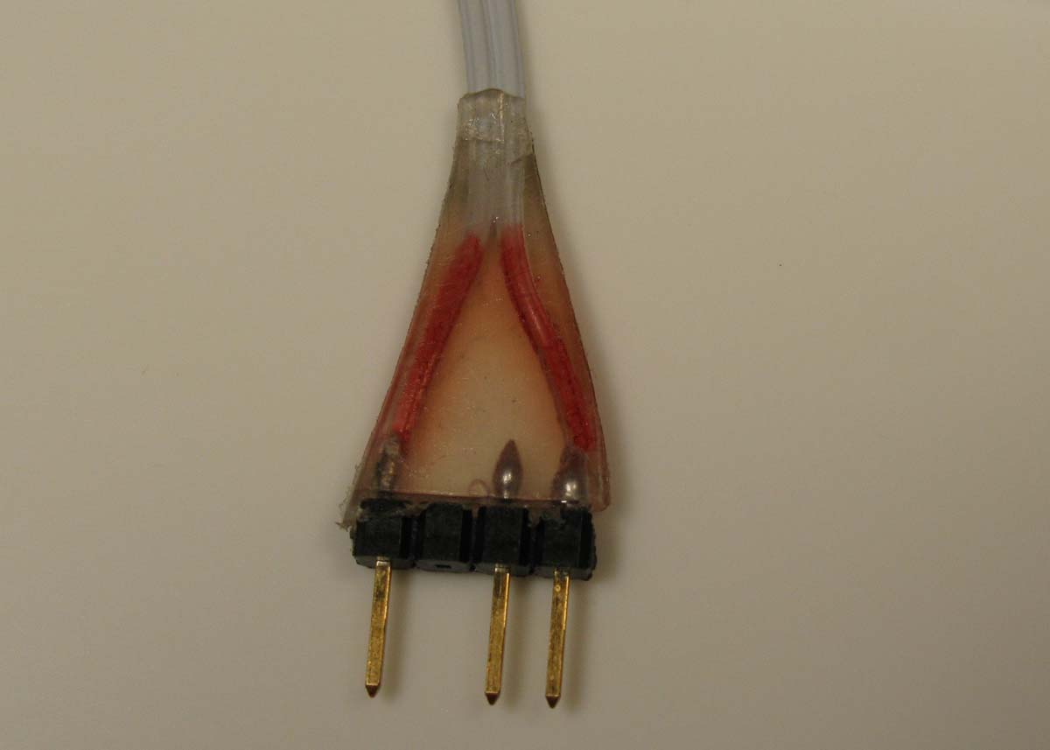

Male Header Soldered to an LCD Header Encased in Hot Glue

  - Surfboards:
    - Single-In-Line (SIP) breadboards accept discrete parts (resistors, diodes, etc.), Integrated Circuits. See other applications at: http://www.capitaladvanced.com/products.htm

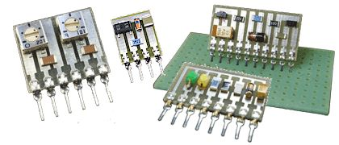

Surfboards for Discrete Parts

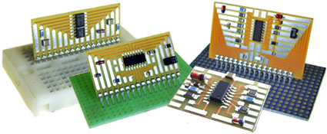

Surfboards for IC’s

  - Perform Simple Circuits and Solderless Breadboards Lab 2 – Power to the Breadboard.
Electronics Technology and Robotics I Week 1
Simple Circuits and Solderless Breadboards LAB 1 – Wiring Simple Circuits

- Purpose: The purpose of this lab is to acquaint the student with elementary electrical circuit symbols and wiring.

- Apparatus and Materials:

  - 1 – 3 Volt Battery Power Supply
  - 1 – 6 Volt Battery Power Supply
  - 1 – 9 Volt Battery Power Supply
  - 2 – 2.5 Volt Lamps
  - 1 – 6 Volt Lamps
  - 1 – 7.5 Volt Lamps
  - 1 – 1 Ohm Resistor (Brown, Black, Gold)
  - 1 – 22 Ohm Resistor (Red, Red, Black)
  - 1 – 68 Ohm Resistor (Blue, Gray, Black)
  - 1 – Knife Switch
  - Alligator Clips

- Procedure:
  - Wire the following circuits by connecting alligator clips to the circuit components.
  - Have your instructor check your circuit before closing the switch.

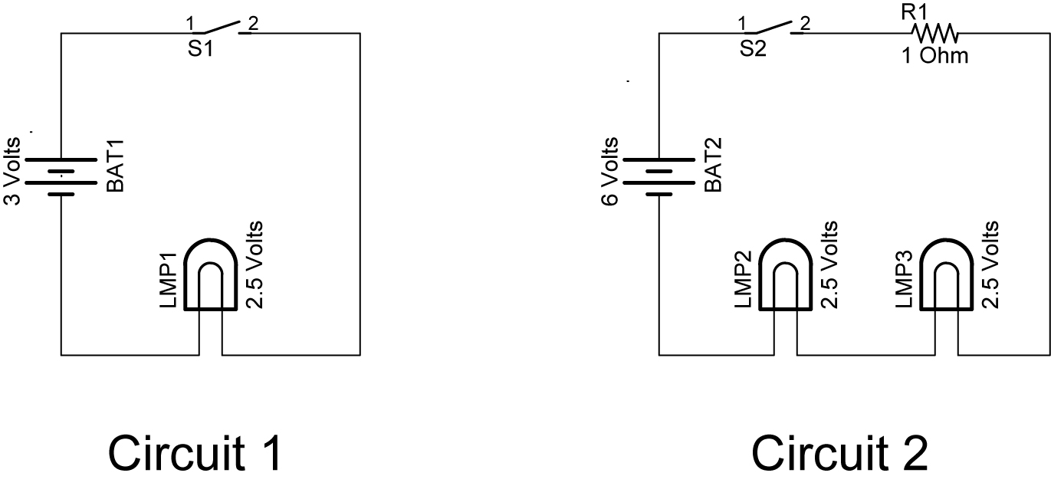

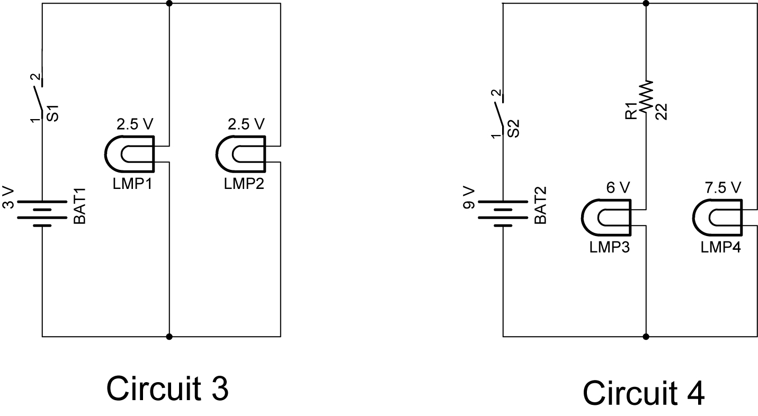

- Results:
  - In Circuit 1, close the switch then disconnect any of the alligator clips and record what happens to the lamp.

  - In Circuit 2, unscrew one of the lamps and record what happens to the other lamp:

  - In Circuit 3, unscrew one of the lamps and record what happens to the other lamp:

  - In Circuit 4, replace the 22 ohm resistor (red, red, black) with a 68 ohm resistor (blue, gray, black) and record the change in the 6 V lamp.

Electronics Technology and Robotics I Week 1
Simple Circuits and Solderless Breadboards LAB 2 – Power to the Breadboard

- Purpose: The purpose of this lab is to have the student wire the breadboard for a +9 V and + 5 V power strips.

- Apparatus and Materials:

  - 1 – 840 Pin Solderless Breadboard (Radio Shack #276-169)
  - 1 – 1660 Pin Solderless Breadboard (Electronix Express #03MB104)
  - 1 – 9 Volt Battery
  - 1 – 9 Volt Battery Snap
  - 1 – SPDT Switch (Electronix Express #17SLDH251)
  - 1 – LED
  - 1 – 470 Ohm Resistor (Yellow, Violet, Black)
  - 1 – 78L05 Voltage Regulator
  - 1 – 0.1 uF Capacitor
  - # 22 Solid Wire (Black and Red)

- Procedure:
  - 840 Pin Solderless Breadboard:
    - Power to binding posts: Install the battery snap and wire to the binding posts.
    - Layout the switch, LED, and resistor.
    - Power to buses: Connect the binding posts to the breadboard as shown. Buses are used for distribution of electrical power to components of a system.
    - Connecting the bus strips: Connect the top two bus strips (+9 V and Ground) to the bottom two bus strips.
    - Power indicator LED: Install the final connections as shown. Be sure that the flat side of the LED is facing toward ground.
    - Check voltages at points on the two bus strips.

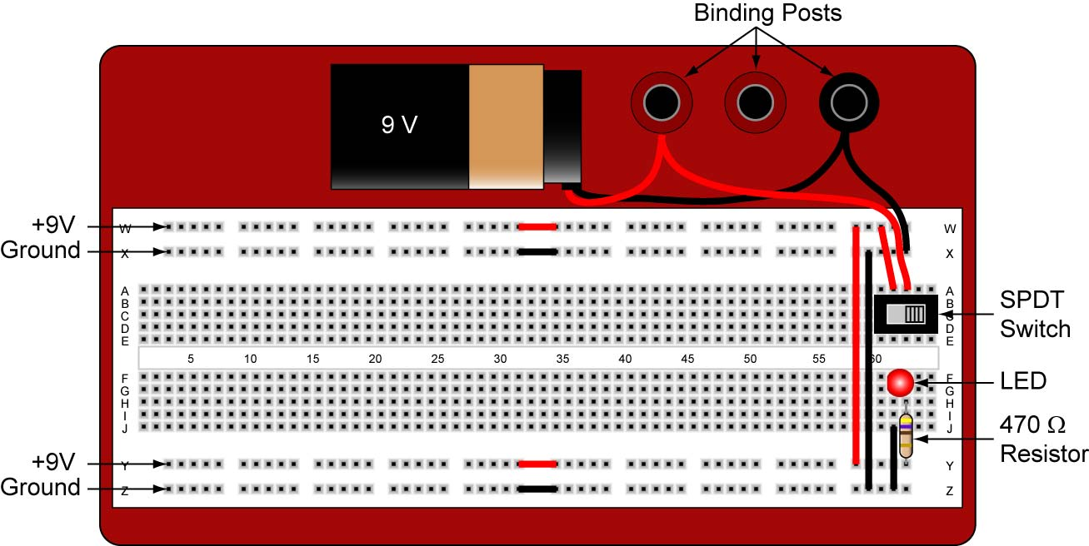

840 Pin Solderless Breadboard Setup

