Electronics and Robotics I Week 15
Programming PIC Microcontrollers in PICBASIC PRO – Lesson 1

- Administration:
  - Prayer
- PICBASIC PRO Programs Used in This Lesson:
  - General PICBASIC PRO Program Listing: http://www.cornerstonerobotics.org/picbasic.php
  - Lab 1 flicker1 as .pdf: http://www.cornerstonerobotics.org/code/blink1.pdf
  - Lab 1 flicker1 as .pbp: http://www.cornerstonerobotics.org/code/blink1.pbp
  - Lab 1 railroad1 as .pdf: http://www.cornerstonerobotics.org/code/railroad.pdf
  - Lab 1 railroad1 as .pbp: http://www.cornerstonerobotics.org/code/railroad.pbp
- Computer Programming:
  - In order to achieve the task at hand, a programmer must write a sequence of instructions and create data structures for the computer to execute.
  - Write a list of detailed instructions for the instructor to make a peanut butter and jelly sandwich, given the starting conditions before you.
- PIC Microcontrollers Overview:
  - Using microcontrollers (MCUs):
    - You will need to know how to connect the microcontroller to the hardware.
    - You will need to know how to write and program code into the microcontroller.
  - Levels of Programming Languages:
    - MCUs are programmed in machine language code (binary code) which looks like:

0000100001001001
0001100000000011
0111100000000111

- Machine language code is the native language for PIC MCUs.
- PIC machine language code ends with .hex
    - Assembly level code makes programming commands more recognizable; however, it forces the programmer to deal with the MCUs internal structure. Assembly code looks like:

movlw h’07’
addwf INDF, w
btfsc STATUS,C

- Another difficulty with assembly-level code is that each line of machine code must have a line of assembly code written.
- Assembly code commands are executed at the crystal frequency/4.
- PIC assembly code ends with .asm
    - High-level language: A programmer needs a programming language that relates to problem solving more than the internal structure of a microcontroller.
      - The most common high-level language for programming MCUs is C.
      - We will start with the language PICBASIC PRO, then in time, move on to C. PICBASIC PRO code appears like:

For c0 = 1 TO 100 ‘ Count from 1 to 100
SOUND 1, [75,100] ‘ Generate tone on pin 1
Pause 20 ‘ Delay 20 milliseconds
Next ‘ Return to FOR and add 1 to c0

      - PICBASIC PRO code ends with the extension .pbp.
  - Programming the microcontroller with PICBASIC PRO:
    - You will need to communicate with the microcontroller and tell it what instructions you want it to perform. The program language for the PIC microcontrollers uses about 75 words, or instructions, called PICBASIC PRO language. Make sure you program using commands that are handled by the PICBASIC PRO compiler (PBP), not the PICBASIC Compiler. See: http://store.melabs.com/cat/PBP.html
    - You will program on the computer in PICBASIC PRO language. You will then compile your program using the PICBASIC PRO compiler. The compiler first compiles the program into assembly code (.asm) and then automatically converts the assembly code into the final machine code (.hex) which is then programmed into a microcontroller using the melabs U2 programmer. See: http://melabs.com/products/usbprog.htm
    - Steps in programming a microcontroller will be discussed in more detail later in the class.
  - PIC16F88:
    - Cost is about $2.60 each
    - The PIC 16F88 is an 18-pin device that is equipped with two input/output ports, PORTA and PORTB.
    - PORTA has eight input/output (I/O) lines and the PORTB has eight I/O lines available.
      - PORTA I/O lines are labeled RA0, RA1, RA2, RA3, RA4, RA5, RA6, and RA7.
      - PORTB I/O lines are labeled RB0, RB1, RB2, RB3, RB4, RB5, RB6, and RB7.
    - Ordering direct from Microchip: http://www.microchip.com/wwwproducts/Devices.aspx?dDocName=en010243
    - PIC16F88 datasheet: http://ww1.microchip.com/downloads/en/devicedoc/30487c.pdf
    - Pin Layout:
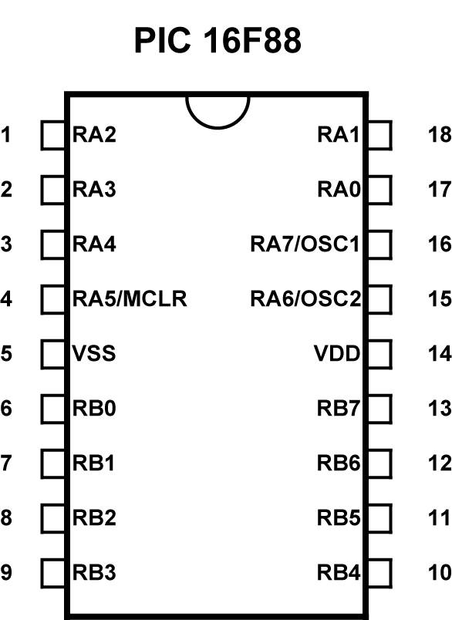

- Programming PIC Microcontrollers:
  - Outline of a PICBASIC PRO program:
    - PICBASIC PRO programs generally follow a predetermined format in the order given below.
      - Title
      - Program description
      - Revision history
      - Constants/Defines
      - Variables
      - Initialization
      - Main Code: During each main code cycle:
        - The MCU monitors the status of the input sensors
        - Executes the logic programmed in the main code
        - Changes the state of the output devices
  - Input/Output Port Registers and Input/Output Pins:
    - In a computer, registers are a set of data storage places that are part of a computer processor. A register may hold a computer instruction, a storage address, or any kind of data. In our immediate case, data stored in the I/O port register is 8-bit wide information about I/O pins. See lesson addendum for the PIC16F88 Register File Map.
    - Ports are connected to input/output (I/O) pins in a PIC. PORTB is the I/O port name for the I/O pins associated with PORTB.
    - Typically, an I/O port contains 8 pins. For example, PORTB has 8 pins.

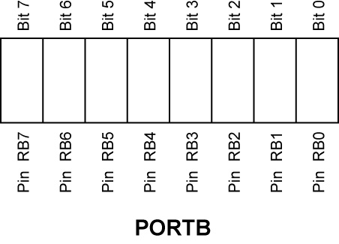
    - The PIC16F88 has two ports, PORTA and PORTB.
    - PORTA has 8 – I/O pins (RA0 – RA7) and PORTB has 8 – I/O pins (RB0 – RB7)
    - Pins can be accessed in a number of ways. One way to specify a pin is to use its PORT name and bit number:

PORTB.1 = 1 ‘ Set PORTB, bit 1 to a 1 or HIGH (+5V)
‘ PORTB.1 is pin RB1.

PORTA.3 = 0 ‘ Set PORTA, bit 3 to a 0 or LOW (0V)
‘ PORTA.3 is pin RA3.

    - Another way to access pins is to change the entire I/O port register.

PORTB = %00000000 ‘ Set all PORTB pins to LOW
PORTB = %11111111 ‘ Set all PORTB pins to HIGH
PORTA = %00000001 ‘ Set RA0 HIGH and RA1-RA7 to LOW.

  - Tri-State Registers (TRISx Registers):
    - TRISx as the data-direction register name for PORTx. For example, TRISB is the TRIS register for PORTB.
    - TRISx register is used to set up or initialize a pin as an input or an output. A “1” makes a pin an input and a “0” makes a pin an output. To remember, 1 looks like the I in Input and the 0 looks like the O in Output. Pins can be arranged in any combination of input and output.
    - TRISB Register Order:

In graphic form:

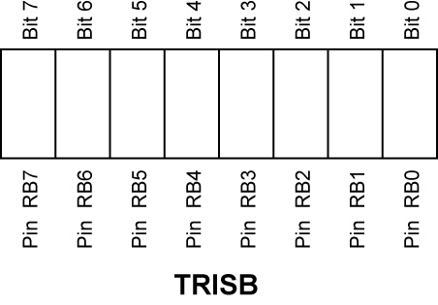

As written in a program:

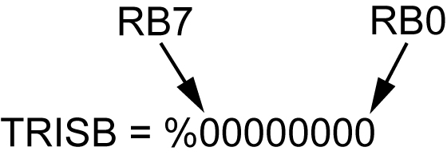

    - Example TRIS Registers:

TRISB = %00001111 ‘ Set RB0 – RB3 as inputs and
RB4 – RB7 as outputs.

TRISA = %00000001 ‘ Set RA0 as an input and RA1 – RA7 as outputs.

    - TRISx registers may be written in decimal form as well. TRISA = %00000000 can be written as TRISA = 0 and TRISB = %11111111 is the same as TRISB = 255.
    - Individual bit directions may also be set.

TRISB.2 = 0 ‘Set pin PORTB.2 as an output.

- New PICBASIC PRO Commands:
  - PAUSE:
Format:
PAUSE Period
Explanation:
Pause the program for Period milliseconds. Period is 16-bits, so delays can be up to 65,535 milliseconds (a little over a minute). PAUSE has the same accuracy as the
system clock. PAUSE assumes an oscillator frequency of 4MHz. If an oscillator other that 4MHz is used, PBP must be told using a DEFINE OSC command. See the section on speed for more information.
Example:

PAUSE 1 ‘ Delay for 1 millisecond
PAUSE 1000 ‘ Delay for 1000 milliseconds or 1 second

See page 112 in the melabs PICBASIC PRO Compiler manual: http://melabs.com/resources/pbpmanual/

  - GOTO:
Format:
GOTO Label
Explanation:
Program execution continues with the statements at Label.
Example:

LED1: ‘ Label named LED1

PORTB.0 = 1 ‘ Set pin RB0 to HIGH (+5V)

GOTO LED1 ‘ Program jumps to LED1

See about page 146 in the PICBASIC PRO Compiler manual: http://melabs.com/resources/pbpmanual/
  - END:
Format:
END
Explanation:
Stop program execution and enter low power mode. All of the I/O pins remain in their current state. END works by executing a Sleep instruction continuously in a loop.
An END or STOP or GOTO should be placed at the end of every program to keep it from falling off the end of memory and starting over.
Example:

END

- Review of +5V Voltage Regulator Circuit:
  - The circuit below will create a +5 V voltage source for the PIC microcontroller circuits.

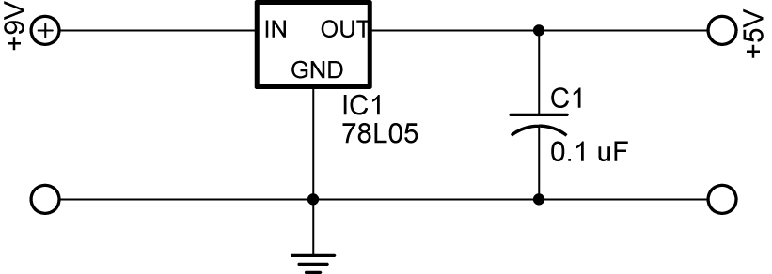

+5 Volt Voltage Regulator Circuit

- Procedure to Write, Compile and Download Your Program into the PIC Chip:
  - Double click on the MicroCode Studio icon on your desktop.
  - Go to Desktop and open the folder with your name.
  - Make sure you have opened your own folder before proceeding.
  - Now open blink1.pbp if it is not already on one of the program tabs.
  - Type in your program or program changes.
  - Make sure that the microcontroller on the tool bar matches the microcontroller you are programming.
  - Click on Project on the tool bar.
  - Now double click on Compile and Program or strike F10. This step will automatically save your program and set up the .HEX file to be downloaded into the 16F88 chip.
  - On the melabs Programmer, make sure the 16F88 chip is selected.
  - If the 16F88 is inserted on the breadboard, carefully use the chip extractor tool to remove the chip from the breadboard.
  - Install the 16F88 microcontroller into the ZIF adapter; verify the 16F88 is pointing in the correct direction.
  - Find and click on the Program button to download the program into your chip. The LED will flash several times. Click on the OK button.
  - Remove the chip from the ZIF adapter and insert it into the proper position on your breadboard.
- Complete LAB1 - blink1.pbp Program
Electronics and Robotics I Week 15
PIC Microcontrollers Programming 1 LAB 1 - blink1.pbp Program

- Purpose: The purpose of this lab is to acquaint the student on how to:
  - Compile a PICBASIC PRO program
  - Download a PICBASIC PRO into a PIC16F88 microcontroller
  - Structure a program using three PICBASIC PRO commands
  - Make simple modifications to a PICBASIC PRO program
  - Make modifications to the TRIS register

- Apparatus and Materials:

    - 1 – Robotic Car by Student
    - 1 – Breadboard with +5V and +9V Power Supplies
    - 1 – 150 Ohm, ½ Watt Resistors
    - 2 – 470 Ohm, ½ Watt Resistors
    - 1 – 1K, ½ Watt Resistor
    - 1 – LED
    - 2 – DC Motors
    - 2 – 2N2222A NPN Transistors
    - 1 – 78L05 Voltage Regulator
    - 1 – 0.1 uF Capacitor

- Procedure:
  - Wire the blink1 circuit below on your robotic car’s breadboard.

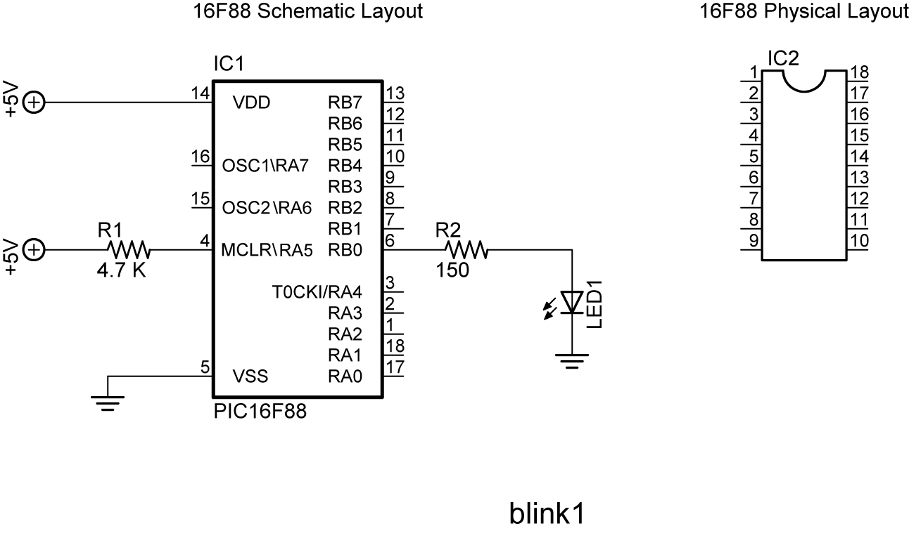

  - Program blink1.pbp into the PIC16F88 following the procedure to write, compile and download your program into the PIC chip at the end of the lesson.
  - Install the 16F88 and test the circuit and program
  - Change the PAUSE values (timing values) and reprogram the chip.

Electronics and Robotics I Week 15
PIC Microcontrollers Programming 1 LAB 1, Continued

- Challenges:
  - Connect the resistor and LED to RB1 and make it blink. Save the program as blinkrb1. Remember to change the TRISB register to make RB1 an output.
  - Railroad Crossing: Wire a circuit using RB0 and RB1 as outputs and program the chip so that two LEDs alternate flashes like a railroad crossing. Let the flash time be 0.75 seconds. Save the program as railrd1.
  - Drive a Motor: Design a circuit and program a PIC16F88 which will drive a motor in one direction only. Name the new program road1.
    - Use a 9 vdc power source on a separate breadboard to drive the motor.
    - Tie the grounds of the +5 vdc and +9 vdc breadboards together, but NOT the +5V and +9V power sources. Use two batteries for the power sources; one for the +5 vdc and the other for the +9 vdc bus rows.
    - Step down the +9 vdc to +5 vdc using a 78L05 voltage regulator circuit. Verify the +5 vdc and +9 vdc bus rows with a DMM.
    - You may use notes from prior classes to review NPN transistor switches.
    - Hints:
      - Keep wires away from the 16F88 chip since it will be removed frequently from the circuit.
      - Place the motor on the on the collector side of the NPN transistor. Place a 1K ohm resistor between the 16F88 drive pin and the base of the NPN transistor. See the circuit below:

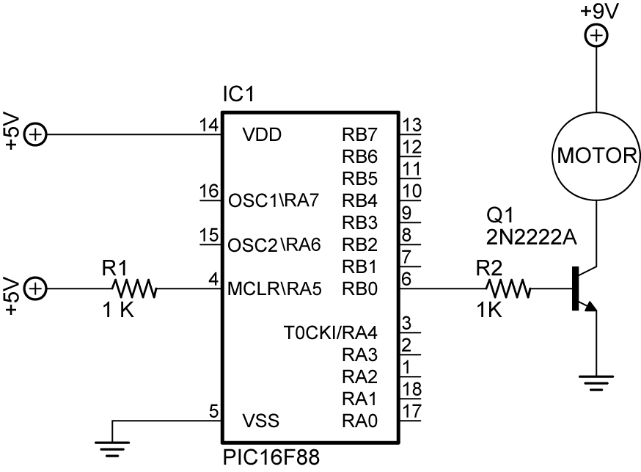

Transistor Switch as a Motor Driver

  - Drive a Robot: Now combine this lesson’s circuitry and programming to drive your robotic car through the taped course without crossing the inside boundaries of the tape. Revise the program road1.
    - You will have to use the process called dead reckoning since the robot is not equipped with any sensors. Wikipedia definition of dead reckoning: Dead reckoning is the process of estimating one's current position based upon a previously determined position, or fix and advancing that position based upon known speed, elapsed time, and course.
    - Hints:
      - Put the following code at the end of the program:

PORTB.0 = 0 ‘ Set PORTB, bit 1 to a LOW (0V)

PORTB.1 = 0 ‘ Set PORTB, bit 2 to a LOW (0V)

PAUSE 1 ‘ Pause 1 millisecond

This code will stop the robotic car.
