Cornerstone Electronics Technology and Robotics I Week 11
Capacitance

- Administration:
  - Prayer
  - Turn in quiz
- Capacitance and the Capacitor:
  - Capacitors: In physical terms, a capacitor is made of two conductors or plates that are separated by an insulator called a dielectric. In electrical terms, a capacitor is an electrical component that stores electrical charge in an electrostatic field when a voltage is applied. Demonstrate charging/discharging a 3300 microfarad capacitor at 18 volts.
  - Important Characteristics of a Capacitor:
    - Capacitance is a property that opposes any change in voltage. Perform Capacitance Lab 1 – Opposing Changes in Voltages
    - When a voltage source is connected to a capacitor, the capacitor does not dissipate energy like a resistor, but it stores energy in an electrostatic field. When the voltage source is removed, the capacitor returns the stored electrical energy back into to the circuit.
    - There is no electron flow through a good dielectric.

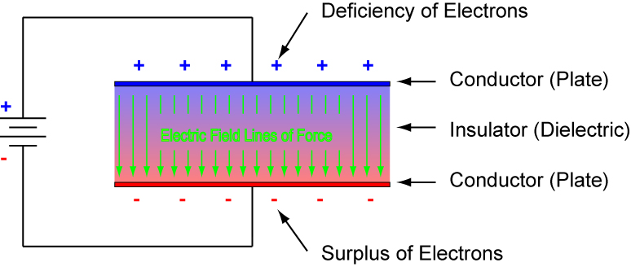

Figure 1: Basic Capacitor Parts When Charged

    - Perform Capacitance Lab 1 – Storing and Releasing Charge
    - See: http://micro.magnet.fsu.edu/electromag/java/capacitor/index.html
      - Charging: When you slide the switch toward the battery, electrons flow for a period of time charging the plates of the capacitor. Electrons from the negative terminal of the source flow to one plate of the capacitor. These electrons repel electrons in the other plate which are drawn to the positive terminal of the source. This continues until the capacitor is fully charged at which point, the current drops to zero. In the charging process, no electrons flow from one plate to the other plate in the capacitor.
      - Discharging: The charge (electrons) stored in the negative plate of the capacitor are drawn through the current path to the positively charged capacitor plate. This continues until the plates are neutralized, i.e., they have the same charge.
  - The value of a capacitor is dependent upon:
    - The area of the plates (directly related)
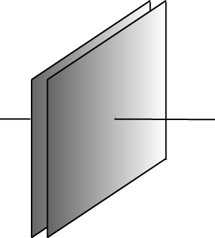  Figure 2a: More Area –  More Capacitance | 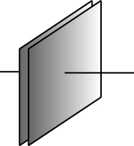  Figure 2b: Less Area –  Less Capacitance
    - The thickness T of the dielectric (inversely related):
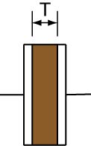  Figure 3a: Less Thickness –  More Capacitance | 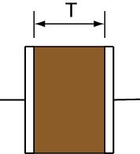  Figure 3b: More Thickness –  Less Capacitance

    - The dielectric constant of the material between the plates (directly related). Dielectric materials vary in their ability to support an electric field. This ability is called dielectric constant.

Material | Dielectric Constant (K)
Vacuum | 1.00
Glass | 5 – 10
Mica | 3 – 6
Mylar | 3.10
Plexiglas | 3.40
Teflon | 2.10
Water | 80.40
Air (1 atm) | 1.00059

Table 1: Dielectric Constants @ 20 Degrees C

  - The formula for capacitance is:

C = (0.225 K A)
_________________________________________________________________________________
T
Where:
C = capacitance, in picofarads
K = dielectric constant for the dielectric material
A = area of plates, in square inches
T = thickness of the dielectric in inches
  - Web site with java demonstration in meters: http://micro.magnet.fsu.edu/electromag/java/capacitance/index.html
  - Unit of measure:
    - The basic unit of capacitance is the farad (F).
    - Typical values of capacitance are in the microfarads (uF), (one-millionth, 1 x 10⁻⁶ F) or picofarads (pF), (one micromicrofarad, 1 x 10⁻¹² F).
1 uF = 1,000,000 pF, 0.000001 uF = 1 pF.
  - Ceramic Capacitor Code:
    - Electrolytic and large types of capacitors usually have the value printed on them like 470uF 25V.
    - Ceramic disk capacitors marked in pF: Some values are marked in picofarads using three digit numbers. The first two numbers of the printed value are the two digits or base number of the value. The third digit of the printed value is the multiplier of the first two digits in pF. See the Table 30 – 2.

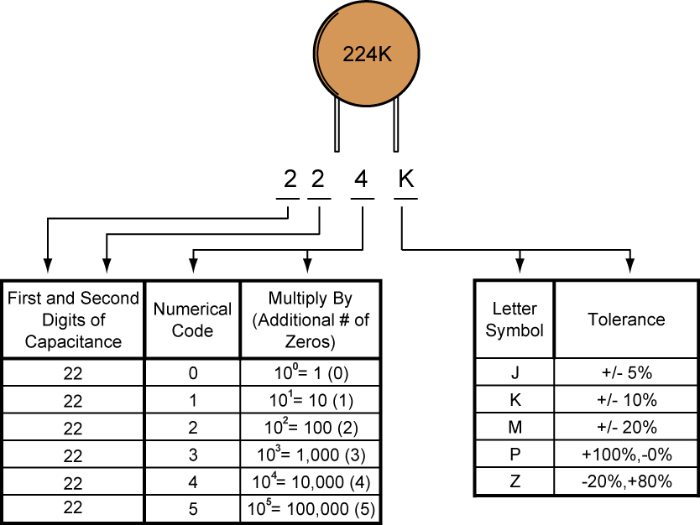

Table 2: Ceramic Disk Capacitor Standard Code (pF)

Example 224K: 22 x 10⁴ pF = 220,000 pF = 220 nF = 0.22 uF +/- 10%.
  - Types of Capacitors:
    - Ceramic (samples)
    - Can type electrolytic:

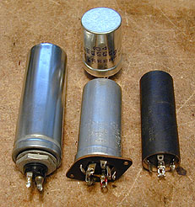

Figure 4: Can Type Electrolytic Capacitors

    - Tubular (samples)
    - Variable:
      - Trimmer (samples)
      - Dual Gang Variable:

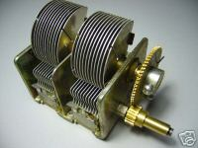

Figure 5: Dual Gang Variable Capacitor

  - Symbols:

Fixed Capacitor:
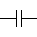
Capacitor Polarized:
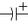
Variable Capacitor:
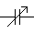
    - If the symbol has a curved plate, that end should be connected to the circuit point closest to ground.
  - Capacitive Reactance: Capacitive reactance is the opposition to the flow of alternating current caused by a capacitor in a circuit rather than by resistor. Capacitive reactance decreases as the ac frequency and or the capacitance increases. Capacitors are a frequency sensitive device. Capacitive reactance is given by:

X_{C} = 1 / 2Π f C

Where:

X_{C} = Capacitive reactance in ohms
Π = pi (3.1416…..)
f = Frequency in hertz
C = Capacitance in farads

For example if f = 1,000 hertz and C = 50 microfarads:

X_{C} = 1 / 2Π f C
X_{C} = 1 / 2Π x 1.0 x 10³ hertz x 5.0 x 10⁻⁵ farads
X_{C} = 1 / 31.4 x 10⁻² ohms
X_{C} = 1 / 0.314 ohms
X_{C} = 3.18 ohms

If f = 60 hertz and using the same capacitor:

X_{C} = 1 / 2Π f C
X_{C} = 1 / 2Π x 6.0 x 10¹ hertz x 5.0 x 10⁻⁵ farads
X_{C} = 1 / 94.2 x 10⁻⁴ ohms
X_{C} = 1 / 0.00942 ohms
X_{C} = 106 ohms

  - Capacitor Applications: Capacitors tend to block direct current and pass alternating current especially at higher frequencies.
    - DC Blocking:

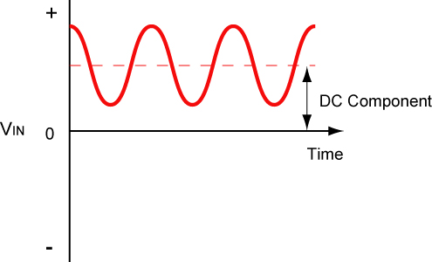 | 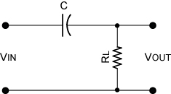 | 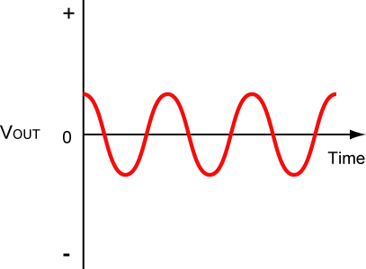
Input Signal with a DC Component | DC Blocked When Signal Sent Through a Capacitor | Output Signal with the DC Component Removed

Figure 6: DC Filtering, DC is blocked and AC is passed

    - Decoupling:

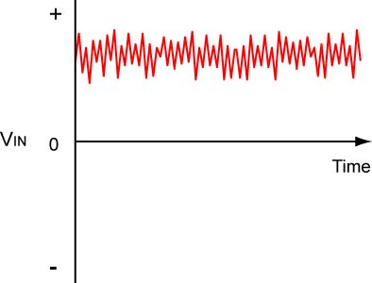 | 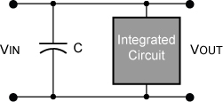 | 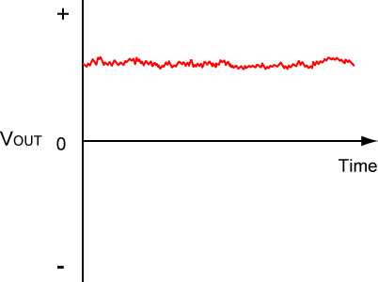
Input Supply Voltage with Undesirable AC Signals | Decoupling or Bypass Capacitor Shunts Undesirable AC Signals to Ground | Undesirable AC Signals Removed

Figure 7: Undesirable AC Ripple Removed through a Decoupling Capacitor

    - Low-pass Filter:

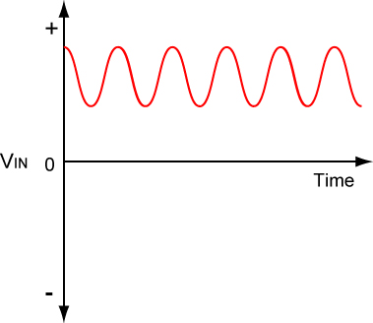 | 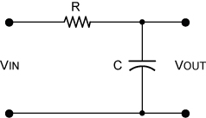 | 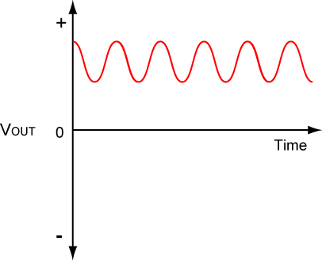
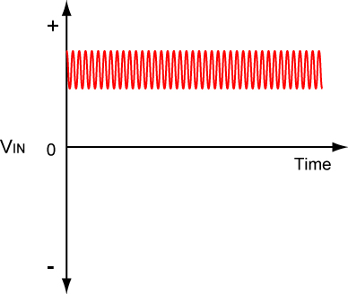 |  | 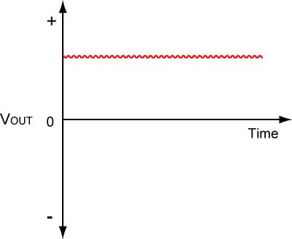
Low and High Frequency Signal Inputs | Capacitor Passes Low Frequency and Shunts High Frequency Signals to Ground | Low and High Frequency Signal Outputs

Figure 8: Capacitor in Bypass or Low-Pass Filter Configuration

    - High-pass Filter:

 | 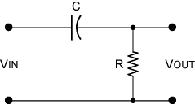 | 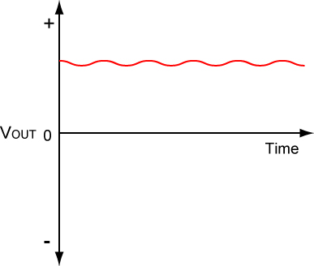
 |  | 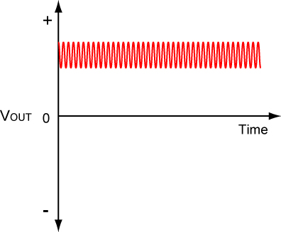
Low and High Frequency Signal Inputs | Capacitor Passes High Frequency and Blocks Low Frequency Signals | Low and High Frequency Signal Outputs

Figure 9: Capacitor in Coupling or High-Pass Filter Configuration

  - Real Capacitors: If the conductors are separated by a material with a small conductivity rather than a perfect dielectric, then a small leakage current flows directly between them. The capacitor therefore has a finite parallel resistance, and slowly discharges over time.

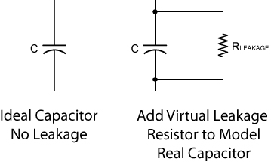

Figure 10: Ideal Capacitor and Leakage Model

Capacitors also deviate from the ideal capacitor equation in a number of other ways including inductance. These additional effects are not covered in this lesson.

  - One of the many uses for capacitors is in computer memories. A typical computer memory chip might contain more than 16,500,000 capacitors; each capacitor is charged to approximately 5 volts to store the binary digit 1 or 0 volts to store the binary digit 0.
- Transient Response of the Capacitor – RC Time Constants:
  - The response of current and voltage in a circuit immediately after a change in applied voltage is called the transient response. Transient is a temporary passing condition in a circuit.
  - RC Time Constants:
      - If a capacitor is charged through a series resistor, the capacitor will charge at a predictable rate.
      - The charging time is directly related to the value of resistance and capacitance in the RC circuit. As the resistor value increases, the electron flow into the capacitor slows and it takes more time for the capacitor to charge. And as the capacitor value increases, it will take more time for the additional electrons to charge the additional charge capacity.
      - The charge and discharge curves look as follows:

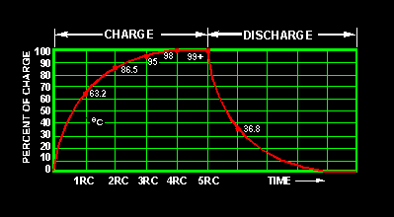

Figure 11: Capacitor Charge and Discharge Curves

From: http://www.tpub.com/neets/book2/3d.htm

      - The time it takes to charge or discharge the capacitor to 63.2% of its full charge is called the time constant (τ). The formula for time constant is:

τ = R C

Where:

τ = time constant, in seconds
R = resistance, in ohms, and
C = capacitance, in farads

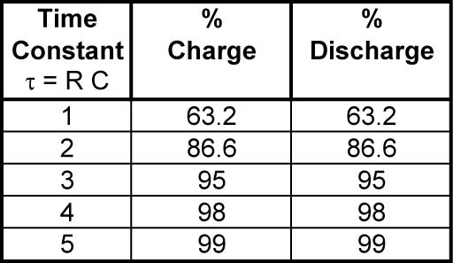

Table 3: Time Constants and % Charge and Discharge

    - Perform Capacitance Lab 2 – Charging and Discharging a Capacitor through a Resistor.
    - Perform Capacitance Lab 3 – Application of an RC Circuit. .
    - See web sites for java applet demonstrations:
      - http://www.phy.ntnu.edu.tw/ntnujava/index.php?topic=31
      - http://webphysics.davidson.edu/physlet_resources/bu_semester2/c11_RC.html
      - http://lectureonline.cl.msu.edu/%7Emmp/kap23/RC/app.htm
      - http://www.falstad.com/circuit/e-cap.html
      - http://www.ngsir.netfirms.com/englishhtm/RC_dc.htm
  - Bleeder Resistor: Bleeder resistors are resistors that are connected across (shunted) the terminals of a capacitor or power supply to discharge capacitors as a safety measure when the power supply is turned off.

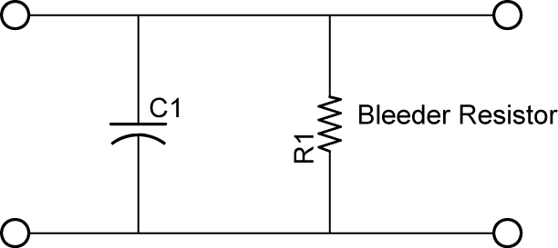

Figure 12: Bleeder Resistor across a Capacitor

  - Capacitors in Parallel:
    - Schematic:

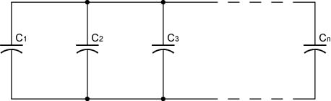

Figure 13: Parallel Capacitors

    - The total capacitance for parallel capacitors is the sum of the capacitors.

C_{T} = C₁ + C₂ + C₃ + ….. + C_{n}

Where n = the number of capacitors in parallel

  - Capacitors in Series:
    - Schematic:

Figure 14: Series Capacitors

    - The total capacitance for series capacitors is given by:

C_{T} = 1/C₁ + 1/C₂ + 1/C₃ + ….. + 1/C_{n}

Where n = the number of capacitors in series

Electronics and Robotics I Week 11
Capacitance Lab 1 – Storing and Releasing Charge

- Purpose: The purpose of this lab is to verify that a capacitor stores electrical charge when a voltage is applied and that when the voltage source is removed, the capacitor returns its stored electrical charge to the circuit.

- Apparatus and Materials:

  - 1 – Digital Multimeter
  - 1 – 3 Volt Battery Power Supply
  - 1 – 2.5 Volt Lamp
  - 1 – Lamp Holder
  - 1 – 30,000 Microfarad Capacitor (http://www.skycraftsurplus.com/index.asp?PAGEACTION=CONTACTUS)
  - 1 – 140,000 Microfarad Capacitor (http://www.skycraftsurplus.com/index.asp?PAGEACTION=CONTACTUS)
  - 1 – 1,000,000 Microfarad or 1Farad Capacitor (http://sciencekit.com/one-farad-capacitor/p/IG0024229/)
  - Alligator Clips

- Procedure:
  - Take an alligator clip and short the terminals of each capacitor.
  - Measure and record the voltage across each shorted capacitor.
  - Charge each capacitor with the 3 volt battery power supply.
  - Measure and record the voltage across each charged capacitor.
  - Connect the 2.5 v lamp to each of the capacitors and remain connected until the lamp dims. Measure and record the time the lamp is illuminated.
  - Measure and record the voltage across each discharged capacitor.

- Results:

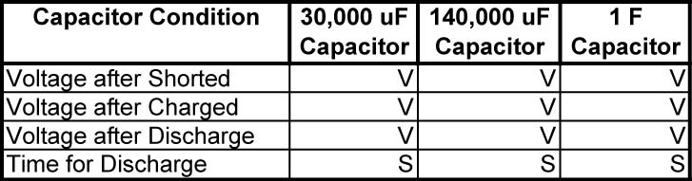

- Conclusions:
  - Which capacitor takes longer to discharge? Explain why.

Electronics and Robotics I Week 11
Capacitance Lab 2 – Charging and Discharging a Capacitor through a Resistor

- Purpose: The purpose of this lab is to verify the formula for the time constant, τ.

- Apparatus and Materials:

  - 1 – Breadboard with a 5 VDC Power Source
  - 2 – Digital Multimeters
  - 1 – Oscilloscope
  - 1 – Stop Watch
  - 2 – 10 K Resistors
  - 2 – 22 K Resistors
  - 1 – SPDT Switch
  - 1 – 1000 uF Capacitor

- Procedure:
  - Build the following circuit and place a voltmeter across the capacitor C1 and an ammeter between S1 and C1.
  - Qualitative Results:
    - Slide the switch toward the battery to charge the capacitor through resistor R1, and then slide the switch to the other position to discharge the capacitor through resistor R2.
    - Observe the voltage across and the current through the capacitor while switching back and forth. Record your observations.

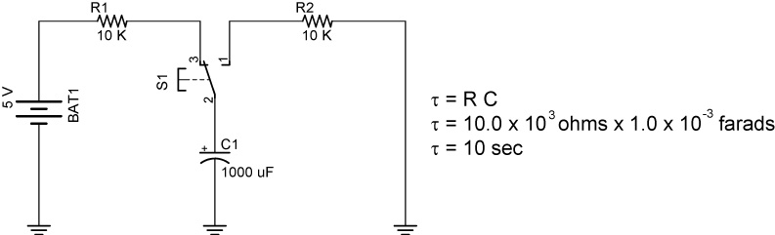

Charging and Discharging a Capacitor through a Series Resistor

  - Quantitative Results:
    - Measure and record the voltage across the power source.
    - Calculate and record 63.2% of the source voltage.
    - Measure and record the time in seconds it takes the capacitor to charge to 63.2 % of the source voltage (the definition of the time constant, τ).
    - Charge the capacitor until it is fully charged to the source voltage.
    - Subtract 63.2% of the source voltage from the value of the source voltage and record the result.
    - Measure and record the time in seconds it takes the capacitor to lose 63.2 % of its full charge (the definition of the time constant, τ).
  - Replace the 2 – 10 K resistors with the 2 – 22 K resistors and repeat the Quantitative Results procedure used for the 10 K resistors.
- Results:
  - Qualitative Results:
    - When charging the capacitor, how does the voltage increase across the capacitor change with time?

    - When charging the capacitor, how does the current decrease through the capacitor change with time?

    - When discharging the capacitor, how does the voltage decrease across the capacitor change with time?

    - When discharging the capacitor, how does the current decrease through the capacitor change with time?

  - Quantitative Results:

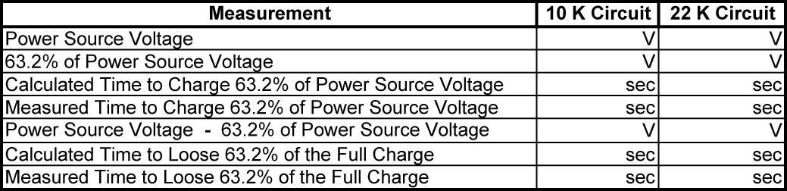

- Conclusions:
  - Compare the calculated and measured times for the capacitor to charge to 63.2% of the power source (the time constant, τ). If the two values are not equal, explain the discrepancy.

  - Compare the calculated and measured times for the capacitor to discharge to 63.2% of the power source (the time constant, τ). If the two values are not equal, explain the discrepancy.

Electronics and Robotics I Week 11
Capacitance Lab 3 – Application of an RC Circuit

- Purpose: The purpose of this lab is to demonstrate an application of a capacitor in a 555 timer circuit.

- Apparatus and Materials:

  - 1 – Breadboard with a 5 VDC Power Source
  - 1 – Oscilloscope
  - 1 – 555 Timer IC
  - 2 – 47K Resistors
  - 1 – 470 Ohm Resistor
  - 1 – 47 Microfarad Capacitor
  - 1 - LED

- Procedure:
  - Wire the circuit in Figure 30 – 13.
    - Using an oscilloscope, observe the waveform across the capacitor on Channel 1 of the oscilloscope and compare it with the waveform on the output pin 3 on Channel 2.
    - Replace C1 with a 10 microfarad capacitor. Note the difference in waveform.

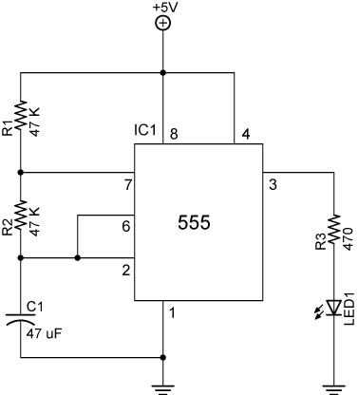

Basic 555 Astable Circuit

    - When charging C1, the current must pass through R1, R2, and C1. See Figure 30 – 14.
    - When discharging, the current passes through only R2 and C1.
    - With C1 = 10 microfarads, calculate and record the time constants for the charge and discharge cycles.

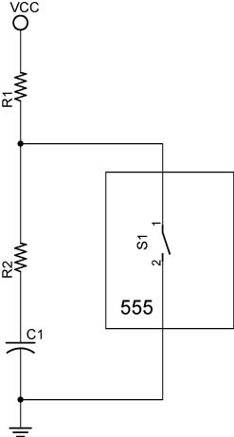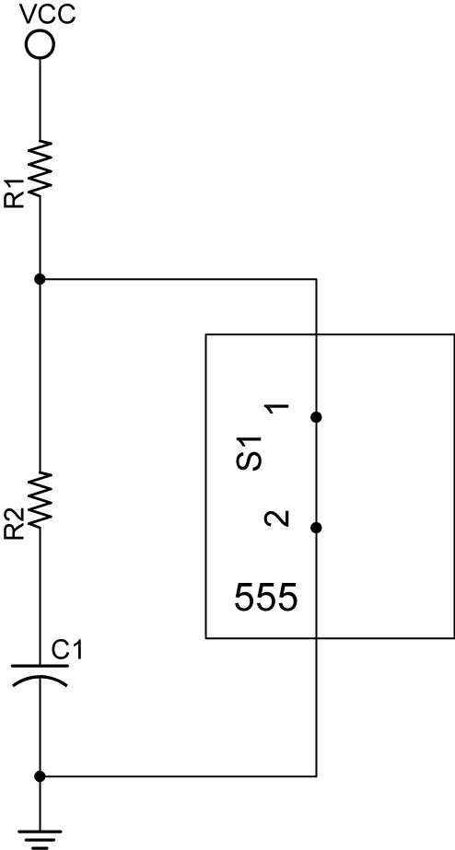

Simplified Diagram of Simplified Diagram of
C1 Charging through R1 & R2 C1 Discharging through R2

- Results:
  - Sketch the waveform across the capacitor.

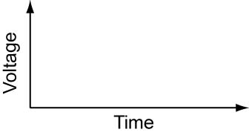
  - Sketch the waveform at the output pin 3.

- Conclusions:
  - Why does it take more time for the LED to light the first time than for the rest of the cycles?

  - Is the time the LED is on equal to the time it is off? Why or why not?

