Cornerstone Electronics Technology and Robotics Week 10
DC Motors
- Administration:
  - Prayer
  - Turn in quiz
- DC Motor Operation Principles:
  - A generator converts rotating mechanical energy into electric energy. Using magnetism, a motor converts electrical energy into mechanical energy by turning an output shaft.
  - "The electric motor is the most convenient of all sources of motive power. It is clean and silent, starts instantly, and can be built large enough to drive the world's fastest trains or small enough to work a watch." – David Macaulay, author of The Way Things Work
  - Motor Parts:
    - Permanent magnets: two magnets that remain magnetized after the electricity is turned off.
    - Armature coils: windings where the magnetic polarity changes. The windings are wound around an iron core to increase the reaction with the permanent magnets. Part of the rotor assembly.
    - Commutator: contains two or more segments to receive the electricity that is then sent to the armature coil. The commutator rotates with the armature coil and is part of the rotor.
    - Brushes: contacts that press against the commutator to make connection between the power source and the armature coils.

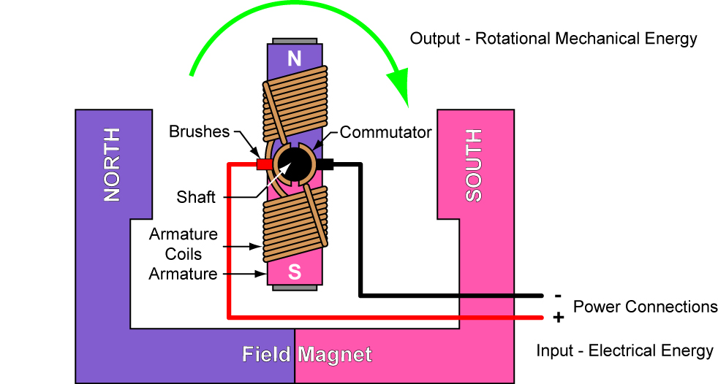

Figure 1: Parts of a Basic DC Motor

  - Simple Rotation Sequence for a Basic DC Motor:

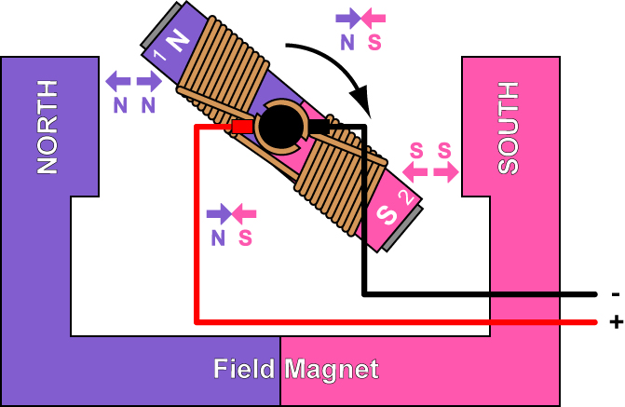  Figure 2 | When current flows through the armature coils, magnetic fields are generated around each end of the coils (Ends 1 and 2). The coils function as electromagnets. The north magnetic field that is generated in End 1 of the coil is pushed away from the north permanent magnet (like poles repel) and drawn toward the south permanent magnet (opposite poles attract) causing rotation. Likewise, the south magnetic field that is generated in End 2 of the coil is pushed away from the south permanent magnet and drawn toward the north permanent magnet also causing rotation.
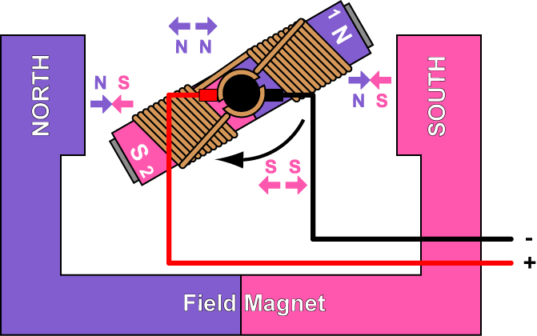  Figure 3 | The magnetic fields in the armature coils are still the same causing the attraction and repulsive forces to continue. Notice the small gap in the commutator – the direction of the current through the coils is about to change once the brushes come in contact with the other side of that gap.
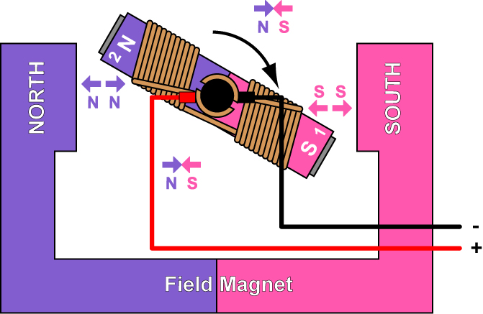  Figure 4 | When the armature rotates past the horizontal alignment, the commutator reverses the direction of current through the coils, reversing or flipping the magnetic fields of the coils. End 1 is now the south pole; End 2 is now the north pole.  The process then repeats.

See: http://pcbheaven.com/wikipages/How_DC_Motors_Work/
Also see dc motor applet at: http://www.magnet.fsu.edu/education/tutorials/java/dcmotor/index.html
  - Motor Input and Output Ratings:
    - Input Ratings: Voltage and Current
    - Voltage: Since mobility is essential in robotics, the main sources of electrical power are batteries and to a lesser extent photovoltaic cells. Roboticists usually use motors that are rated for 6, 12, or 24 volts because the power source, batteries, is normally available in these voltages. 12 Volt batteries are preferred when motors and 5 volt logic are powered from the same source. 5 Volt voltage regulators require 7 volts input to function properly so a 6 volt source is lacking and the 24 volt source may exceed the recommended operating input voltage. In general, a motor can be operated at 50% of the voltage rating.
    - Current: Power is the product of voltage and current so the motor current rating gives an indication of the power consumed by the motor. It also points toward the mechanical power output of the motor.
    - Output ratings: Speed, Torque, and Power
    - Rotational and Angular Speed: Typically, a motor rotational speed is rated when the motor is in a no load state.
      - Rotational speed, ω_{cyc}, is measured in revolutions/minute (rpm) or revolutions/second (rps).

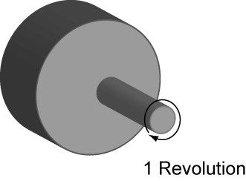

Figure 5: One Revolution

      - Example:

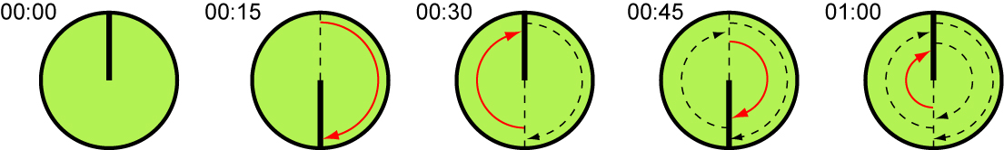

Figure 6: 2 Revolutions per Minute (2 rpm) = 0.033 rps

      - Radians: A single radian is defined as the angle formed in the minor sector of a circle, where the minor arc length is the same as the radius of the circle.

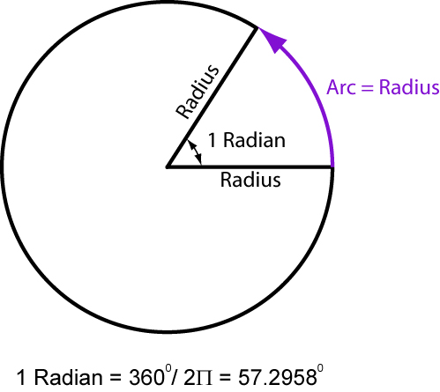 | 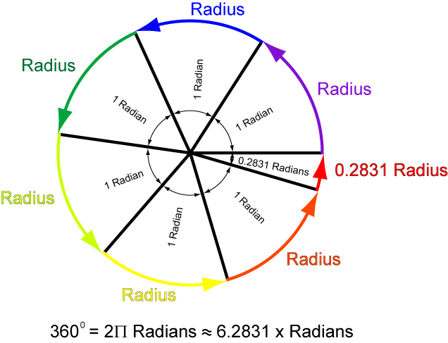

Figure 7: 1 Radian and 2Π Radians Illustrated

      - Angular speed, ω_{rad} or ω_{ang} , is measured in radians/second (rad/s) or degrees/second (deg/s) respectfully. Examples:

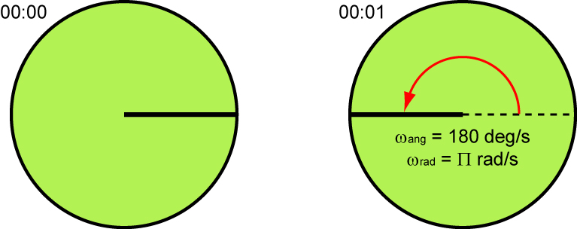

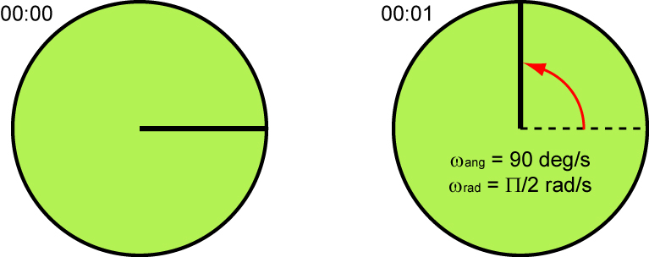

Figure 8: Two Examples of Angular Speed

      - Relation between rotational speed and angular speed:

ω_{cyc} = ω_{rad} / 2Π
and
ω_{cyc} = ω_{ang} / 360

Where:
ω_{cyc} = rotational speed in rpm or rps
ω_{rad} = angular speed in rad/s
ω_{rad} = angular speed in deg/s

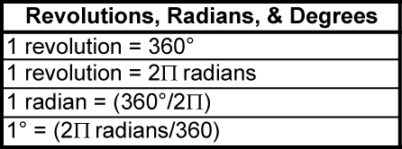

      - In robotics, a high motor torque is more useful than a motor with high rotational speed. Motors commercially available may not have the desirable rotational speed or torque needed for robotics. Gear systems are added to convert high rotational speed (rpm) from a motor to supply a higher torque at a lower rotational speed. Some motors come with reduction gears boxes attached to the motor. This combination is called a gearhead motor. See Figure 23 – 9.

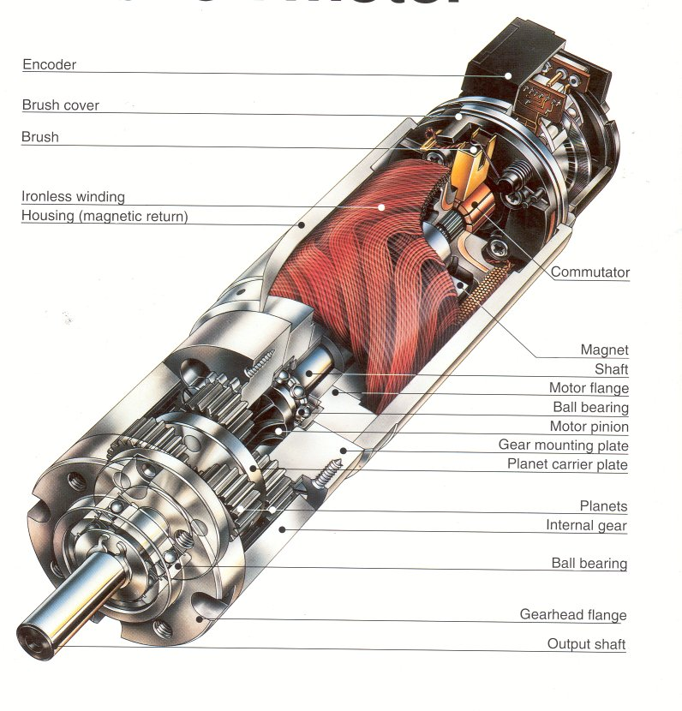
Figure 9: Parts of a Gearhead Motor
    - Torque: Definition 1: Torque is the tendency of a force to cause or change rotational motion of a body. Definition 2: Torque is the tendency of a force to rotate an object about an axis.

τ = F x r

Where:
τ = Torque
F = Force perpendicular to the radius
r = Radius

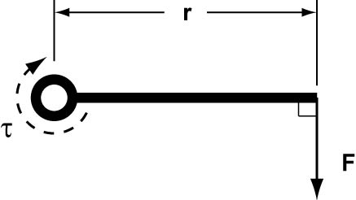

Figure 10: Torque Variables

      - Example: Find the torque for a 7 pound force that is 2 feet from the axis of rotation.

τ = F x r
τ = 2 lbs x 7 ft
τ = 14 ft-lbs

The same torque came be generated with a 14 pound force that is 1 foot from the axis of rotation. See Figure 25 – 11.

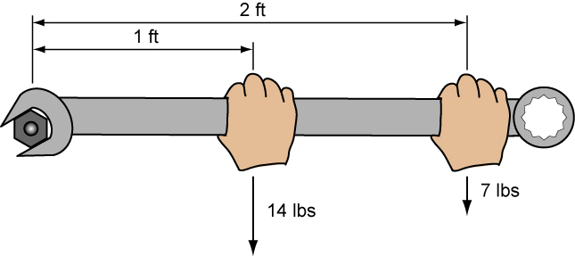

Figure 11: Equal Torques

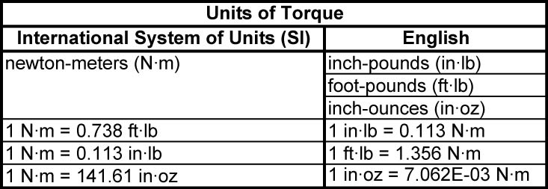

      - See: http://www.physclips.unsw.edu.au/jw/electricmotors.html#DCmotors
    - Power: Power (rate of doing work) is the product of the torque and rotational speed.
P = k x τ x ω
Where:
P = Rotational power
k = Constant
τ = Torque
ω = Rotational speed

For Power in SI units,
P = 2Π x τ x ωcyc
60
Where:
P = Rotational power in Watts
τ = Torque in N m
Π = 3.14159…
ω_{cyc} = Rotational speed in rpm

    - Reversing polarity to a dc motor reverses the direction of rotation. See the lesson on h-bridges: http://cornerstonerobotics.org/curriculum/lessons_year2/erii20_motor_control_h_bridges.pdf
    - Torque-Speed Curve: Torque-speed curve is a graph that shows the relationship between a motor’s torque and speed. The graph below shows a typical torque-speed linear relationship for a DC motor.

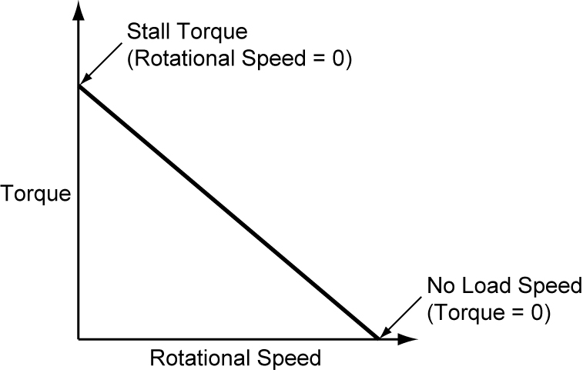

Figure 12: Torque-Speed Curve for Typical DC Motor

      - The stall torque represents the point on the graph at which the torque is a maximum, but the shaft is not rotating (rotational speed = 0).
      - The no load speed is the maximum output speed of the motor when no nothing is attached to the output shaft (torque = 0).
      - Torque is inversely proportional to the speed.
    - Power Illustrated on Torque-Speed Curves: Power may be illustrated on a torque-speed curve as the area of a rectangle under the torque/speed curve.
      - Remember that power as the product of torque and rotational speed.
      - This product (τ x ω) corresponds to the area of a rectangle under the torque/speed curve. See Figure 25 – 13 below.
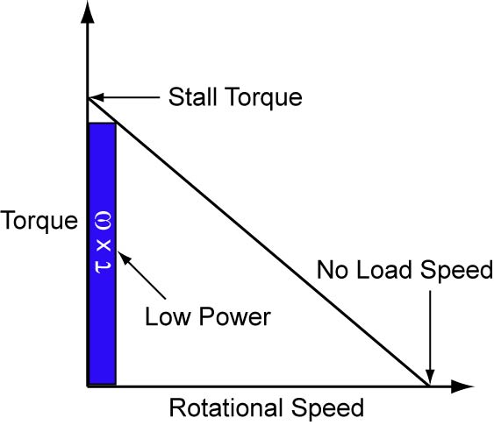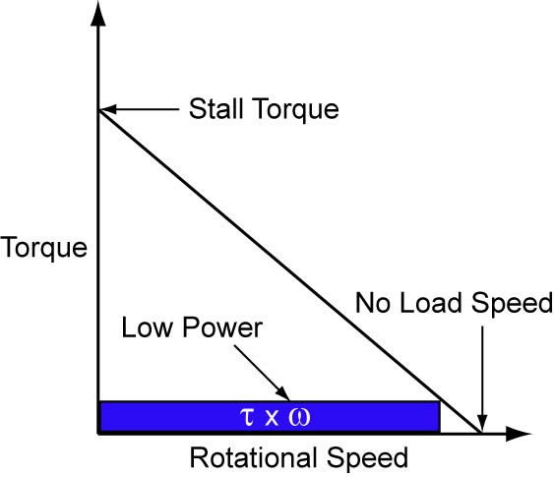

Low Power

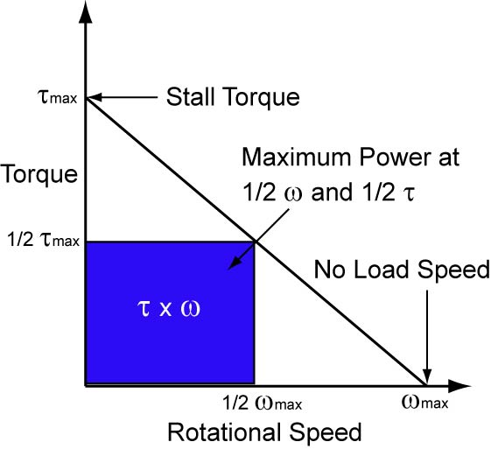

Maximum Power

Figure 13: Low and Maximum Power Illustrated on a Torque-Speed Curve

    - Torque and Power vs. Speed Graph: Power may be added to torque-speed curve as a new scale on the right side of the graph. Note that the maximum power occurs at half the no-load speed and half the stall torque.

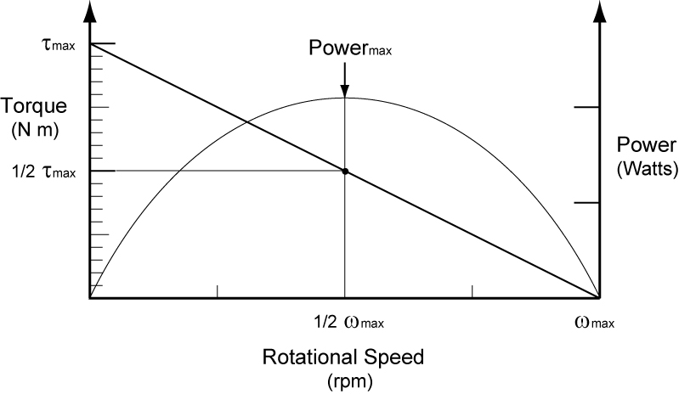

Figure 14: Torque and Power vs. Speed Graph

  - Counterelectromotive Force (Counter emf or cemf):
    - Sometimes called back emf.
    - When a motor starts, it is converting electrical energy into mechanical energy. But when the armature begins to rotate, it becomes a generator, converting mechanical energy back into electrical energy which is called counterelectromotive force.
    - The generated cemf opposes the applied emf.
    - A lot of energy is stored in the magnetic field of the motor coil when it is energized. When we turn off the motor, that energy has to go somewhere. The collapsing magnetic field will generate a current spike.

    - In the circuit below, when the motor is switched off it will generate a large cemf or reverse voltage. A flyback diode will route this cemf back through the motor until the energy is dissipated. A diode should be placed across all inductive loads including relays, solenoids, motors, etc. to protect other circuit components.

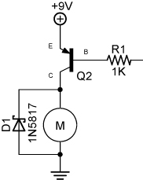

Figure 15: Flyback Diode Inserted into the Circuit

    - Schottky Diode Selection: In the circuit above, a Schottky diode is inserted to reroute the reverse voltage and to protect other connected components. The Schottky diode is used rather than a general purpose diode such as a 1N4001 because the Schottky diode has a lower forward voltage drop than the general purpose diode, making it respond to the cemf faster than a general purpose diode.

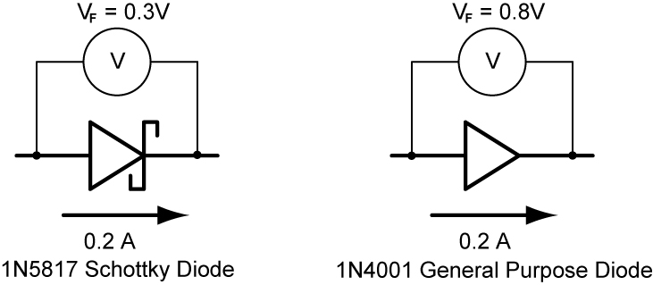

Figure 16: Forward Voltage Drops at Forward Current of 0.2 A (from Datasheets)

  - Overload Protection:
    - When a motor stalls (stops rotating), the armature will pull high currents. This condition is called locked rotor. To protect the motor from locked rotor, an overload device such as a fuse is installed.
- Work on sonar car body.

